**Style Tips**

**Style – Comments**

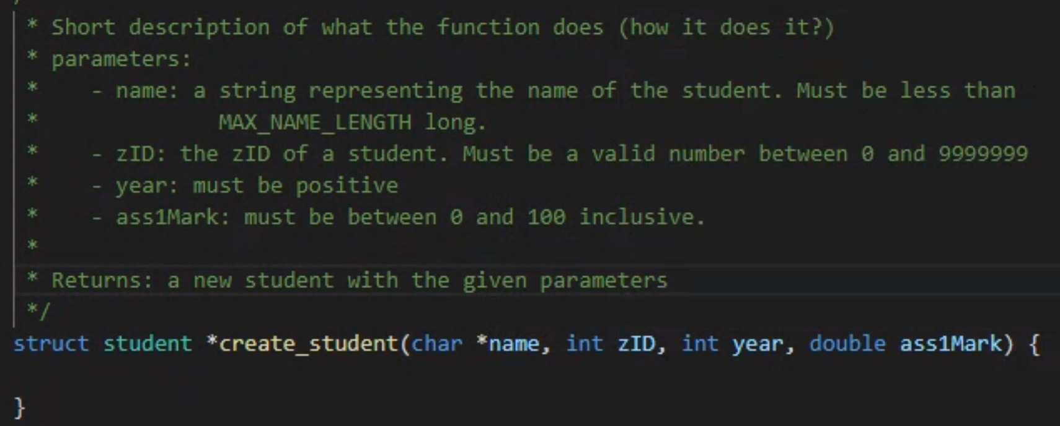

**Using Functions for Nodes**

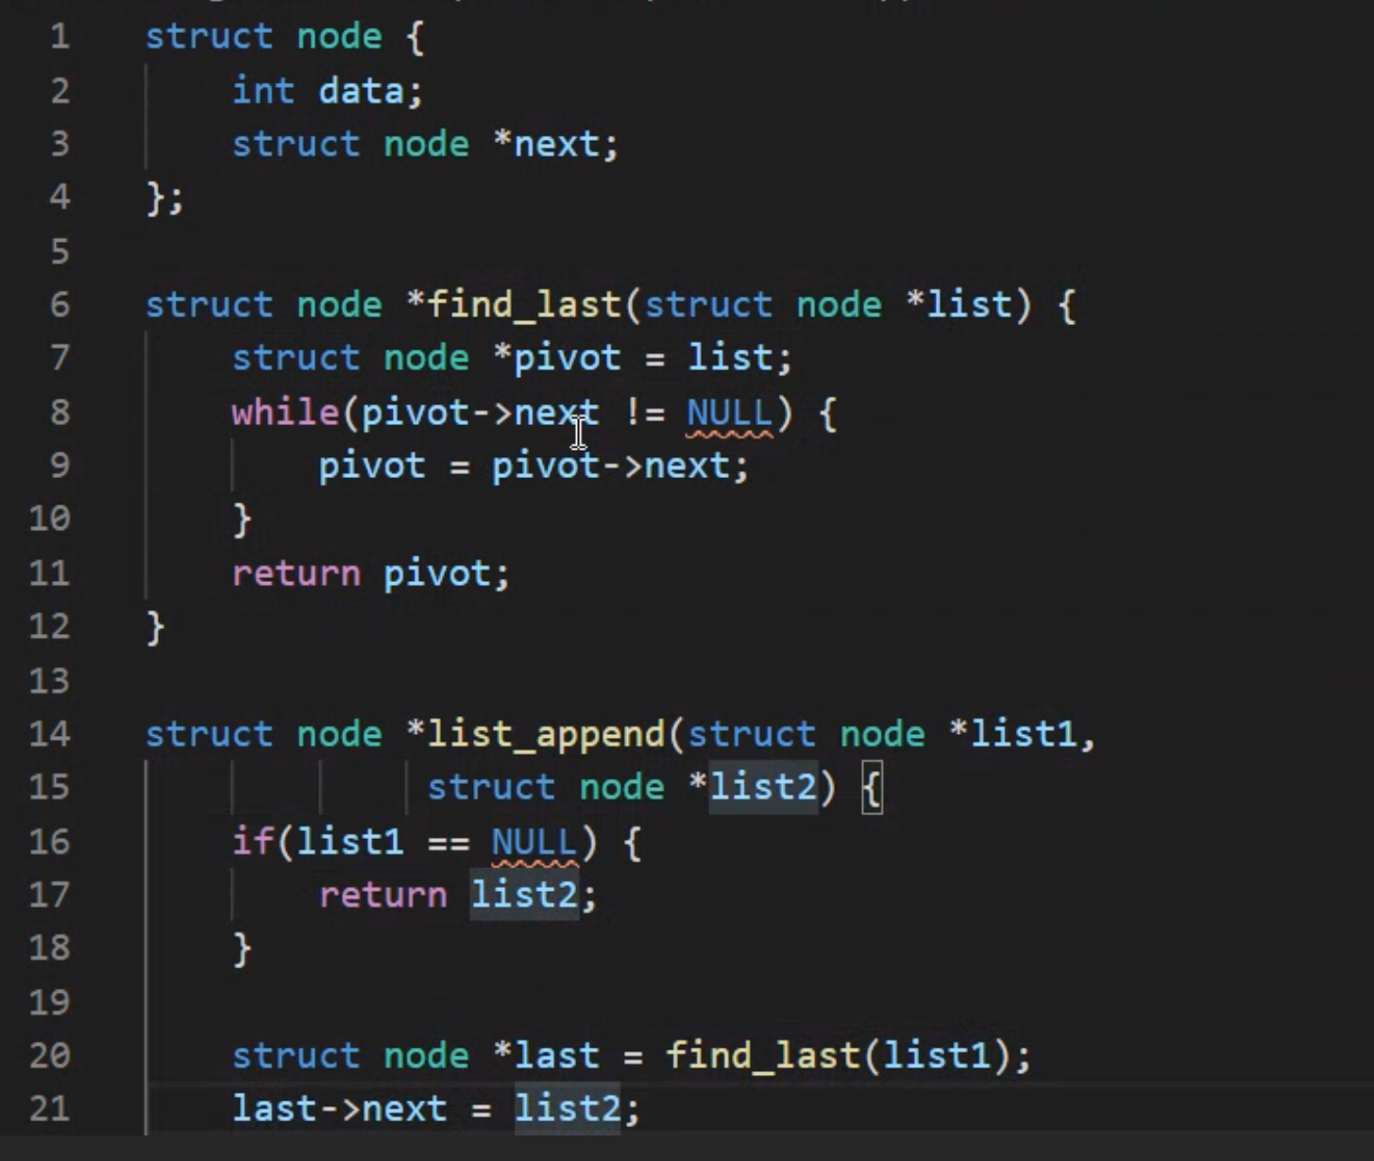

**18/02/20 – Week 1 Lecture 1/Tutorial Questions**

* **Industry Standard**: Every code needs a header (comment) which includes:
  + Name of program
  + Date
  + Short description of program
  + Personal Details such as the developer’s name, zID and email
  + **Follow Style Guide on websms3**
* Good code doesn’t need a lot of comments. Comments are FOR to stop confusion, explain its purpose, add a note or **reference** to other pieces of code.
* Referencing is used for pieces code that extend the range of course content, using another developer’s algorithms.

**What is an operating system?**

An **operating system (OS)** is a series of computer programs (software) that runs on your computer. Its main function is to manage the running of the computer (keeping things like your mouse and keyboard accessible and keeping hardware drivers up to date) as well as providing an interface for programs to run.

Common operating systems are Microsoft Windows, Apple OSX and many versions of UNIX/Linux.

In terms of interaction, most operating systems can either use a GUI (Graphical User Interface) which allows us to interact mostly with a mouse/touchpad and visual elements ->user friendly. Most OSes also provide a command line terminal, which allows access purely via text.

**Structure**:

#include <stdio.h>

int main (void) {

---

}

**Linux Terminal Commands:**

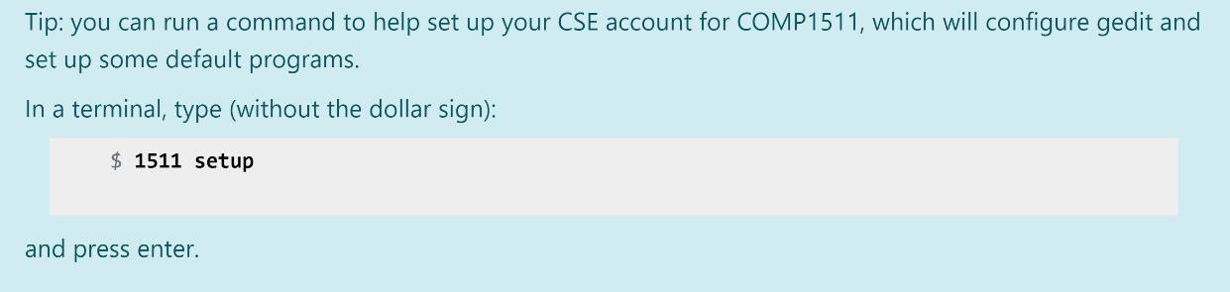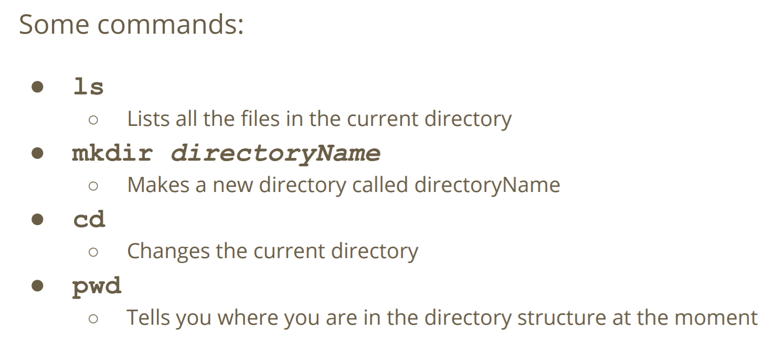

pwd - **p**rint **w**orking **d**irectory

ls - prints a list of the files in the present directory

cd - **c**hange your **d**irectory

mkdir *directoryName* - **m**a**k**es a new **dir**ectory

**Editing and Compilation**

**gedit** *helloWorld.c* **&** - open/create file

**dcc** *helloWorld.c* **-o** *helloWorld* – compile file. The **-o** part tells our compiler to write out a file called “helloWorld” that we can run by typing:

**./**helloWorld – The **./** lets us run the program “helloWorld” in our current directory.

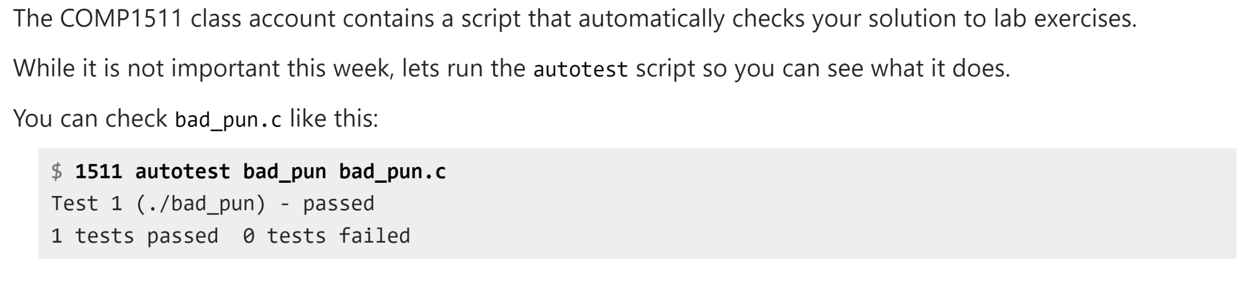



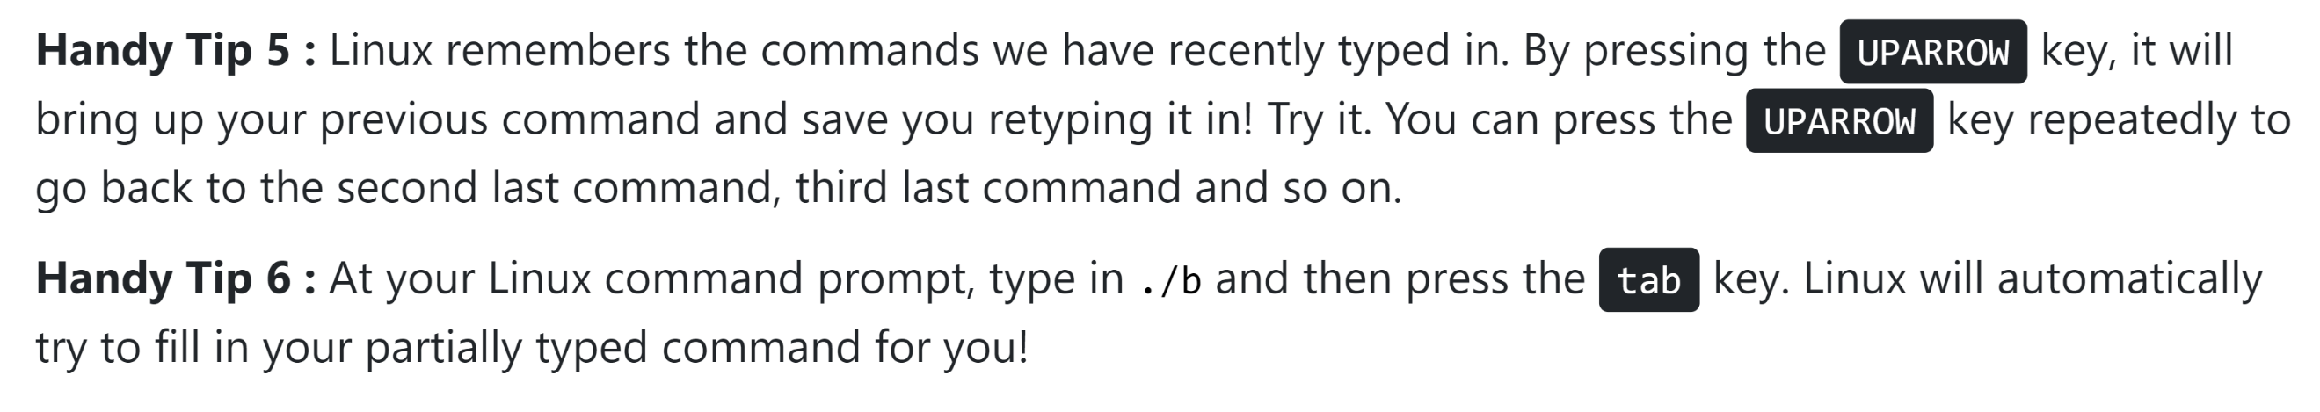

**19/02/20 – Week 1 Lecture 2**

* 1 Byte = 8 Bits

**Variables**

* ***int*** – integer
  + Use 32 bits, giving exactly 2^32 different values.
  + Ranges from *-2147483648 (-2^31)* to *2147483647 (2^31 - 1).* Accessing its limits results in overflow and underflow.
  + whole numbers. In Comp Sci we call it **decimal**
* ***double*** – floating point number
  + Stores "double" the size of integers, 64 bits.
* Variable grabs bits to store it allocated memory
* Always use lower case letters to start our variable names -> Always use names rather than single letter variable
* Reserve words: i.e. “return”, “int”, etc. can’t be used as variable names
* Split words with underscore: “long_answer” or capitals: “shortAnswer”

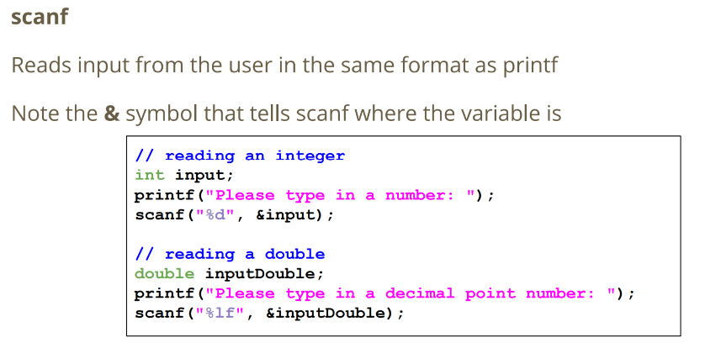**Printing and Scanning Statements (prinf/scanf)**

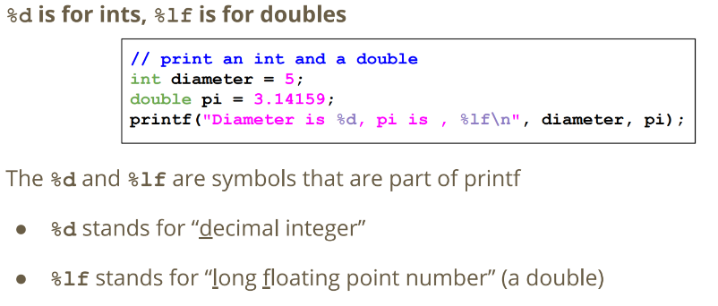

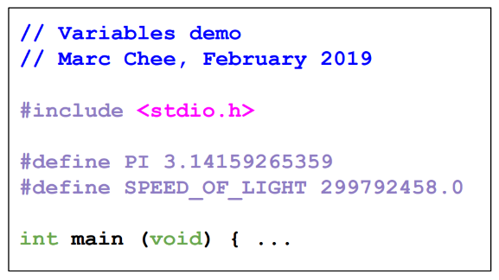

**Constants**

* Constants are like variables, only they never change.
* Sometimes we will use fixed numbers using a special command, **#define**.
* We name them in all caps so that we remember that they’re not variables
* Constant names must be in all **CAPS**

**Division Operation**

* If both numbers are **doubles**, the result will be a double
* If both numbers are **ints**, the result will be an int -> round down i.e. 5/3 will result in 1
* **%** is called **Modulus**. It will give us the **remainder** from a division between integers. i.e. 5 % 3 will result in 2 (3 goes into 5 once, with 2 left over)

**If Statements**

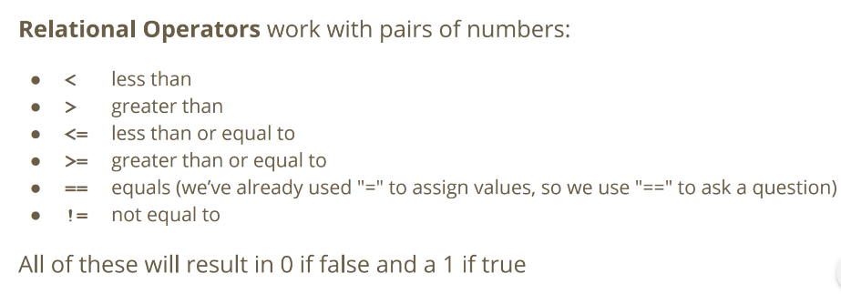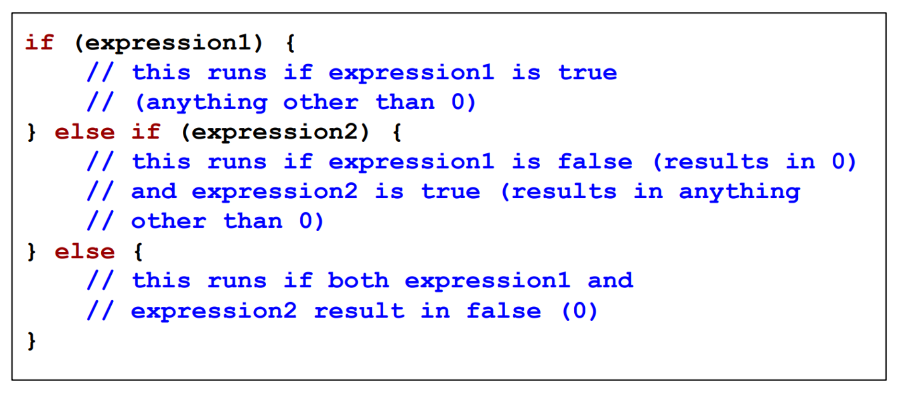

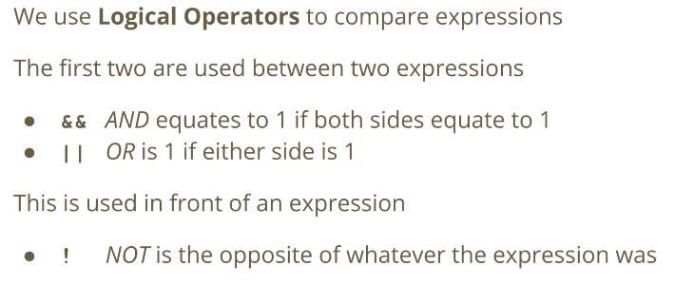

**25/02/20 – Week 2 Lecture 3**

**Correcting the input without exiting**

* ***Clamping*** - anything outside the range gets “pushed” back into the range

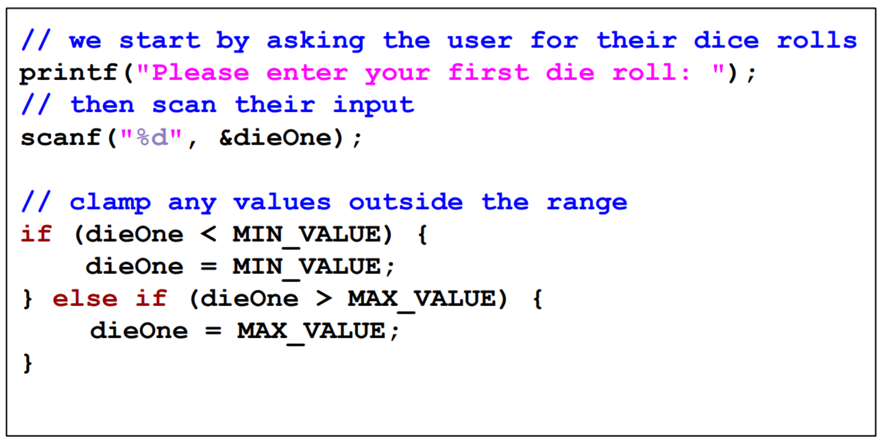

* ***Modulus*** - a possibly elegant solution -> within the range rather than the same value

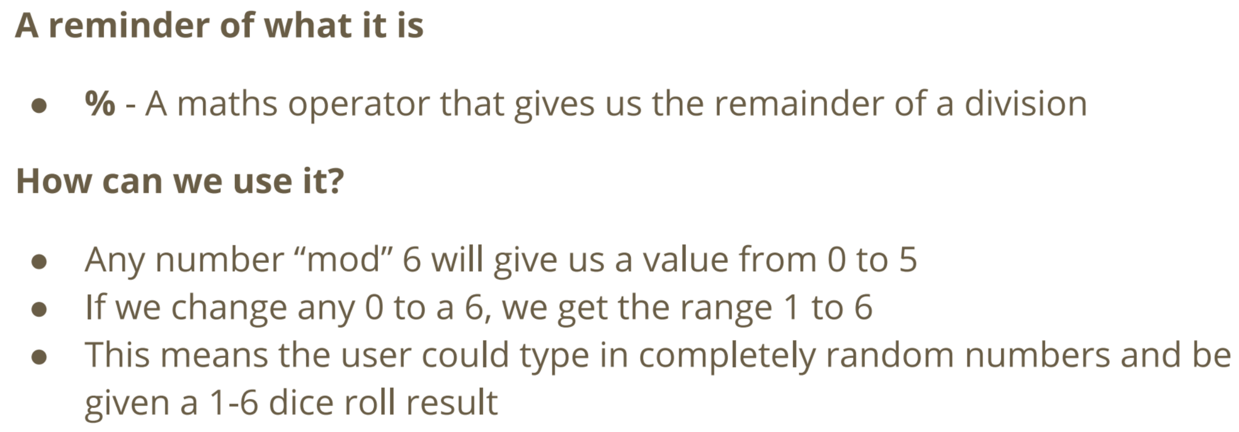

**25/02/20 – Week 2 Tutorial Questions**

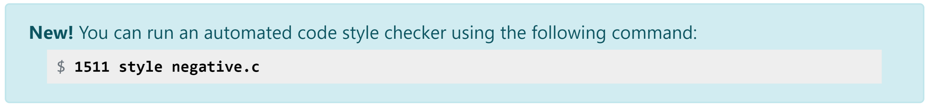

**What is the difference between a variable and a constant?**

**Variable** – can change, value with a specific type that we've saved in memory. Declared variables get given a certain amount of memory to use to store a value. This allows them to be accessed again and changed.

**Constant** – can’t be changed. **#define** actually tells the compiler to replace all instances of the first symbol with the second. This means that it basically acts as a text replacement for the value and it doesn't get a specific piece of memory like a variable.

* Integers that is divided by integers will result in an integer. e.g. 1/2 * 500 = 0 rather than 1/2.0 * 500 = 250.0.
* && operator has a higher priority than ||.

**Definitions**

* Bit: a binary value (0 or 1). The word bit is derived from binary digit.
* Byte: In modern computing a byte is simply 8 bits. 2^8 = 256 possible bit patterns as distinct values can be represented with a single byte
* File: an array (sequence) of bytes stored in a semi-permanent way.
* Directory: a set of files or directories.

**25/02/20 – Week 2 Lecture 4**

**While Loops**

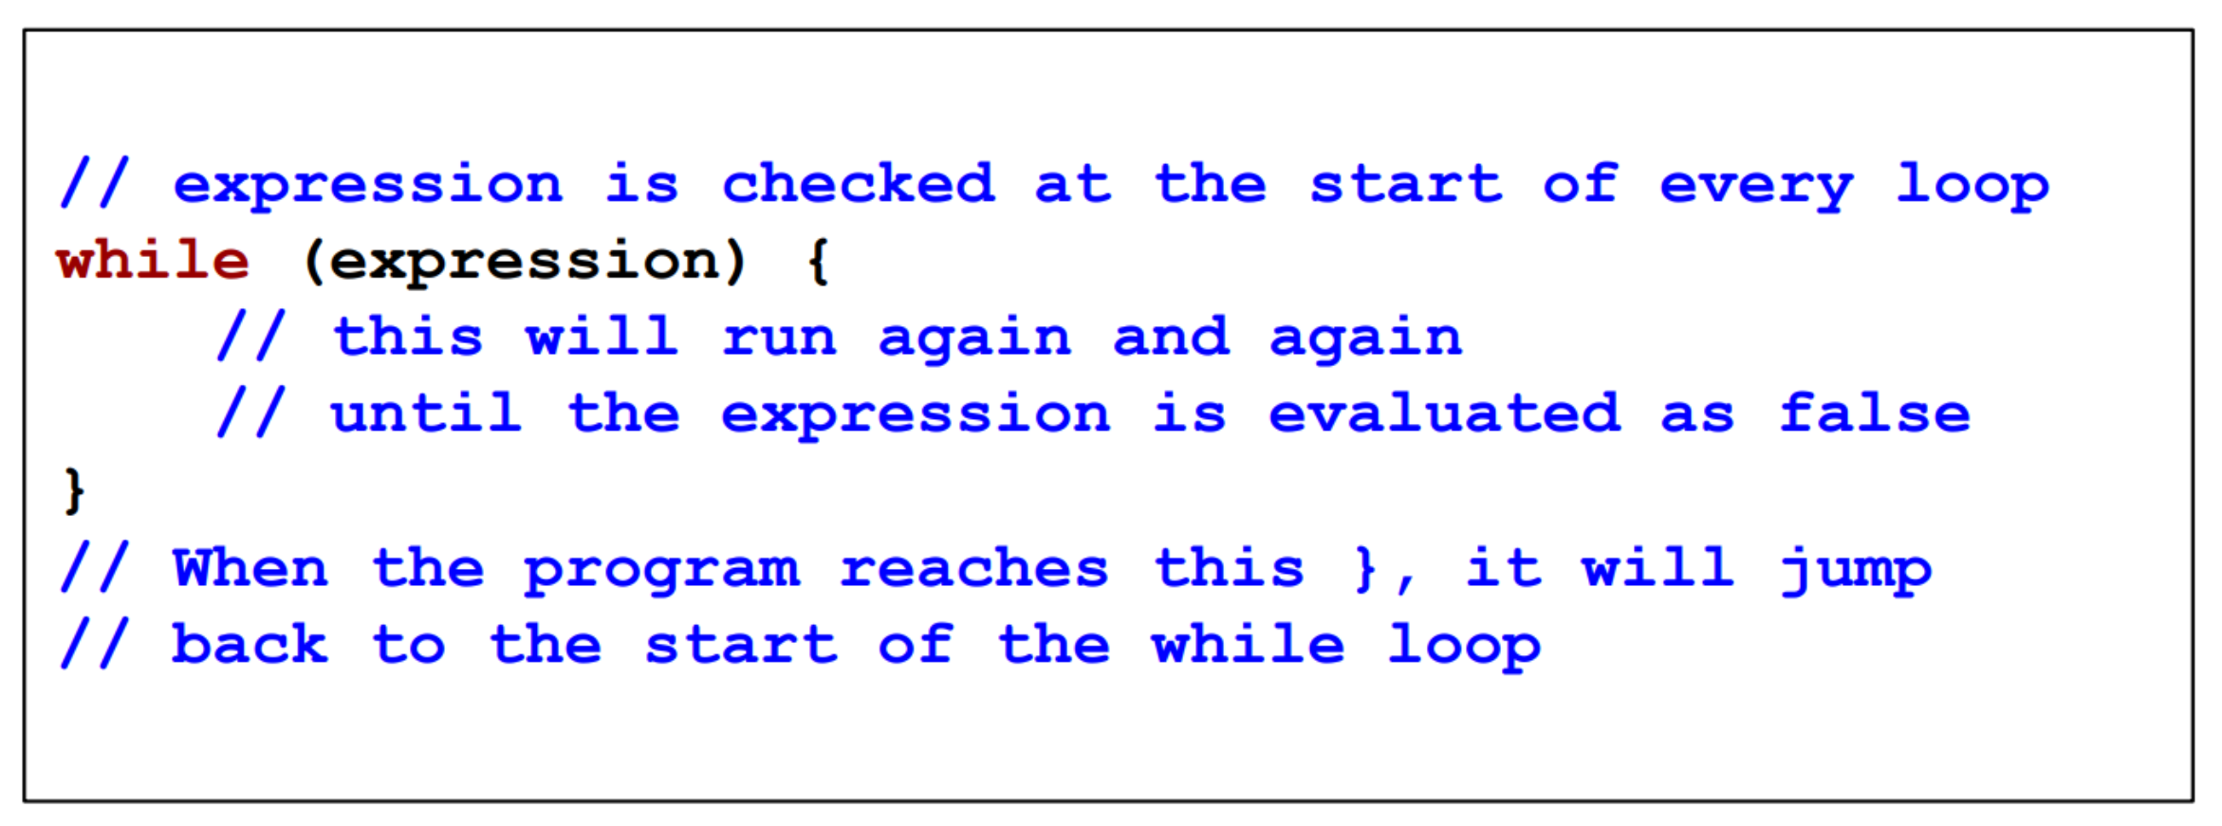

**While Loop with a Loop Counter/Sentinel Value**

* "loop counter" is a variable to control how many times a while loop runs
* It’s an int that’s declared outside the loop
* It’s “termination condition” can be checked in the while expression
* Sentinel Value: a flag used to terminate the loop, variable to decide to exit a loop at any time

**Sentinel Value**

**Loop Counter**

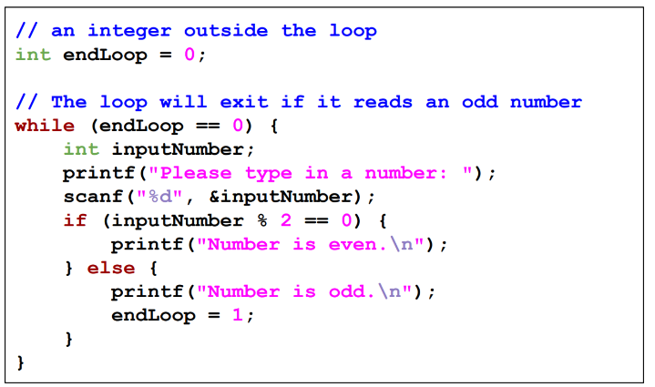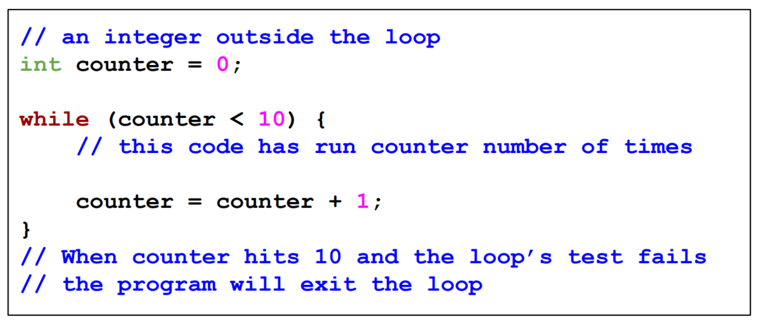

**Curly Brackets**

* What goes on inside the curly braces stays inside the curly braces. Curly braces create the "scope" of a program.
* The use of x is ONLY contained inside a set of curly braces {}. This means that x will only exist inside those braces. The variable x will actually disappear each time the y loop finishes. Anything created inside them only lasts as long as they do!

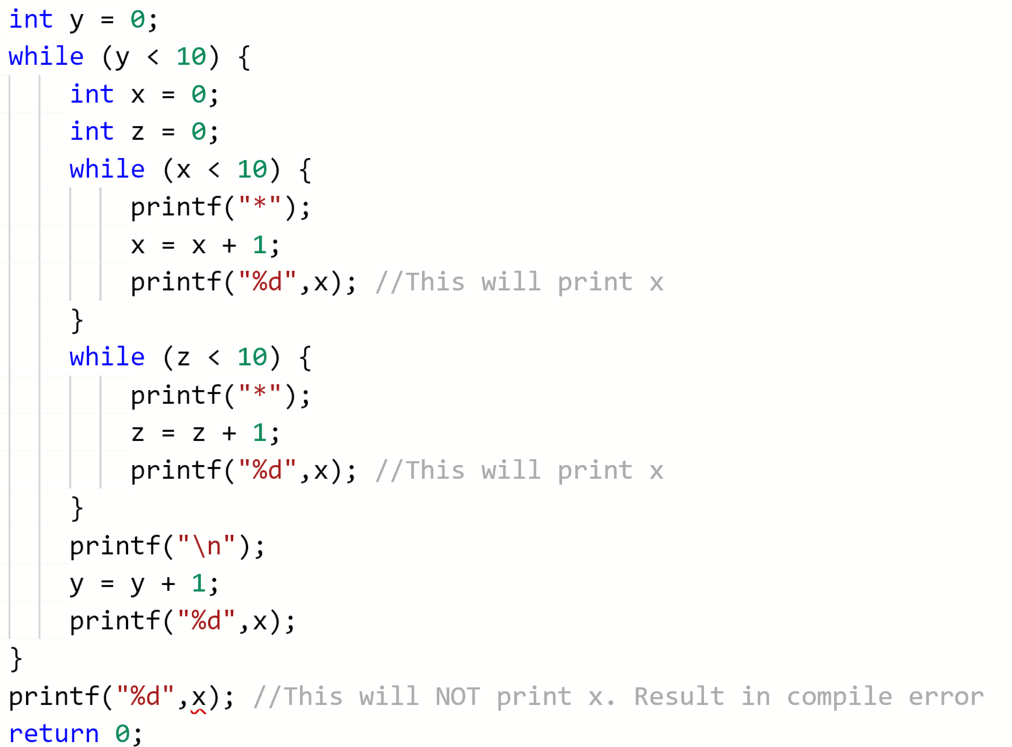

**Incrementing**: i.e. i++

**03/03/20 – Week 3 Lecture 5**

**Good Code Style features:**

* Indentation and Bracketing
* Names of variables and functions
* Repetition (or not) of code
* Clear comments
* Consistency

**Steps for Good Code Style:**

* Write comments before code
* Name your variables before you use them
* { everything inside gets indented 4 spaces
* } line up your closing brackets vertically with the line that opened them
* One expression per line
* Maintain consistency in spacing

**Code Style:**

* Easier to read
* Easier to understand
* Reduces errors later in development
* Makes it easier to test and modify
* Overall, speeds up development

**Specific Issues with Bad Code Style**

* Header comment doesn’t show the program’s intentions
* No blank lines separating different components
* Multiple expressions on the same line
* Inconsistent indenting
* Inconsistent spacing
* Variable names don’t make any sense
* Comments don’t mean anything
* Inconsistent bracketing of if statements
* Bracketing is not indented
* Inconsistent structure of identical code blocks

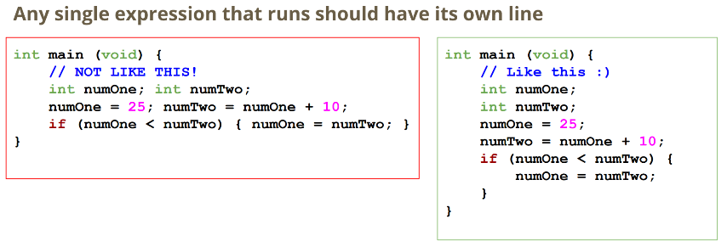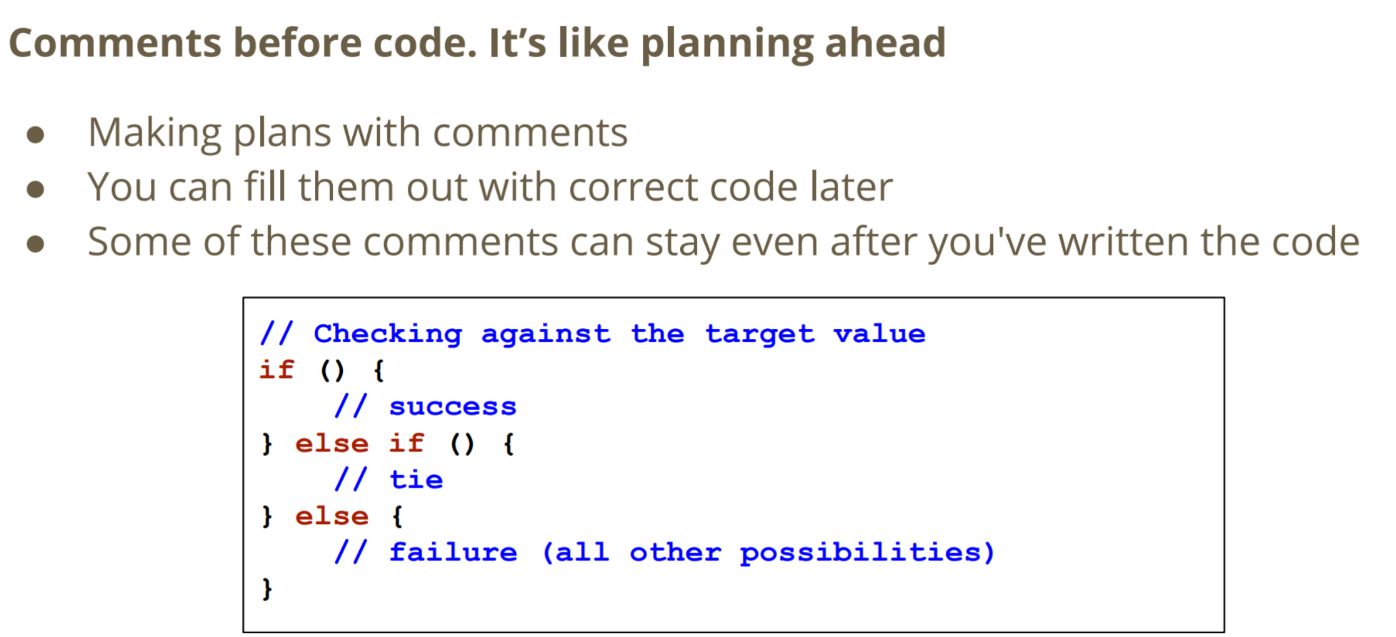

**Why do we review code?**

**Different ways to review code**

***-> Pair Programming***

* Lab partners actively discussing solutions
* Live reviewing and discussion while in development

***-> More formal review***

* Finish a section of code, then ask people to review it
* Sometimes in person, sometimes using software tools

***-> As the code writer***

* Get feedback on how easy it is to understand our code
* Hear about other people’s ideas on solving the same problem

***-> As the code reviewer***

* Get to see how someone else writes code
* Learn more about different ways to solve problems

**Functions**

* *main, printf* and *scanf* are functions
* Function: a separate piece of code identified by a name. It has inputs and an output. If we “call” a function it will run the code in the function

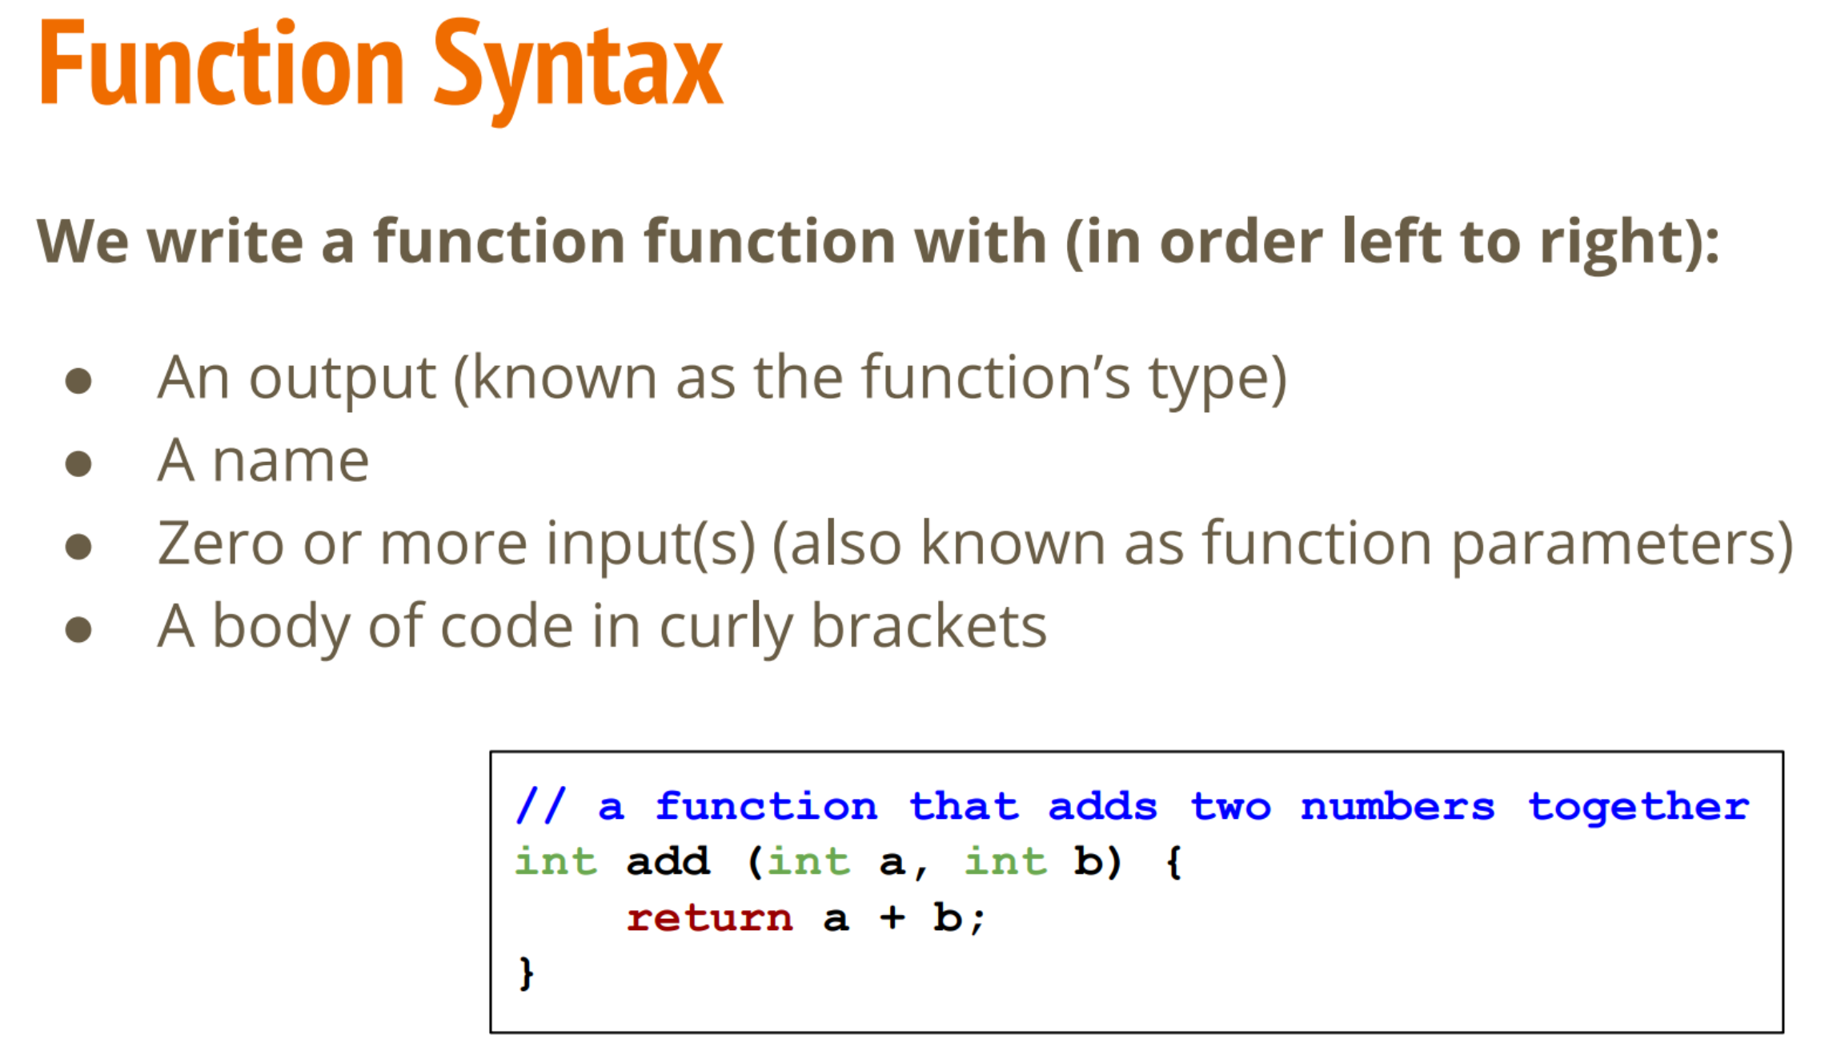

* *return* will deliver the output of a function
* *return* will also stop the function running and return to where it was called from

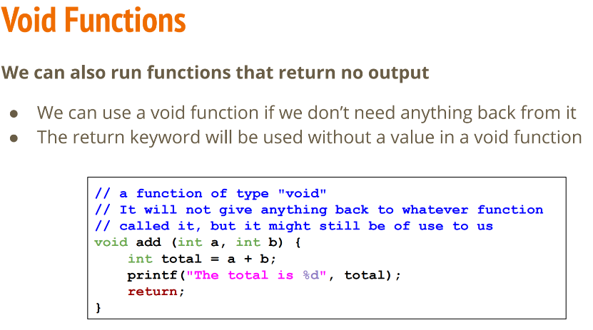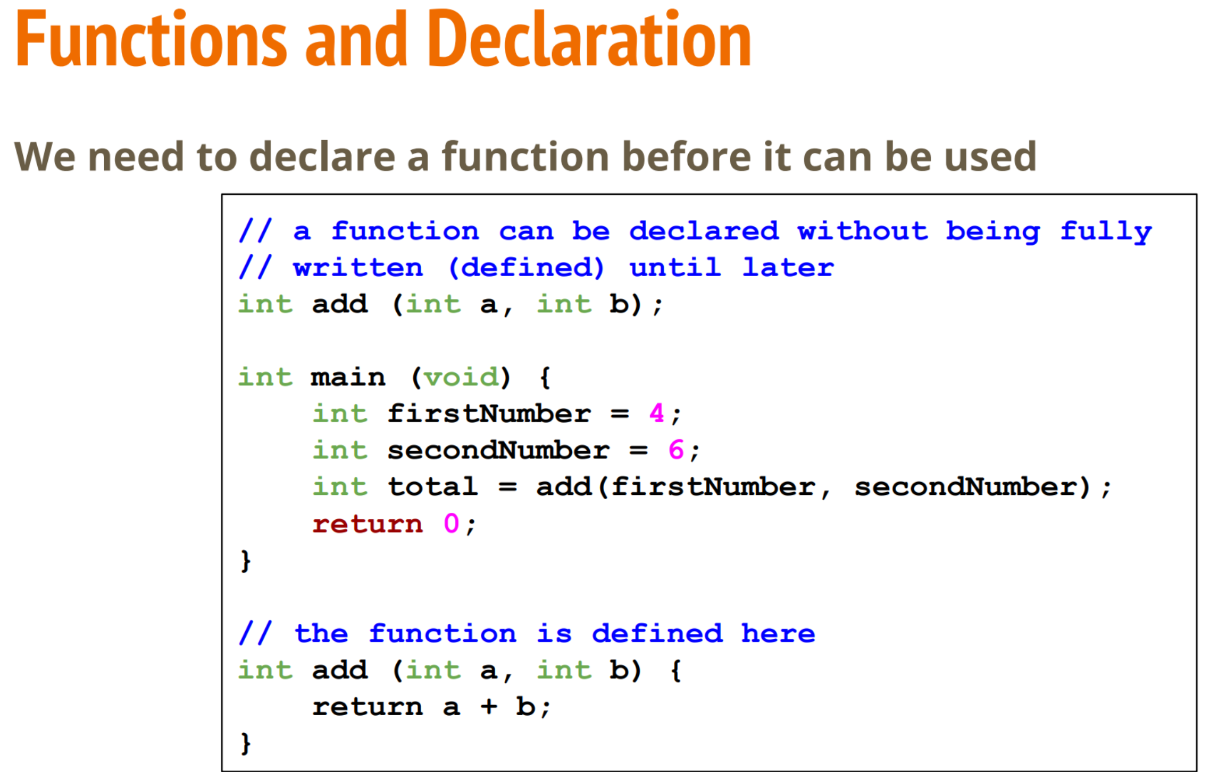

**03/03/20 – Week 3 Tutorial Questions**

**eventCounter** is preferred over **event_counter**

**C is a typed language. What does this mean? Why is this useful?**

In a typed language, program entities (variables, functions, etc.) are declared to be of particular types. This allows additional checks (type-checking) to be performed that ensure the validity of programs. If a type mismatch is detected, then the programmer is warned by the compiler. Typed code is easier to understand and debug since there are guarantees about the kinds of values that are being manipulated. Giving a variable a type also lets the compiler determine the amount of storage space (memory) to set aside for storing values in the variable. Every variable has a predetermined type i.e. x must be an int -> cannot be changed into a float.

**04/03/20 – Week 3 Lecture 6**

**Computer Fundamentals**

***Processing (Central Processing Units (CPUs))***

* Maintains a “state”, works based on a current set of instructions, can read and write from/to memory
* In C, processing maintains a state where are we up to in the code right now, use instructions for compilation, read/write variables.

***Memory***

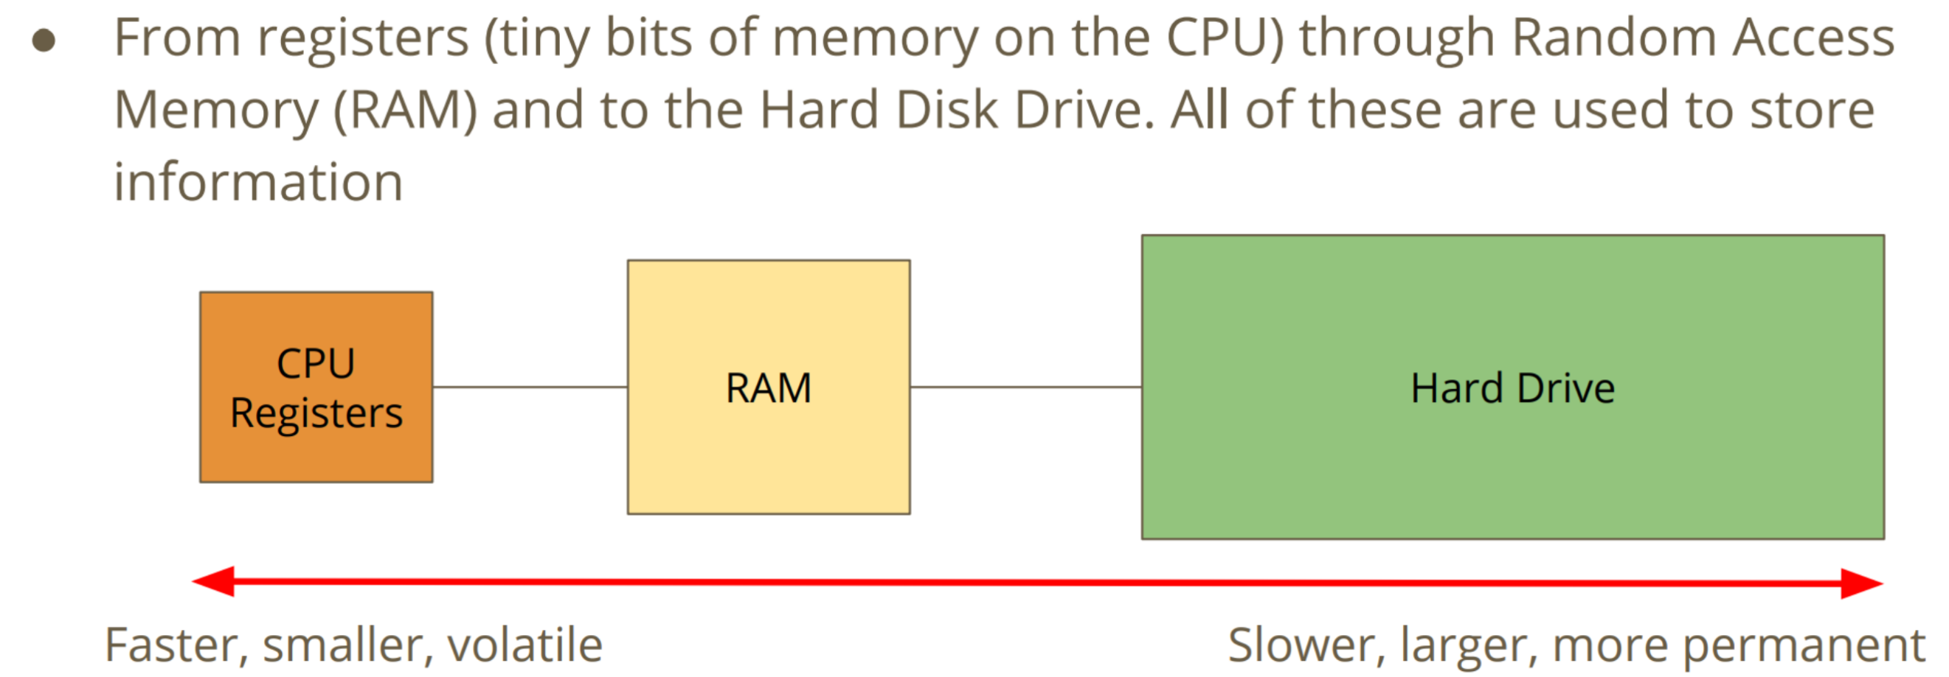

***How does C use memory?***

* **Hard Drive**: Our C source code files are stored on our Hard Drive. Dcc compiles our source into another file, the executable program.
* **RAM**: When we run our program, all the instructions are copied into RAM. Our CPU will work through memory executing our instructions in order. Our variables are stored in RAM. Reading and writing to variables will change the numbers in RAM
* Every time the program begins, the operating system will give the program a certain amount of memory.

**Arrays**

* A variable is a small amount of memory
* An array is a larger amount of memory that contains multiple variables
* All of the elements (individual variables) in an array are the same type
* Individual elements don’t get names, they are accessed by an integer index

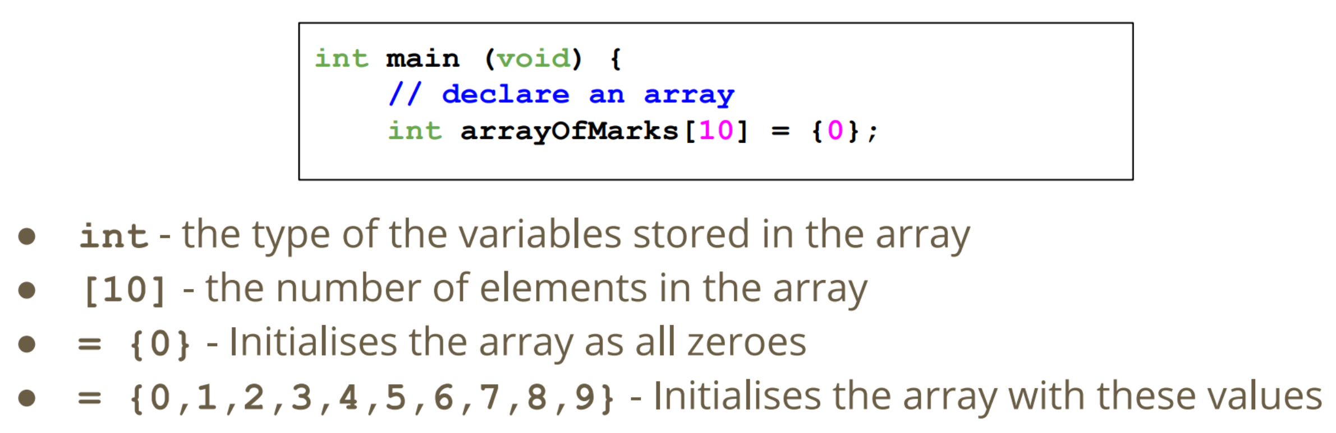

**Array Elements**

* An element is a single variable inside the array
* They are accessed by their index, an int that is like their address
* Indexes start from 0
* Trying to access an index outside of the array will cause errors

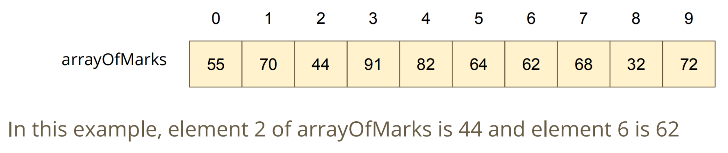

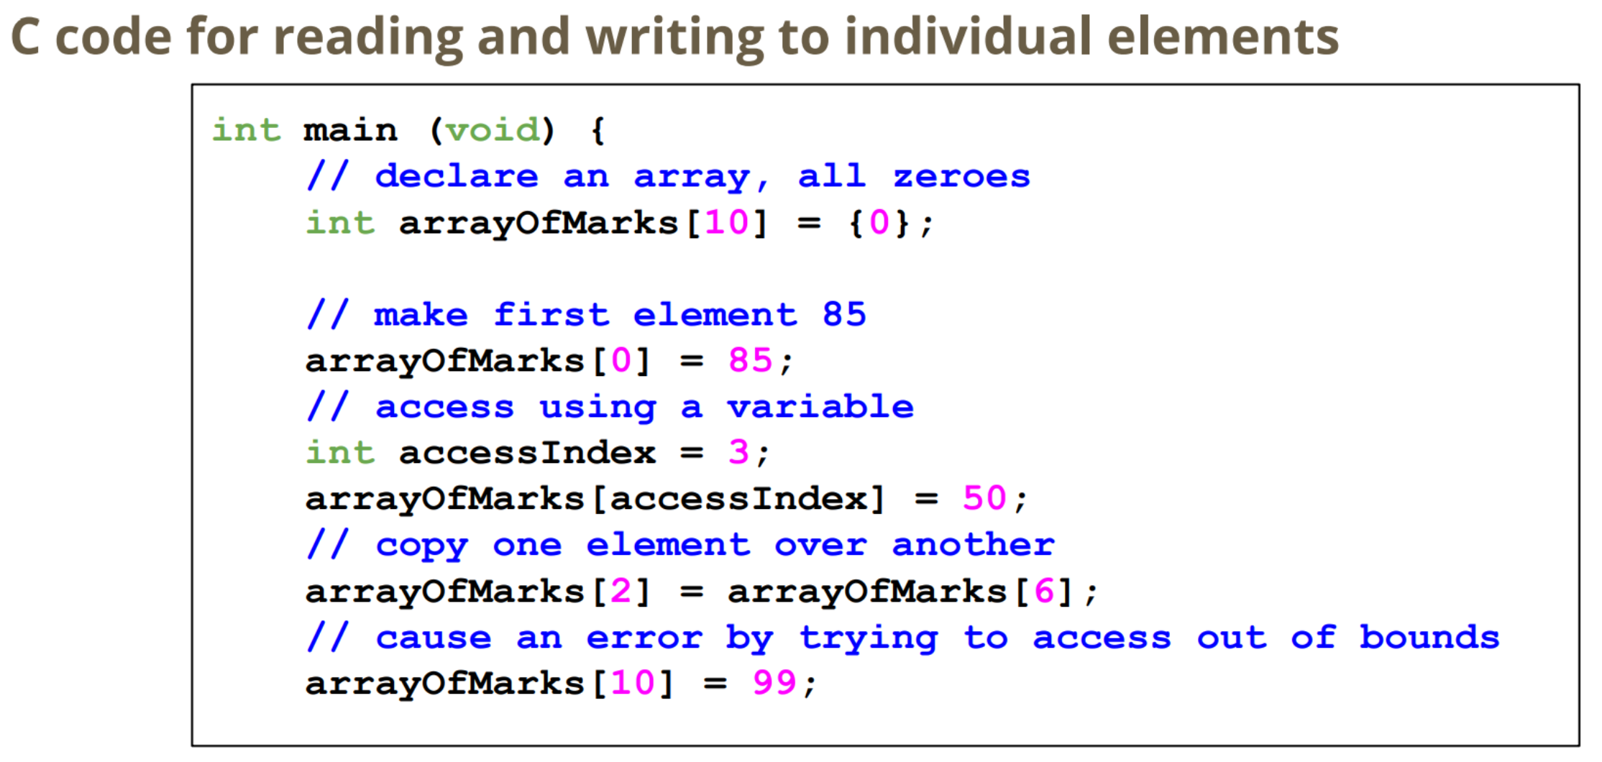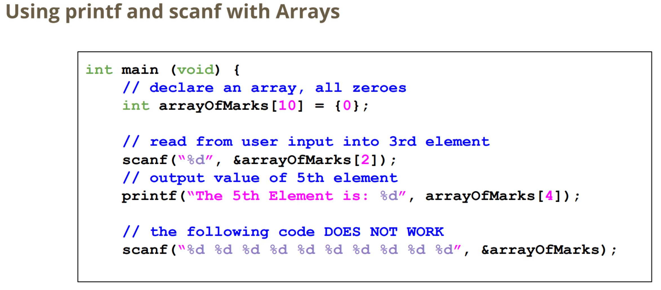

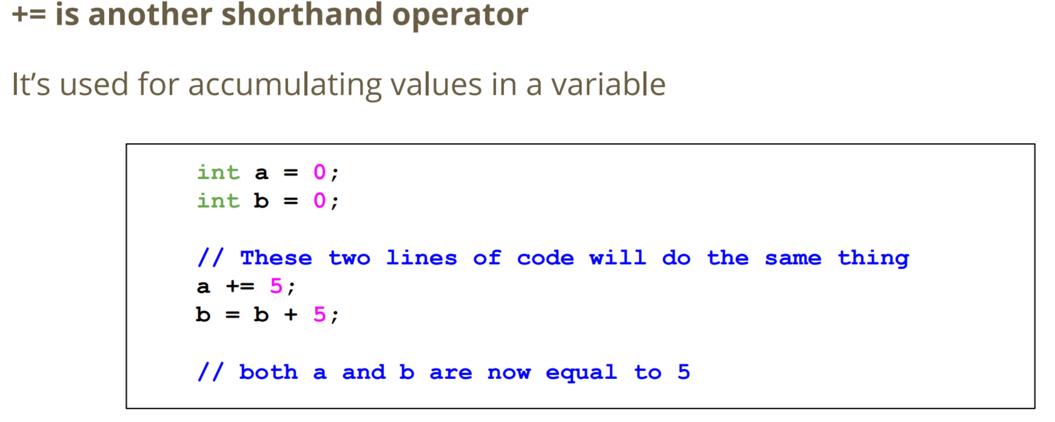

**11/03/20 – Week 4 Lecture 8**

**Pointers**

* Pointers are variables that hold memory addresses. They are created to point at the location of variables.
* In C, the pointer is like an integer that stores a memory address. Pointers are usually created with the intention of "aiming at" a variable (storing a particular variable's address).

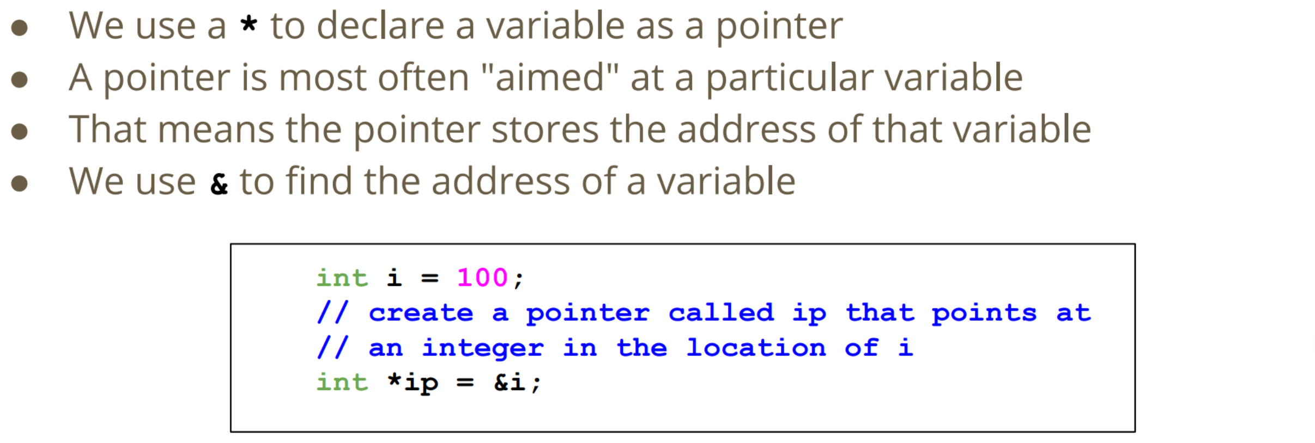

**Pointer Types**

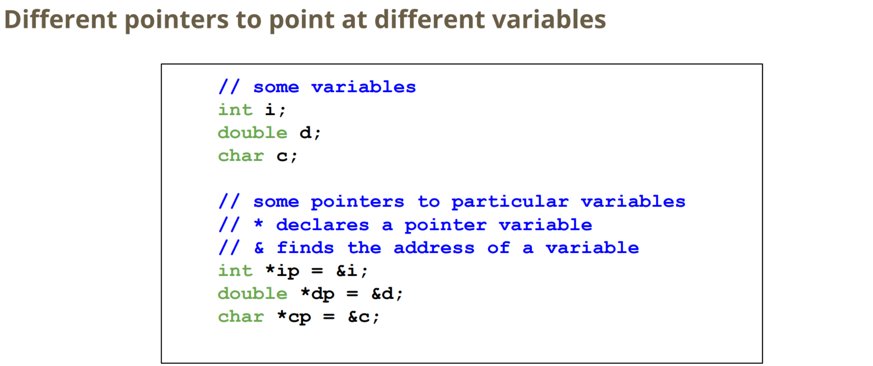

**Initialising Pointers**

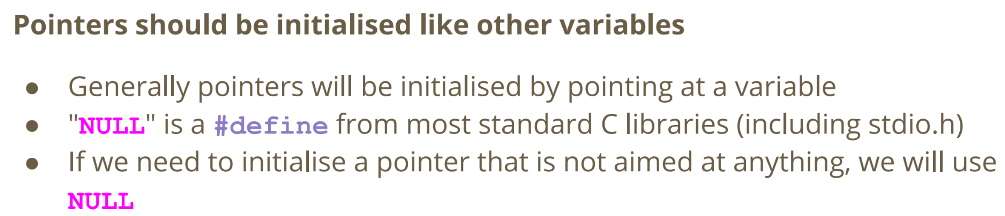

**Using Pointers**

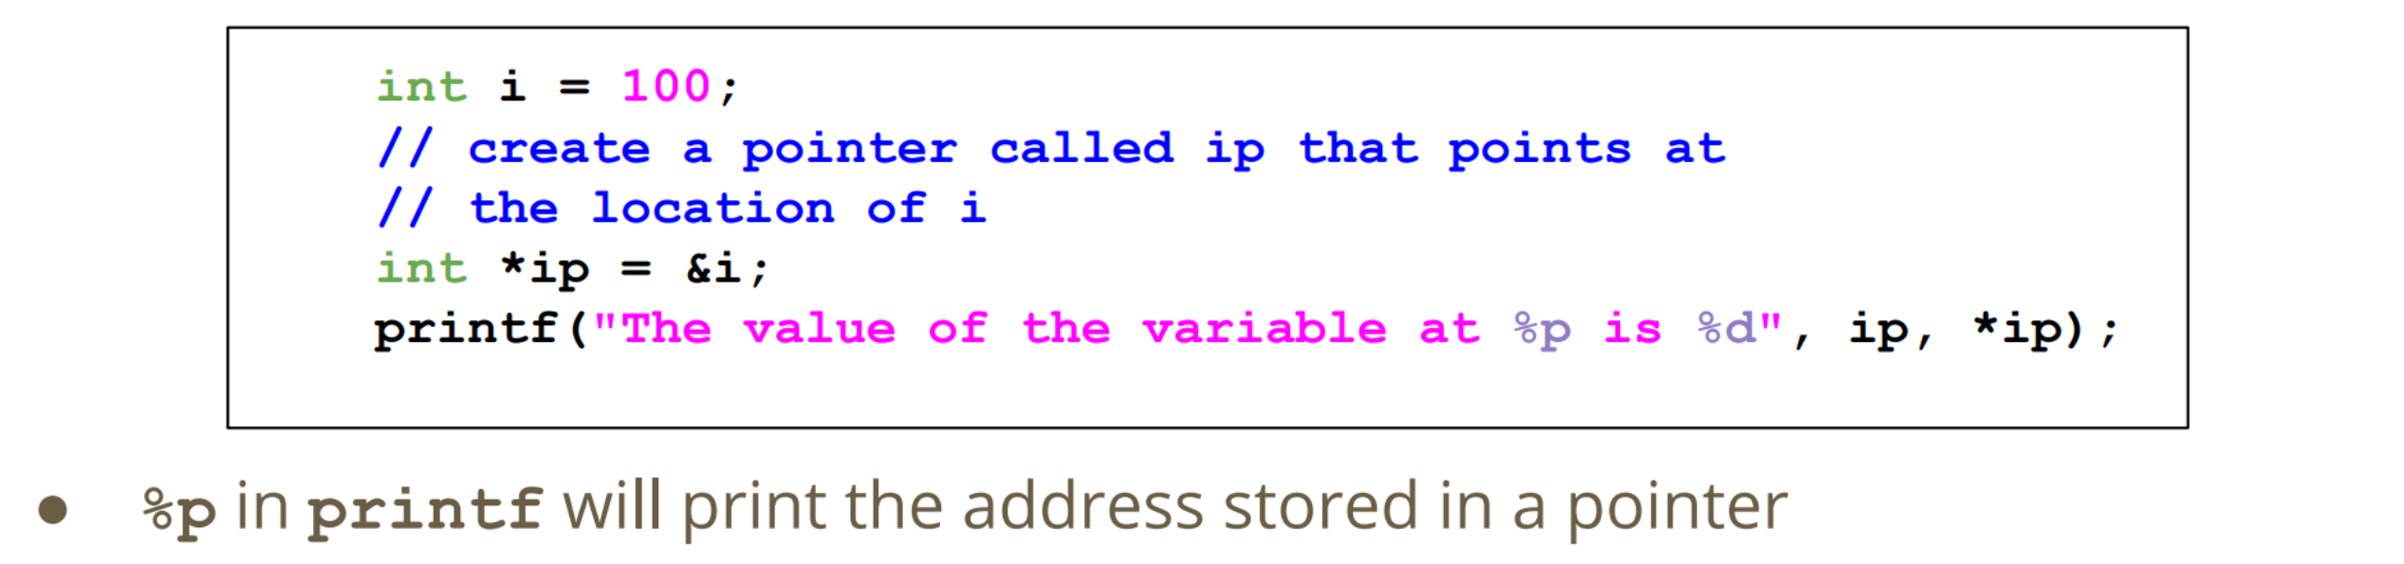

**10/03/20 – Week 4 Tutorial Questions**

* Scanf is a function that can have a result. This result will be the number of values it has read and assigned to variables.
* For example: int result = scanf("%d", &variable);
* The variable result will have the value 1 if one integer was read from the user. We call input from the user "standard input".

while (scanf("%d", &inputVar) == 1) {

// successfully read an integer into inputVar

printf("Read %d", inputVar);

}

* Array: collection of elements with the same data type. Each element is accessed providing the name of the array and an index. The index range is from 0 through to N-1, where N is the number of elements in the array.

**17/03/20 – Week 5 Lecture 9**

**Pointers**

* variable that stores the address of another variable of a specific type
* allow us to pass around the address of a variable instead of the variable itself

**Pointers in Functions**

* Pointers give a function access to a variable that's in memory
* allow us to **affect multiple variables** instead of only having one output

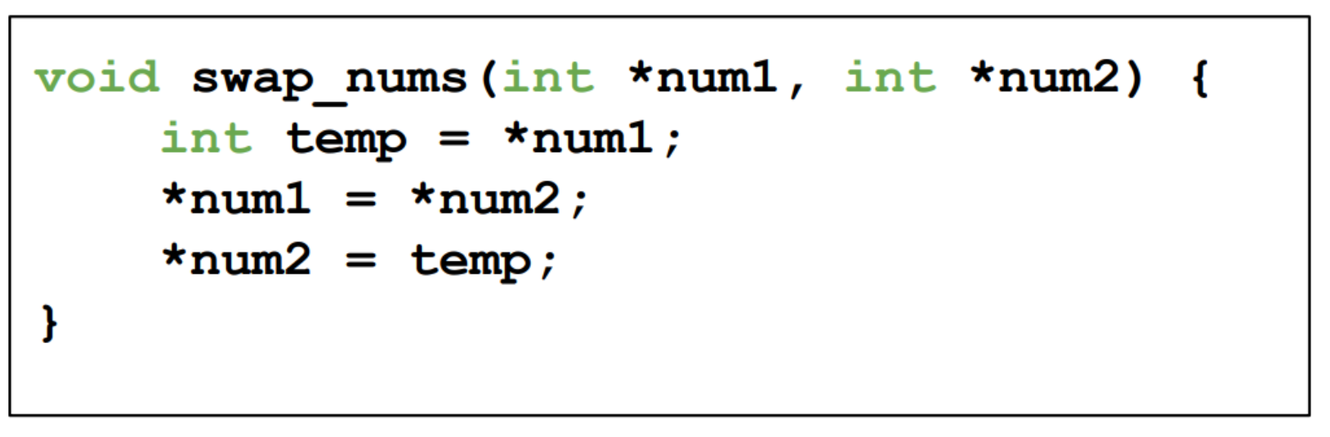

**Debugging and Testing**

* ***Syntax***: precise use of a language within its rules. Slight mistakes in the characters we use can result in different behaviour.
  + *Compilers can catch syntactical bugs*
* ***Logic***: errors can be syntactically correct, but the program might not do what we intended.
  + *Code Reviews*
* Try different input ranges, including 0 and negative numbers
* Try outputting x and y values to make sure they’re working
* Try outputting loop information so that we can see our structure

**Characters (char)**

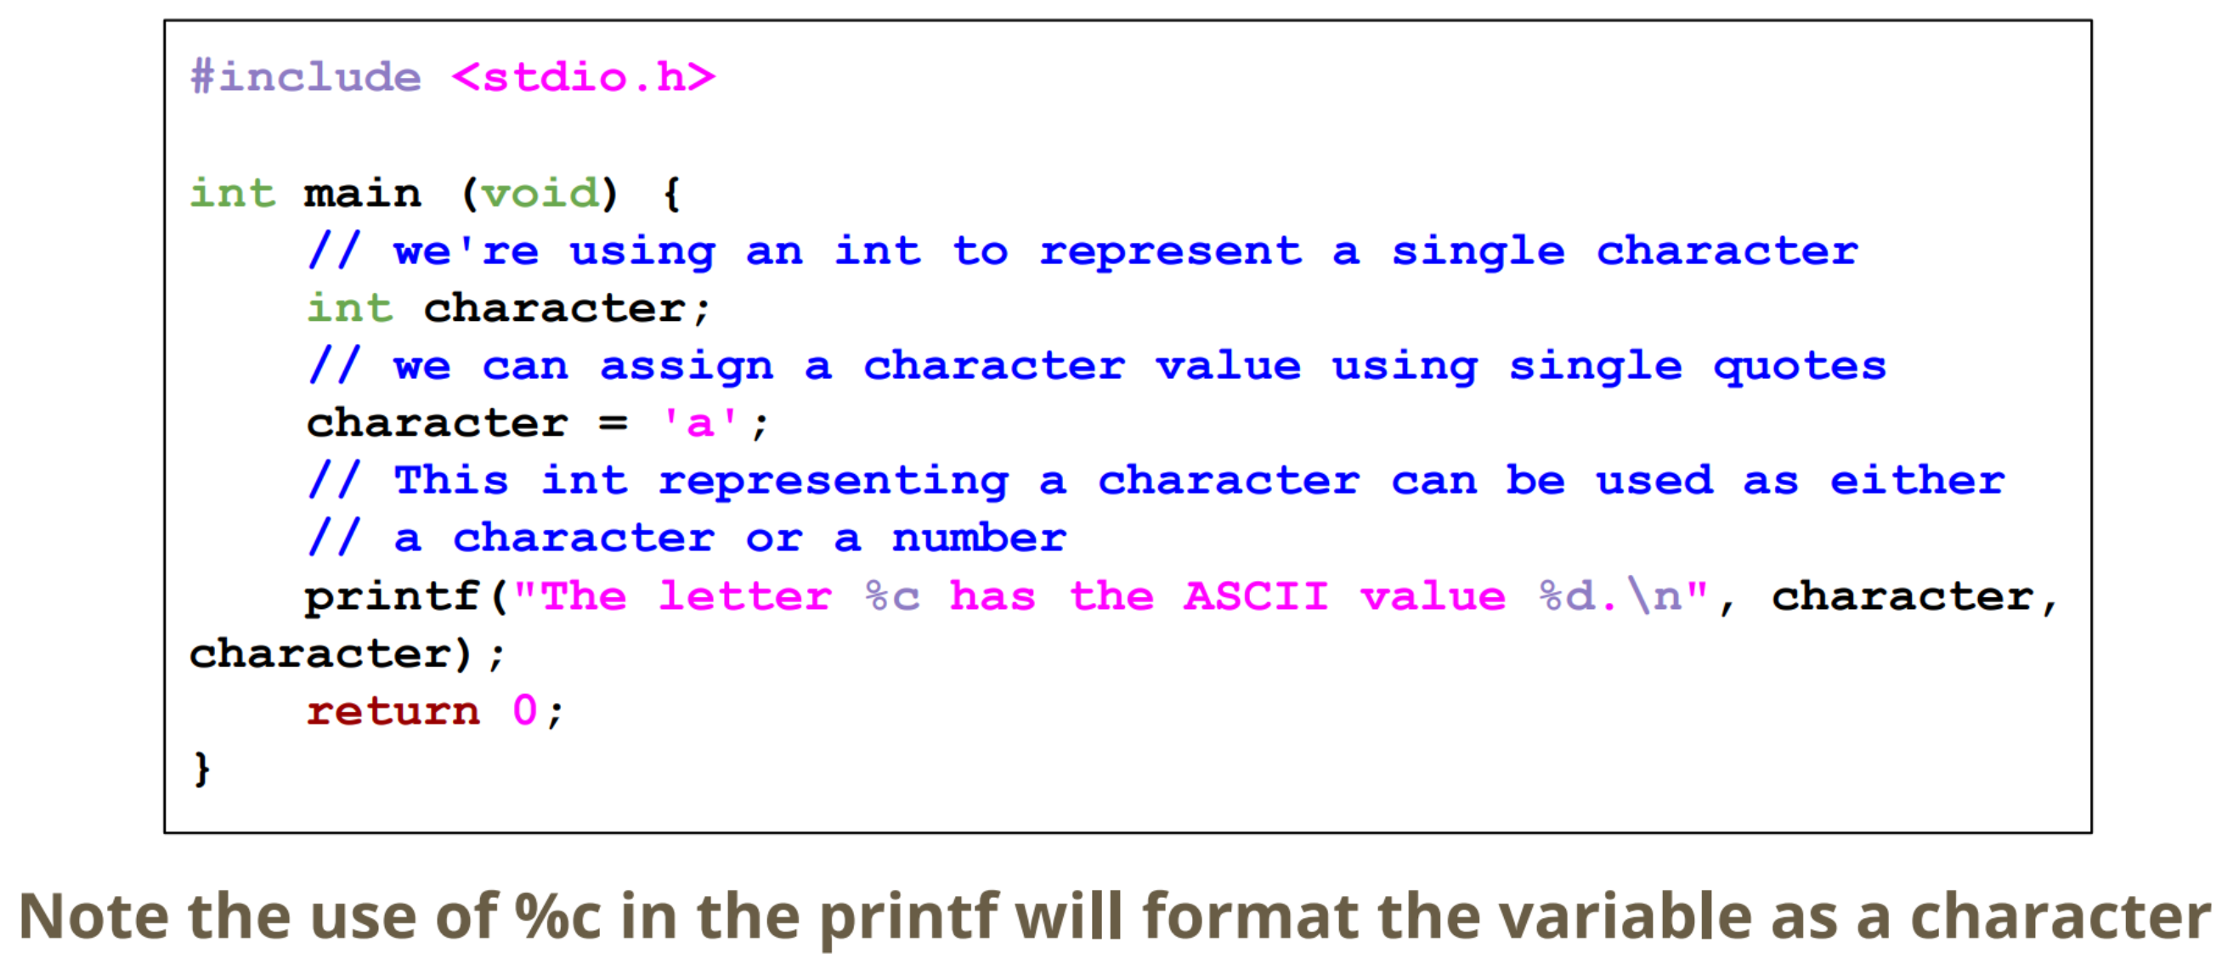

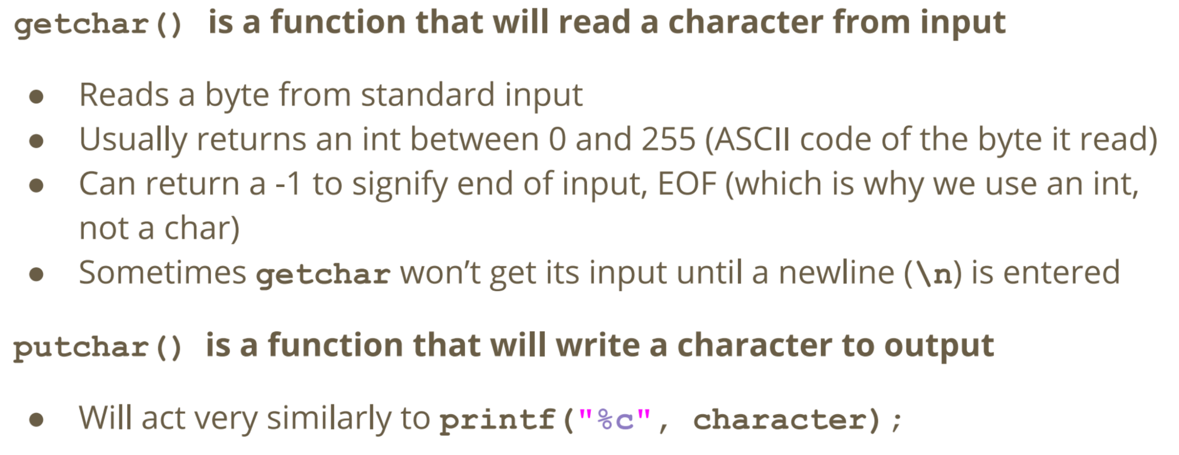

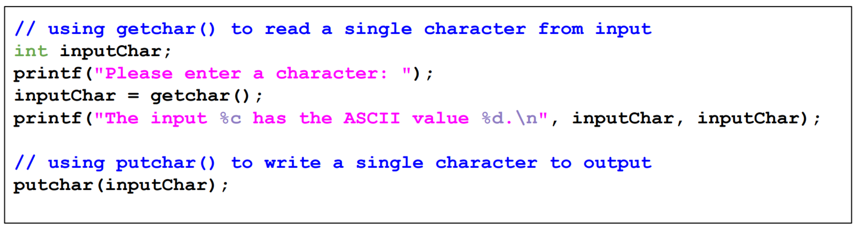

**Character Functions**

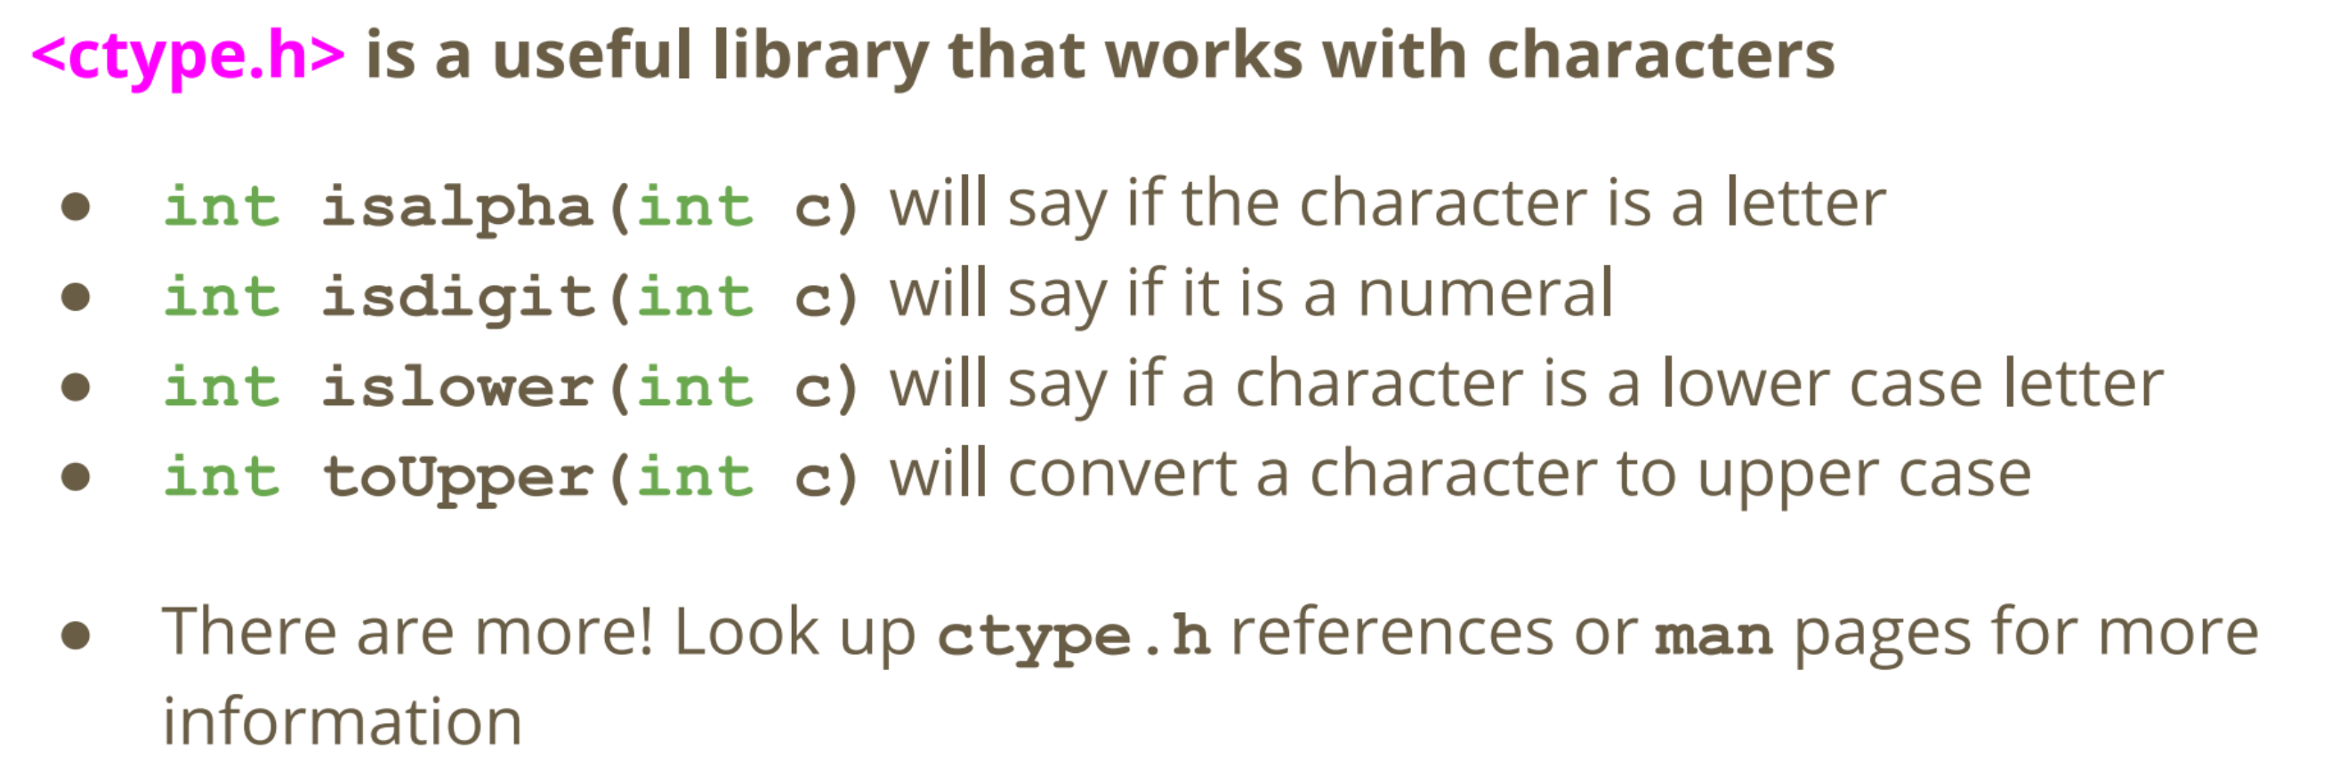

**18/03/20 – Week 5 Lecture 10**

**Strings**

* arrays of char variables containing ASCII code
* Strings have a helping element at the end, a '**\0**'. It’s often called the **'null terminator'** and it is an invisible character. This helps us know if we’re at the end of the string.

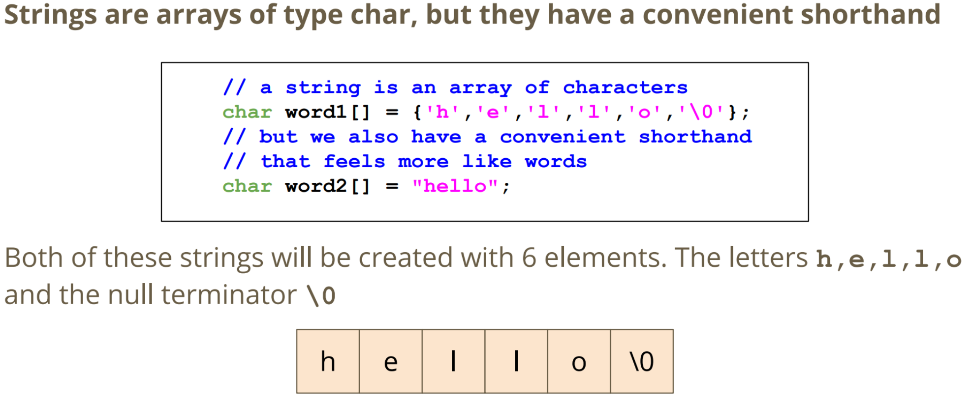

**Reading and Writing Strings**

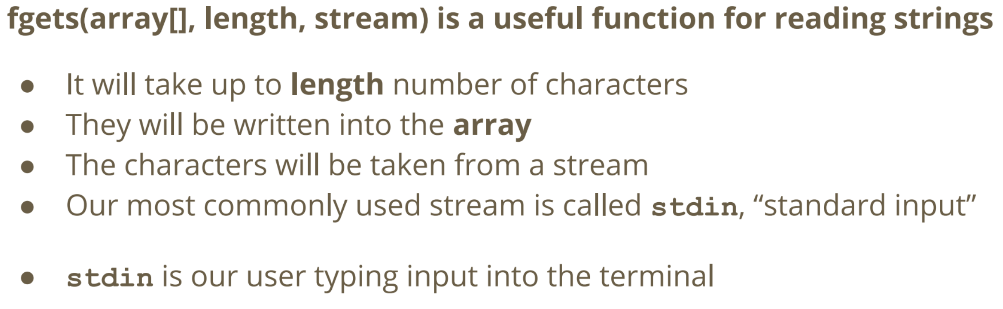

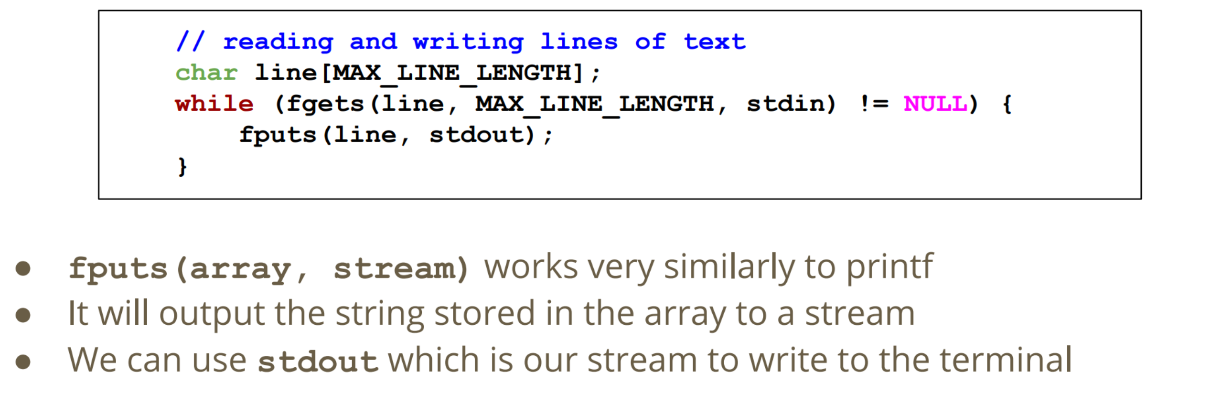

**String Functions**



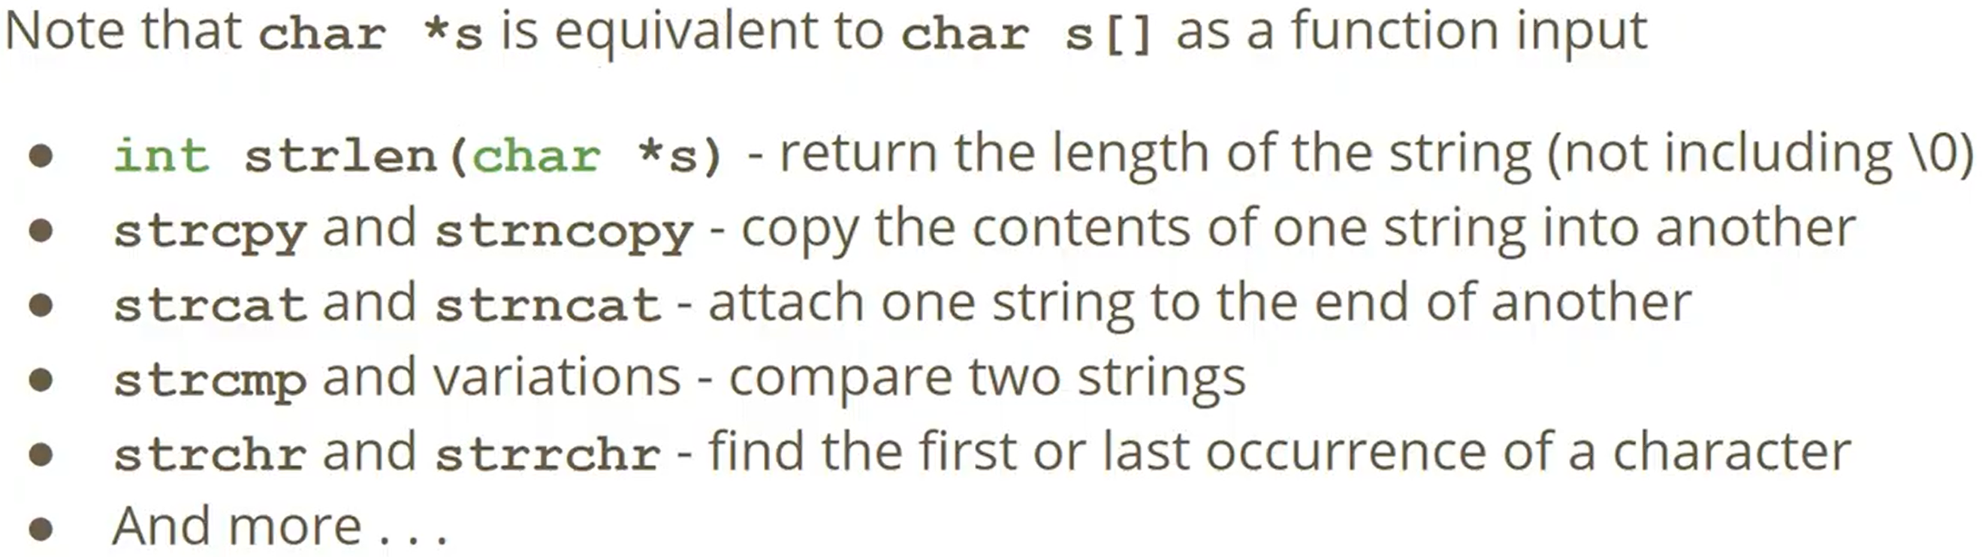

**Structs (Structures)**

* way to create custom variables; structs are variables that are made up of other variables.
* They are not limited to a single type like arrays and can also be able to name their variables
* Must have **;** at the end of the declaration.

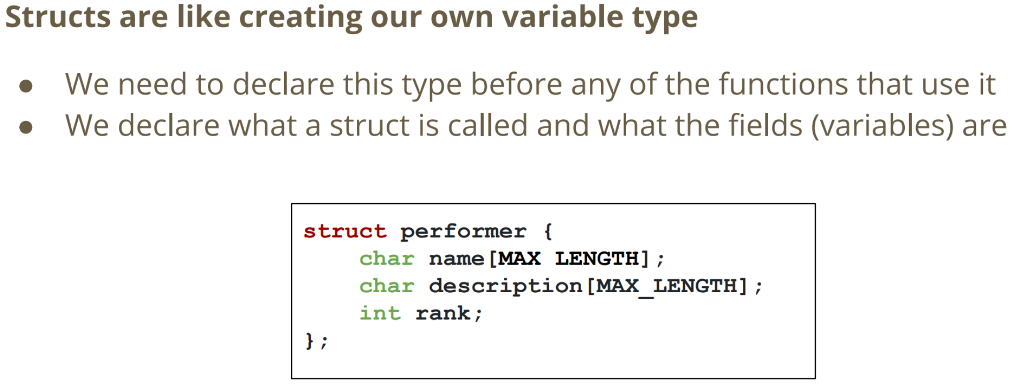

**Creating a Struct Variable and Accessing its Fields**

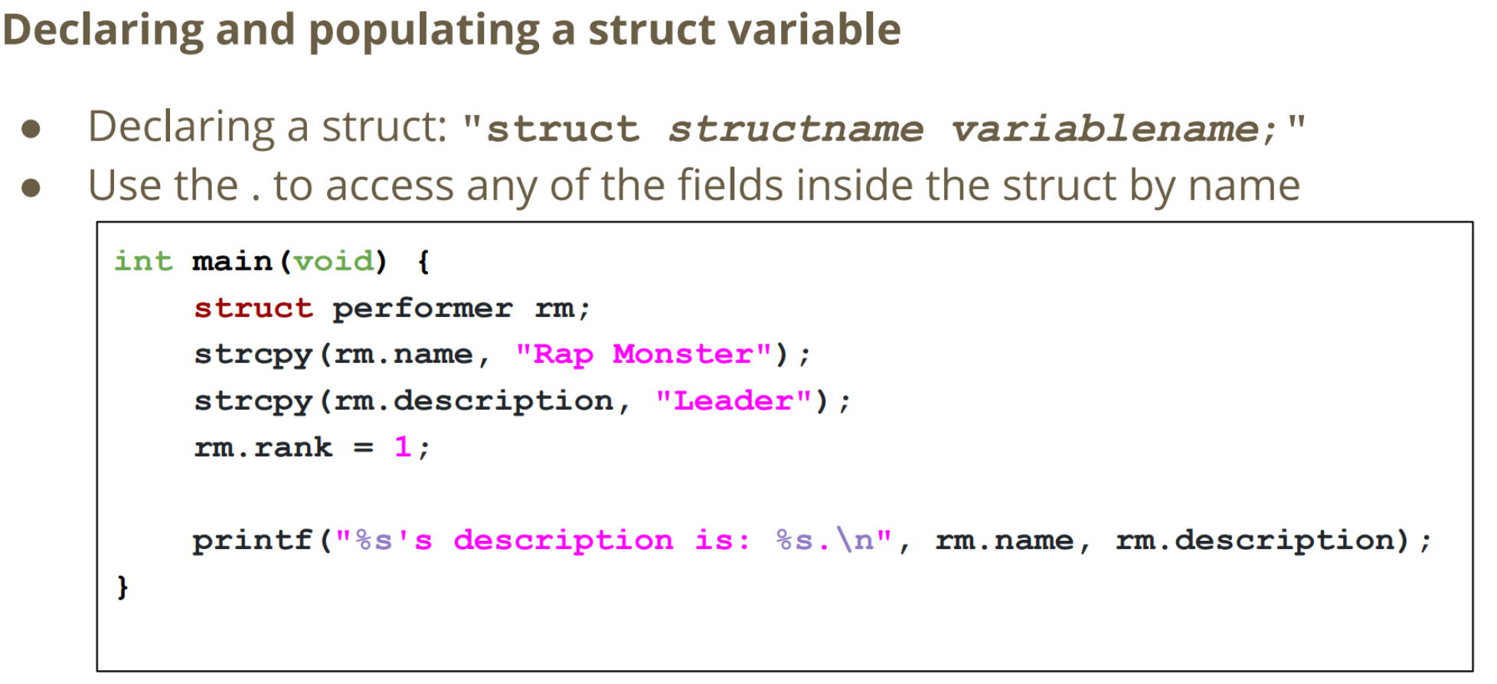

**Accessing Structs using Pointers**

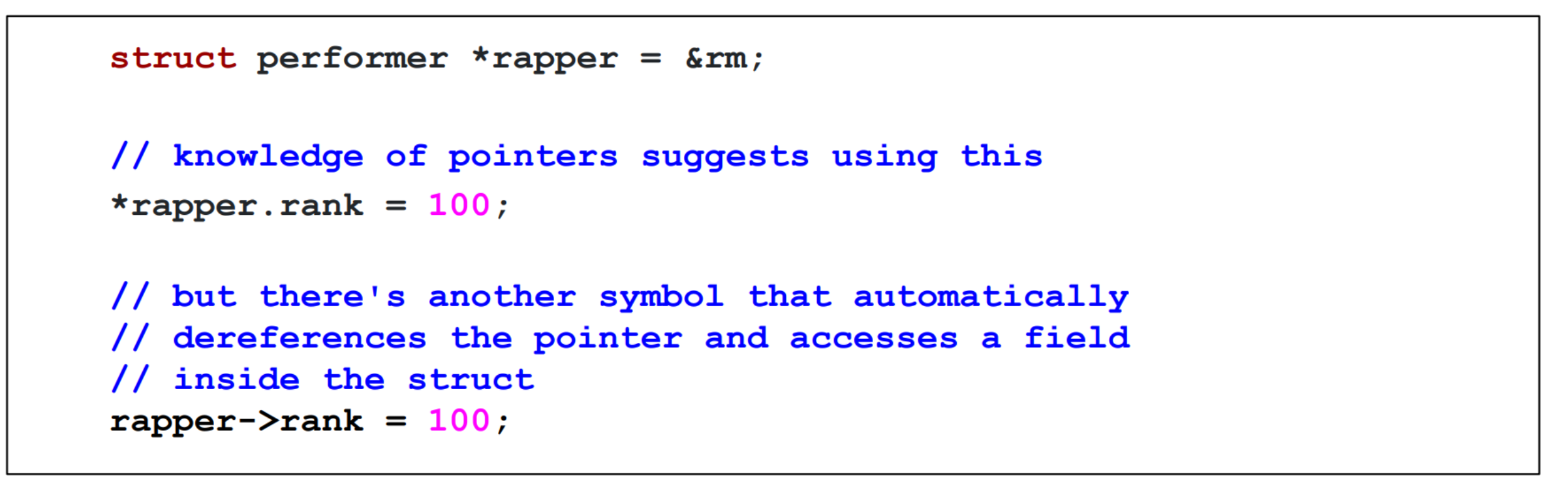

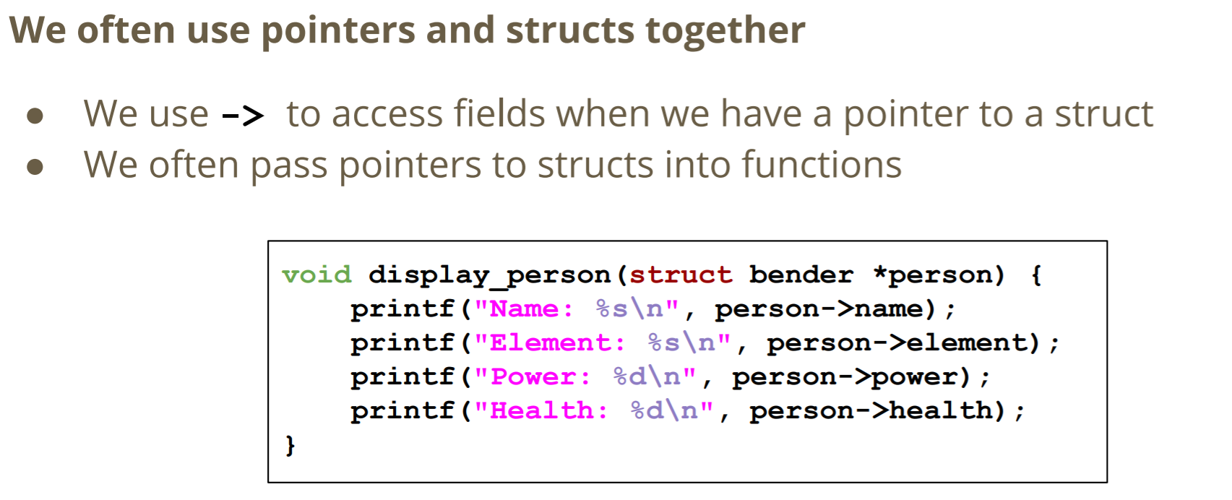

**31/03/20 – Week 7 Lecture 11**

**Memory for Functions, Pointers and Arrays**

***Functions and Pointers***

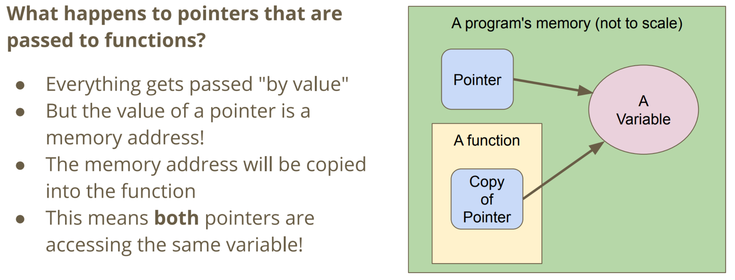

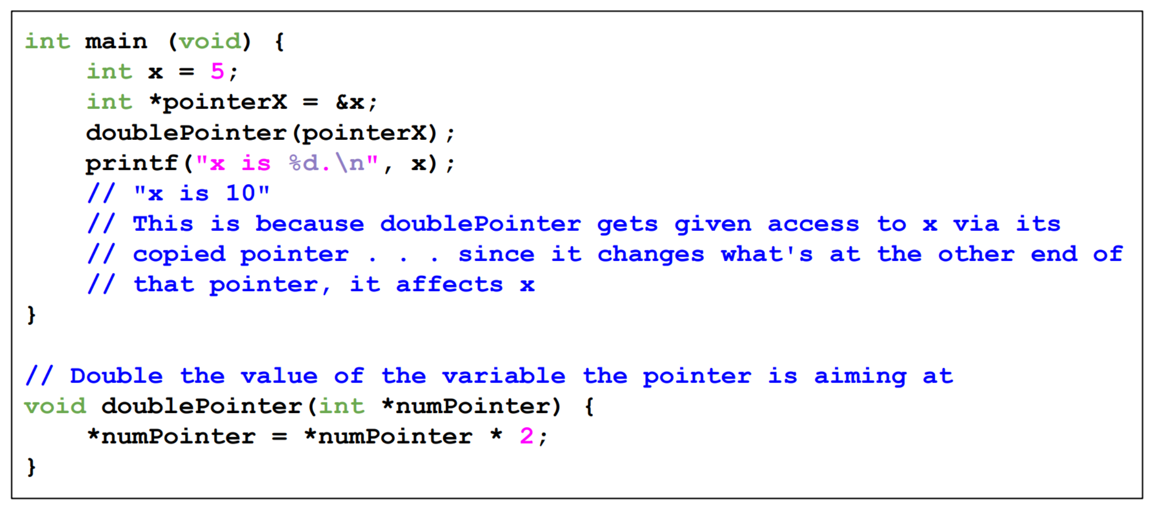

***Arrays Passing Memory similar to Pointers***

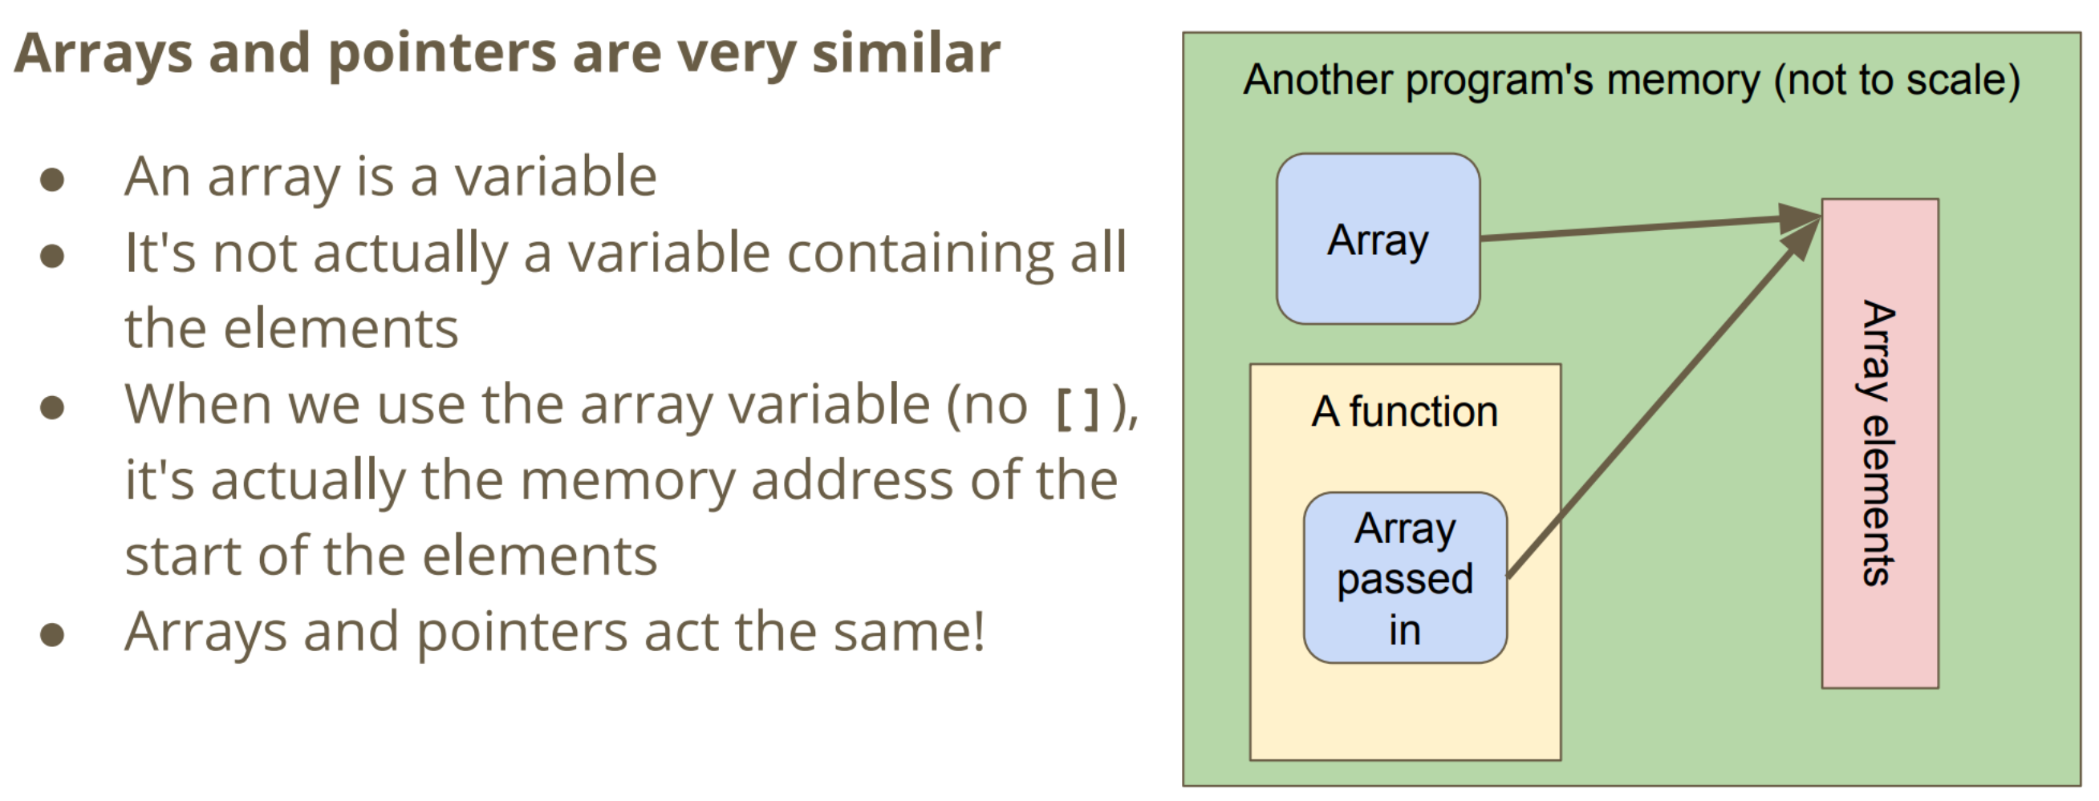

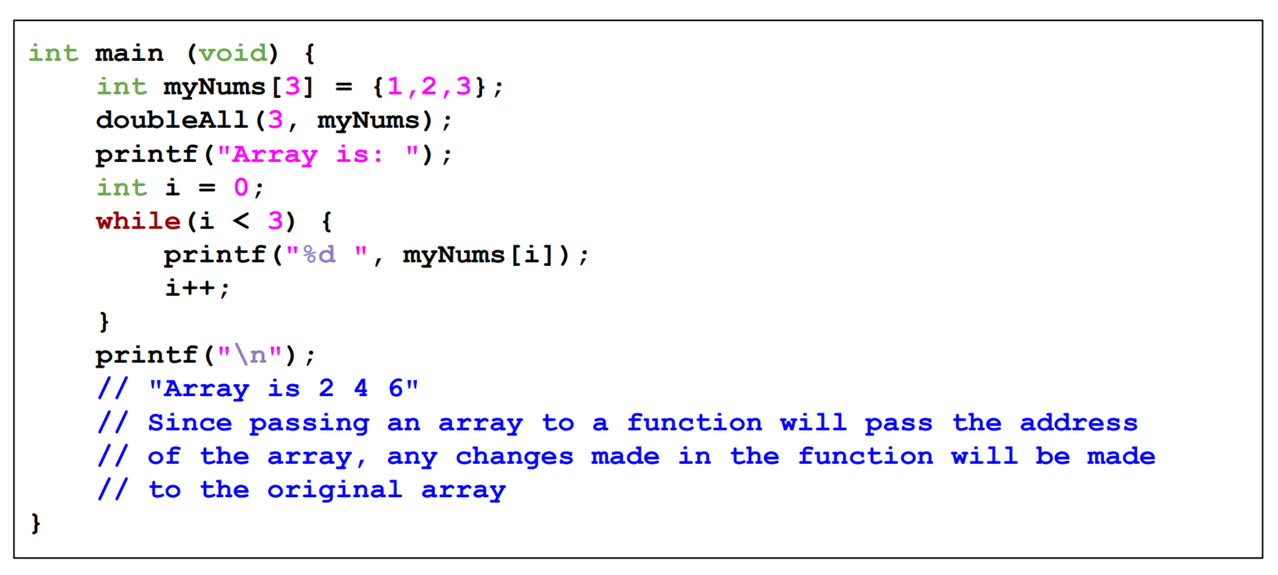

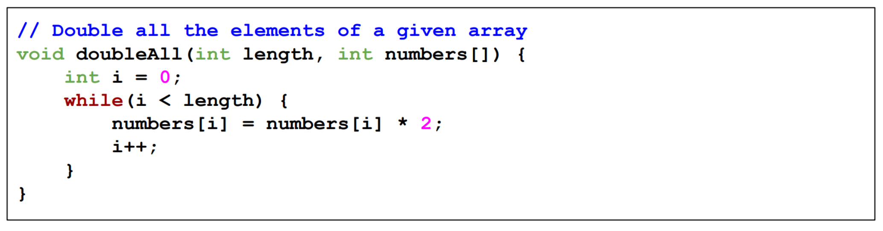

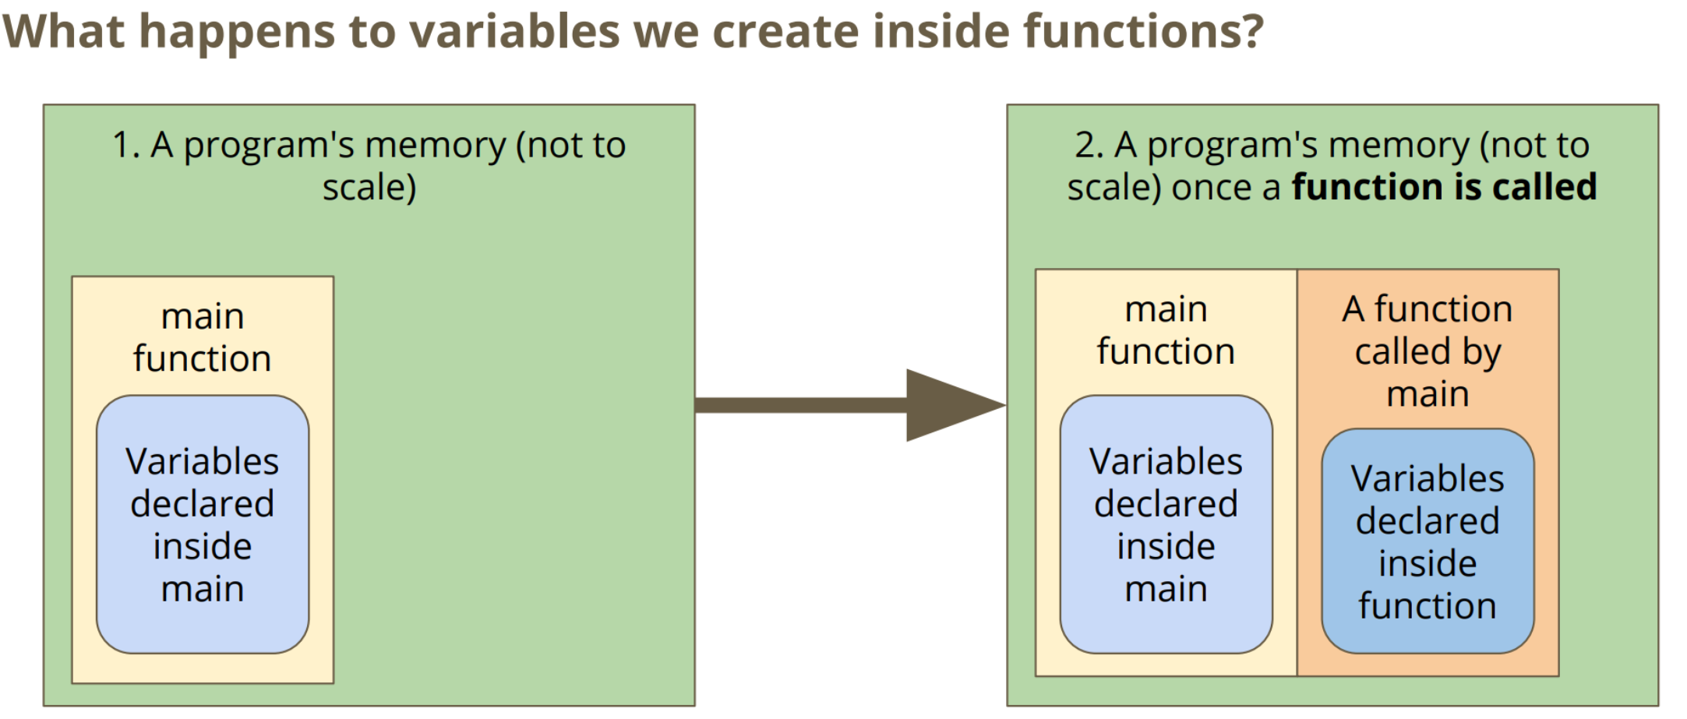

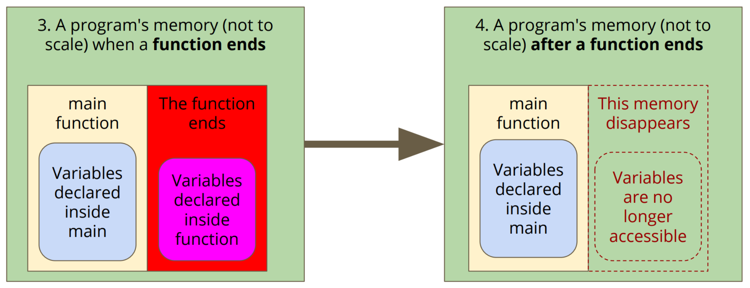

**Memory Allocation (malloc and free)**

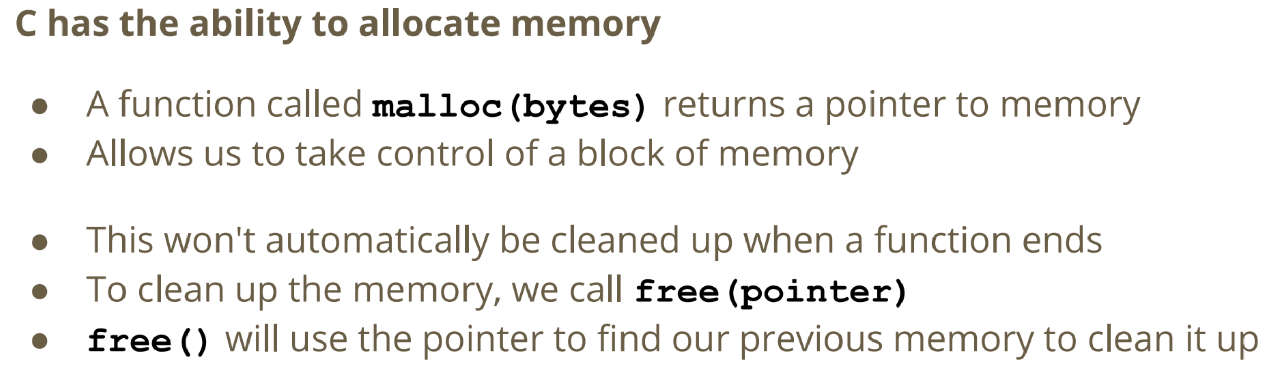

***malloc()***

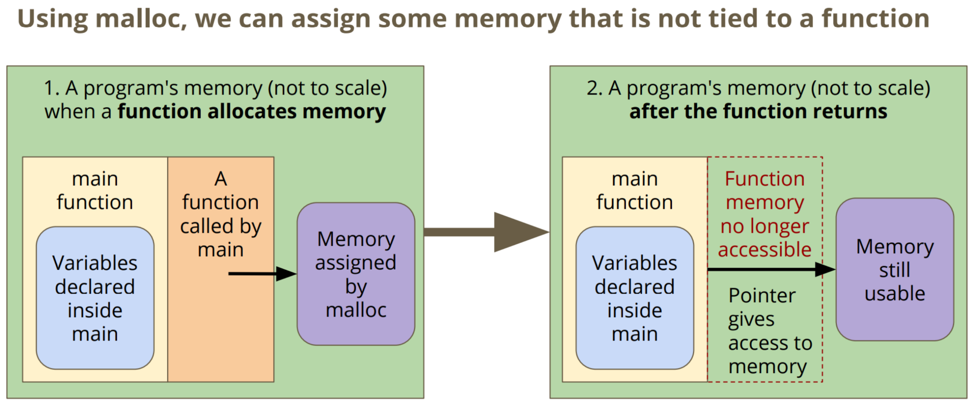

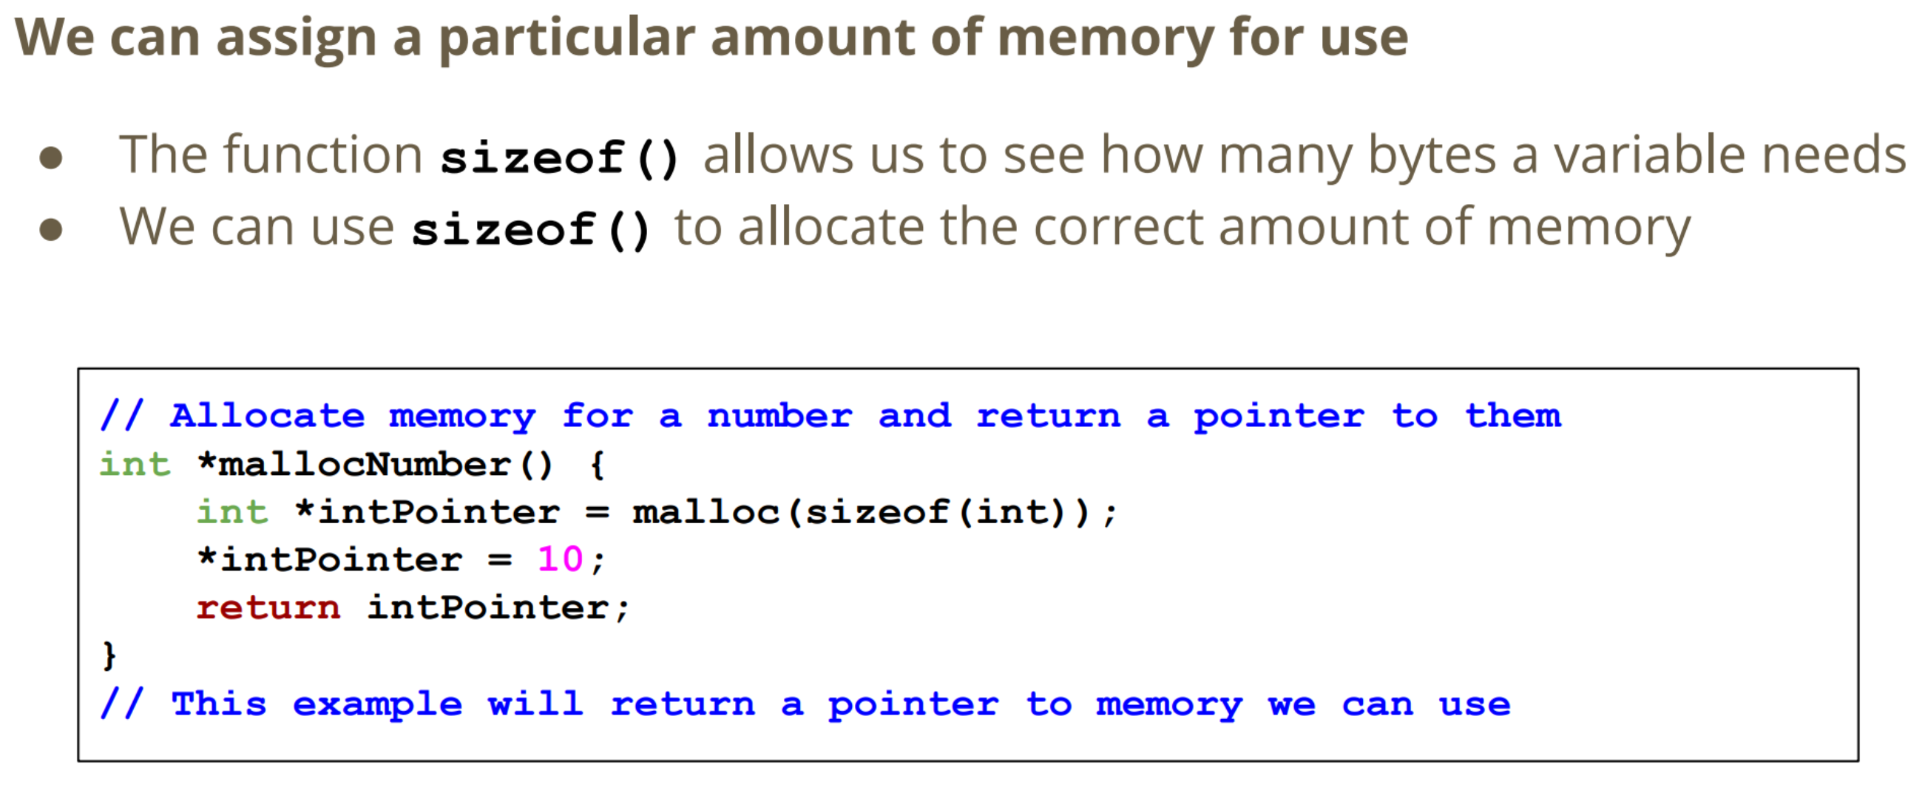



***free()***

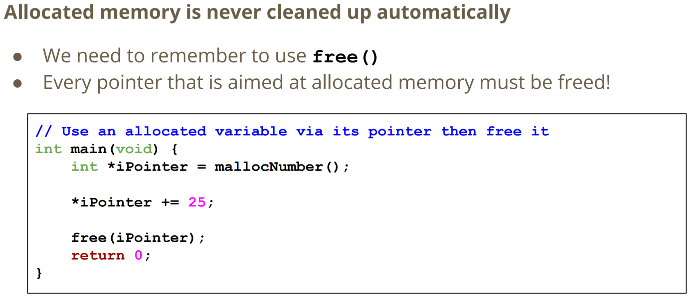

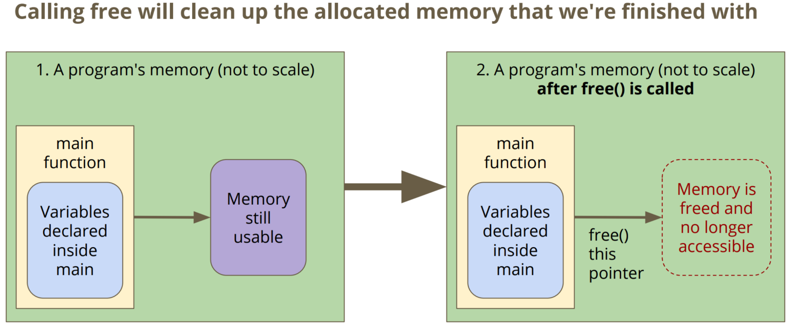

**Using Memory**

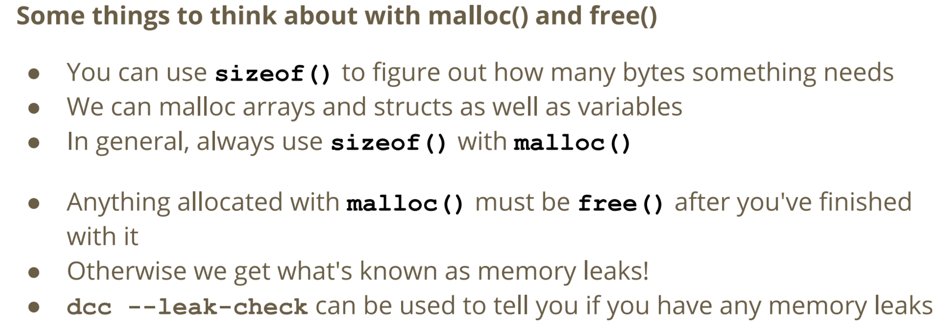



dcc main.c beats.c -o beats --leakcheck

**C Projects with Multiple Files**

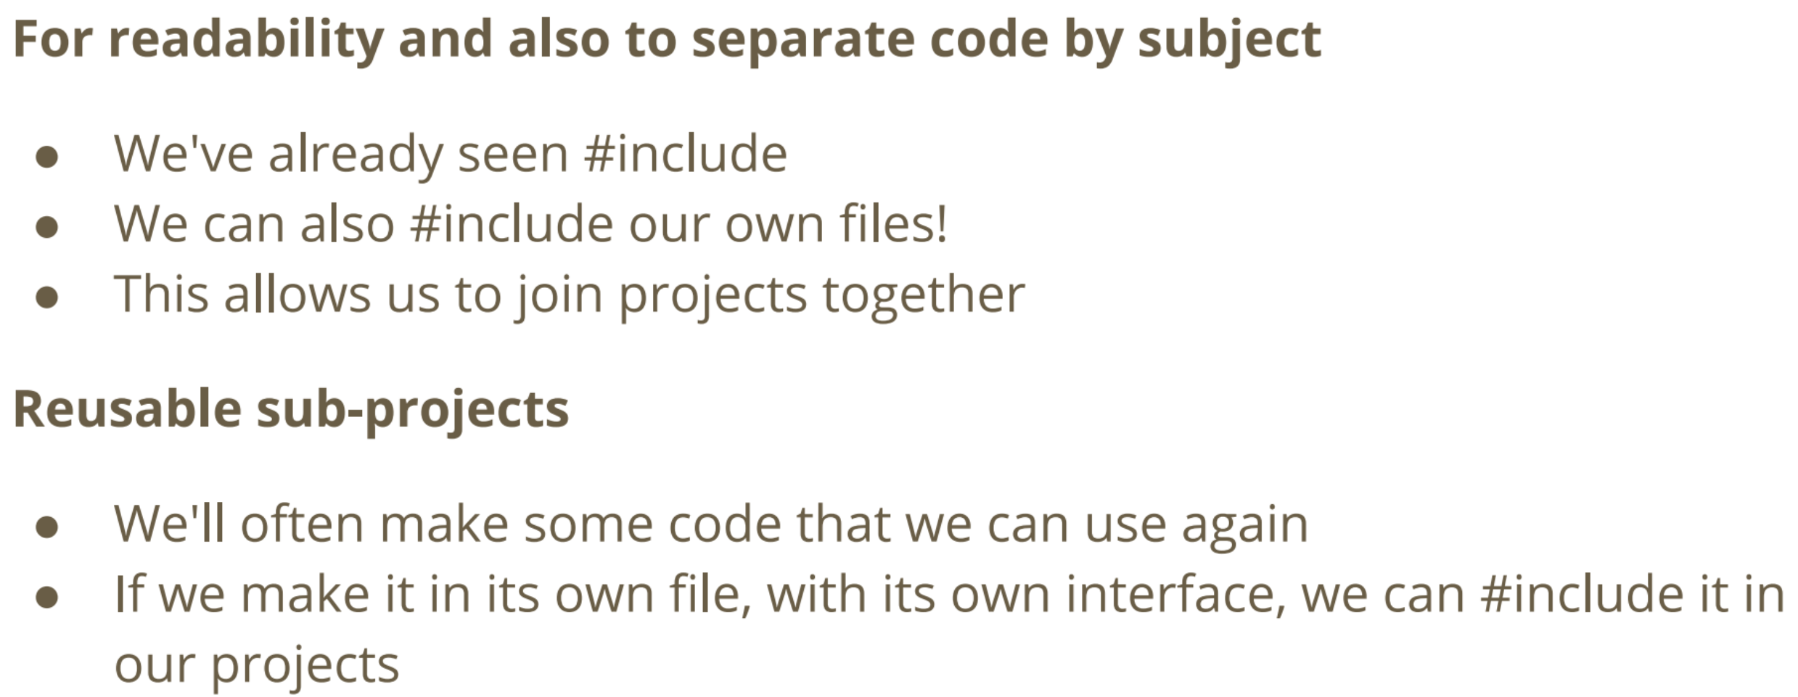

***Header Files and C (Implementation) Files***

* **Implementation Files**: e.g. #include <stdio.h> where its stores code such as function prototypes (i.e. printf()).
* **C Implementation Files**: e.g. stores the code of the function prototype (i.e. code for printf function).

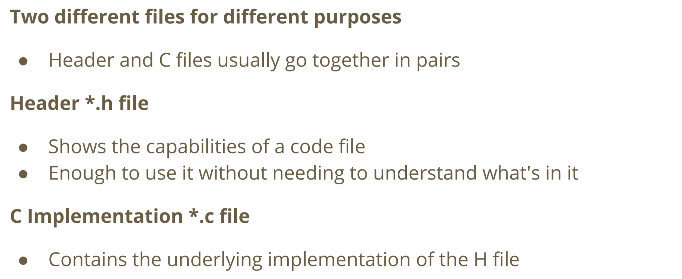

***File*.h (Header Files)**

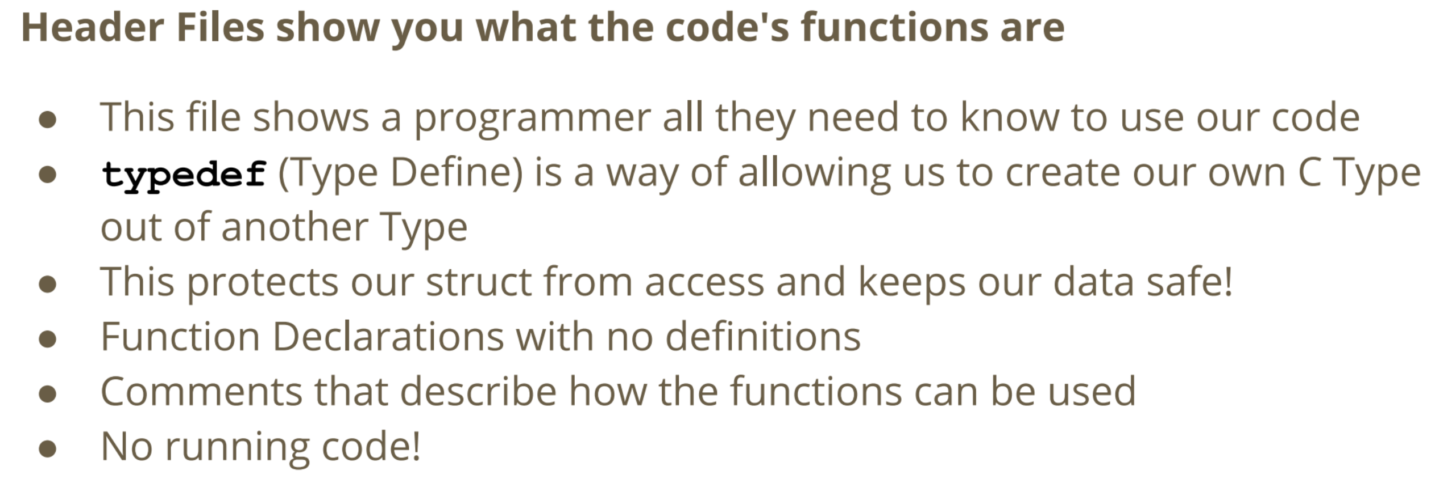

***File*.c (C Implementation Files)**

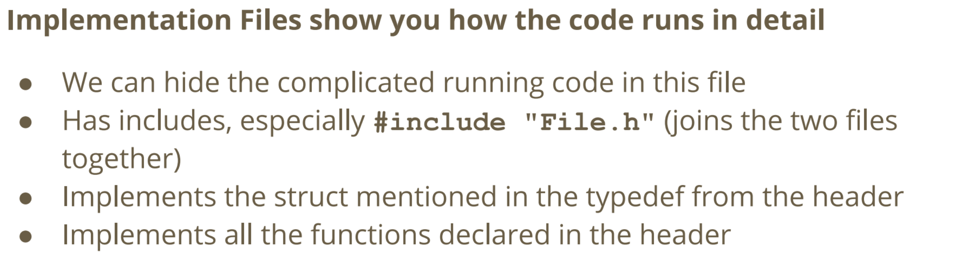

***Main.c and Other Files***

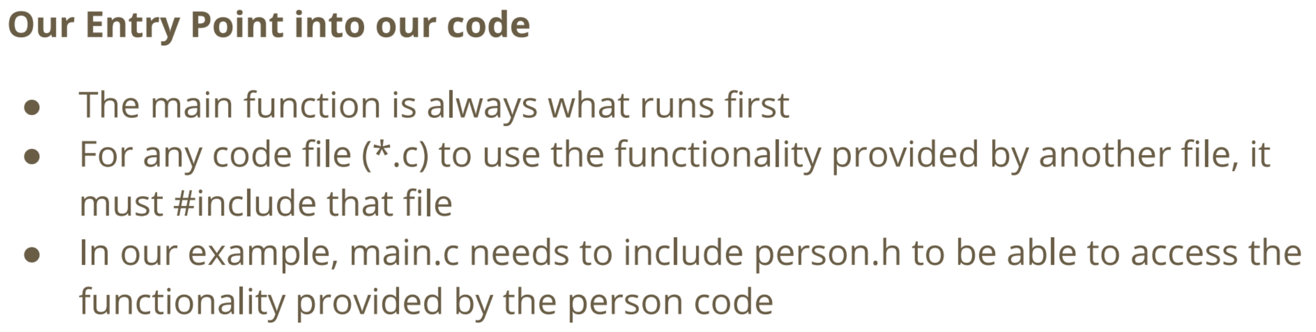

**Compiling a Project with Multiple Files**

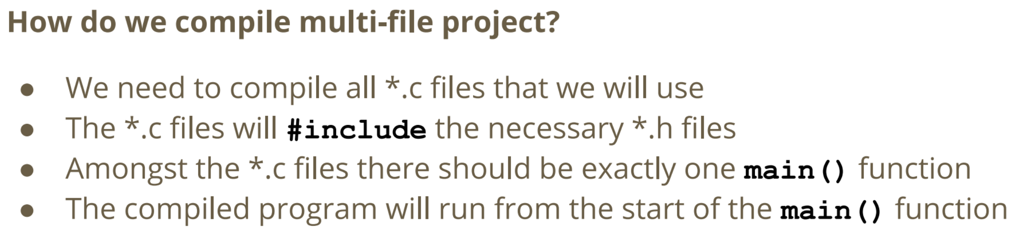

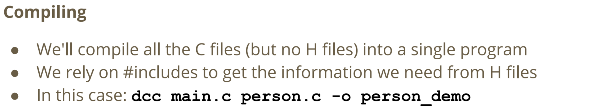

**01/04/20 – Week 7 Lecture 12**

**Command Line Argument**

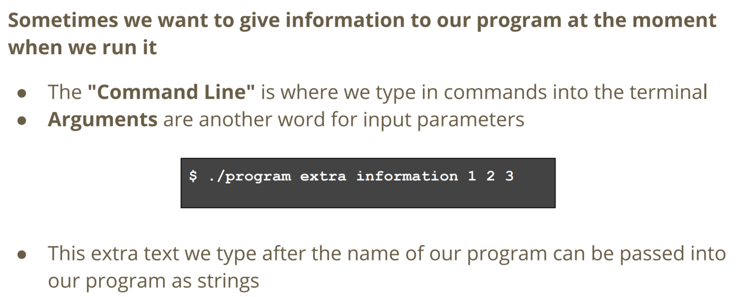

**Main Function that accept Arguments (argc/argv)**

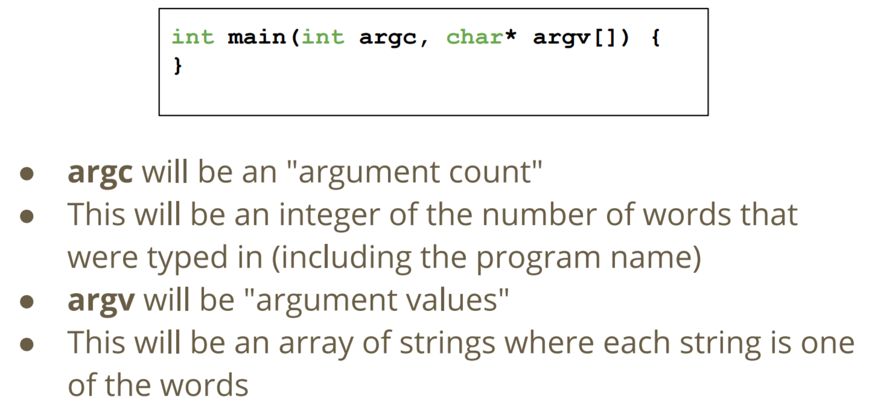

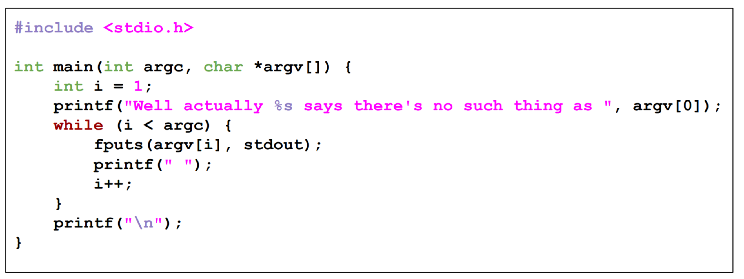

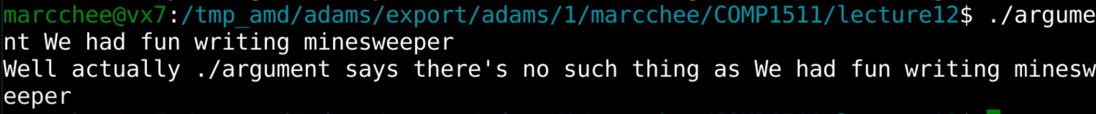

**Transforming Arguments (String to Numbers)**

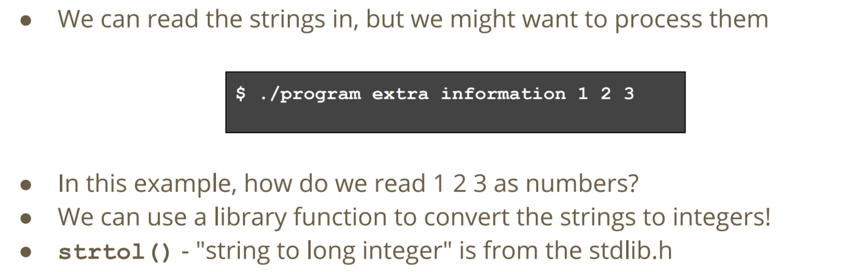

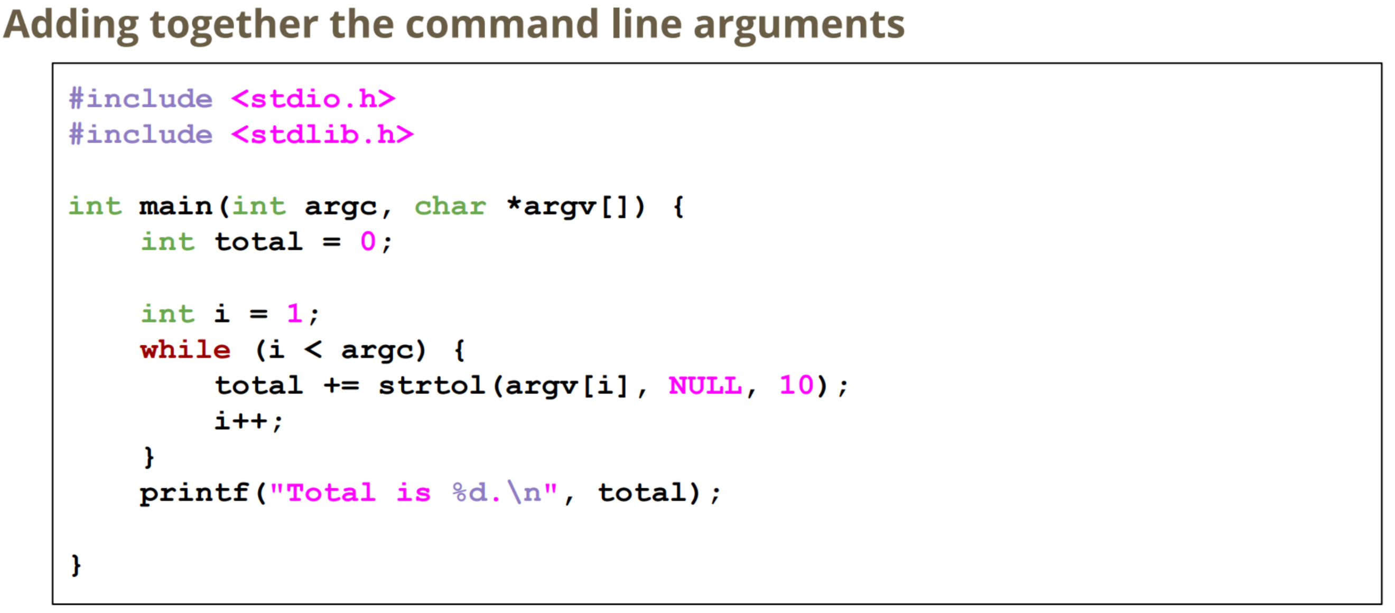



**Linked List (struct node)**

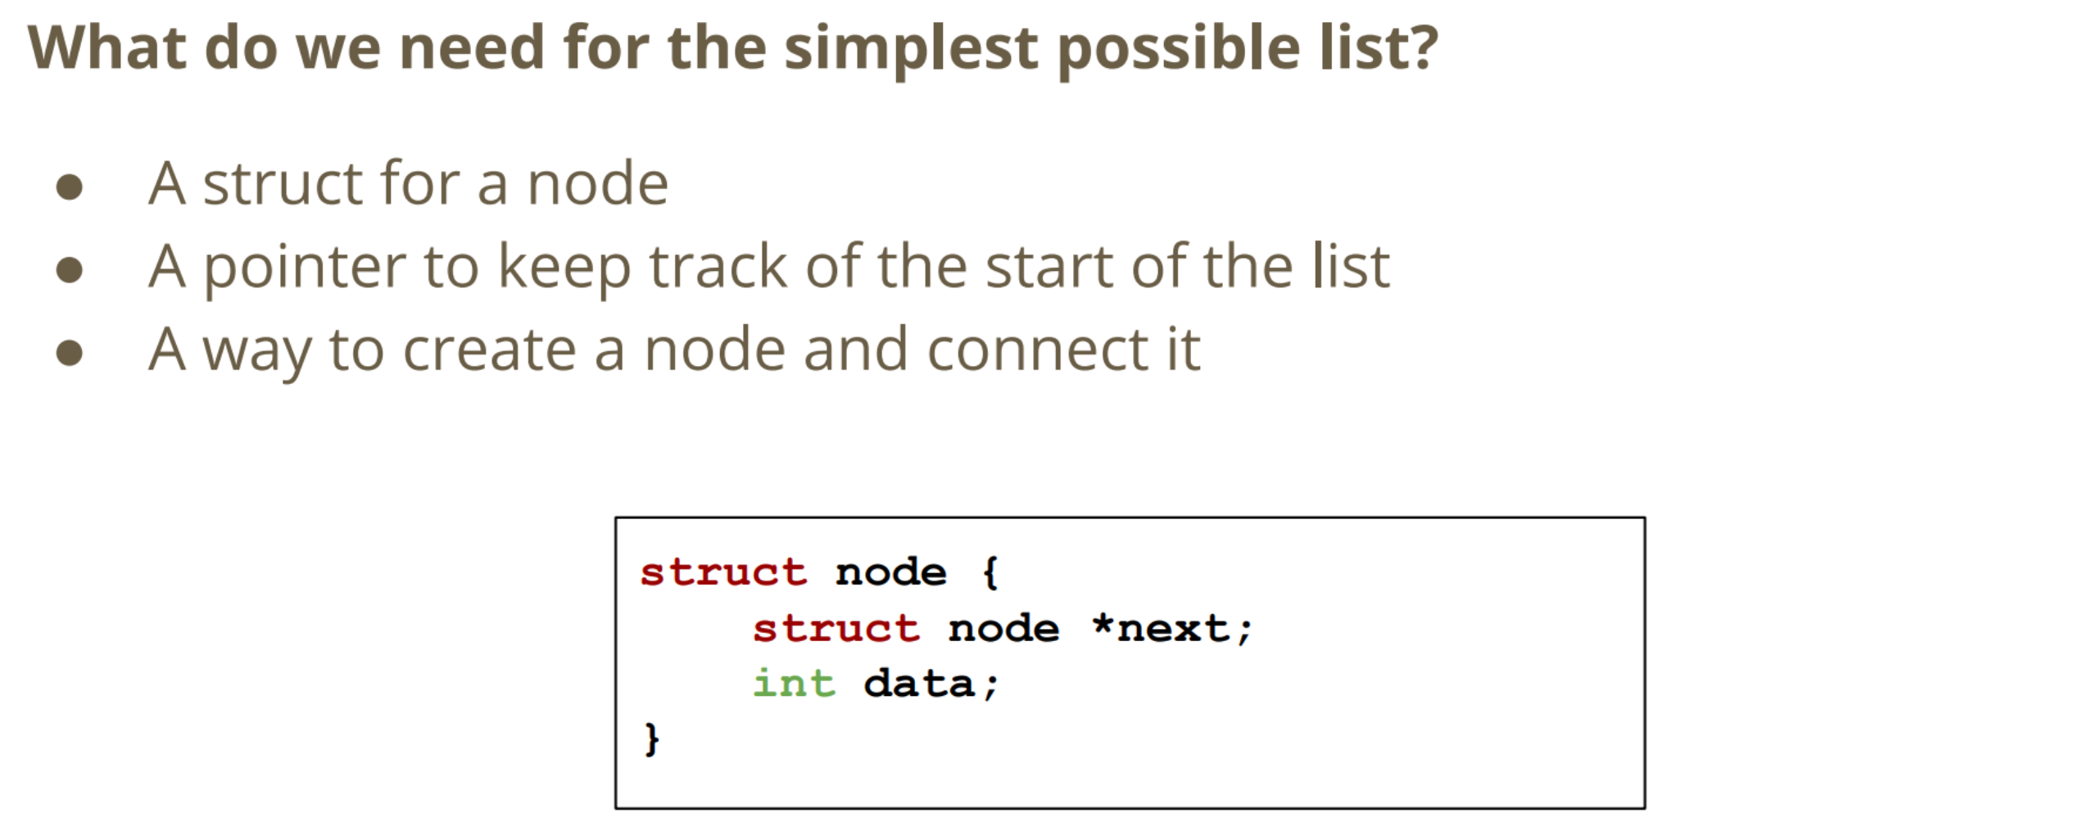

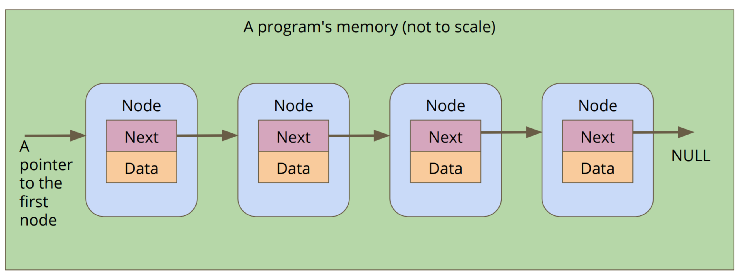

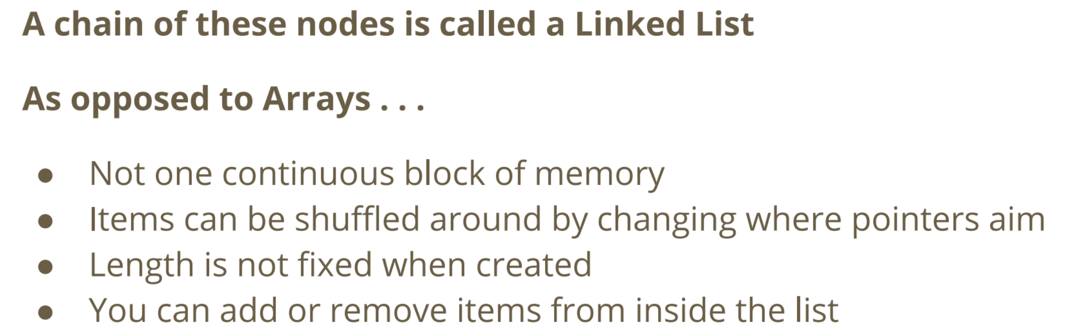

**Function to add a node to a linked list**

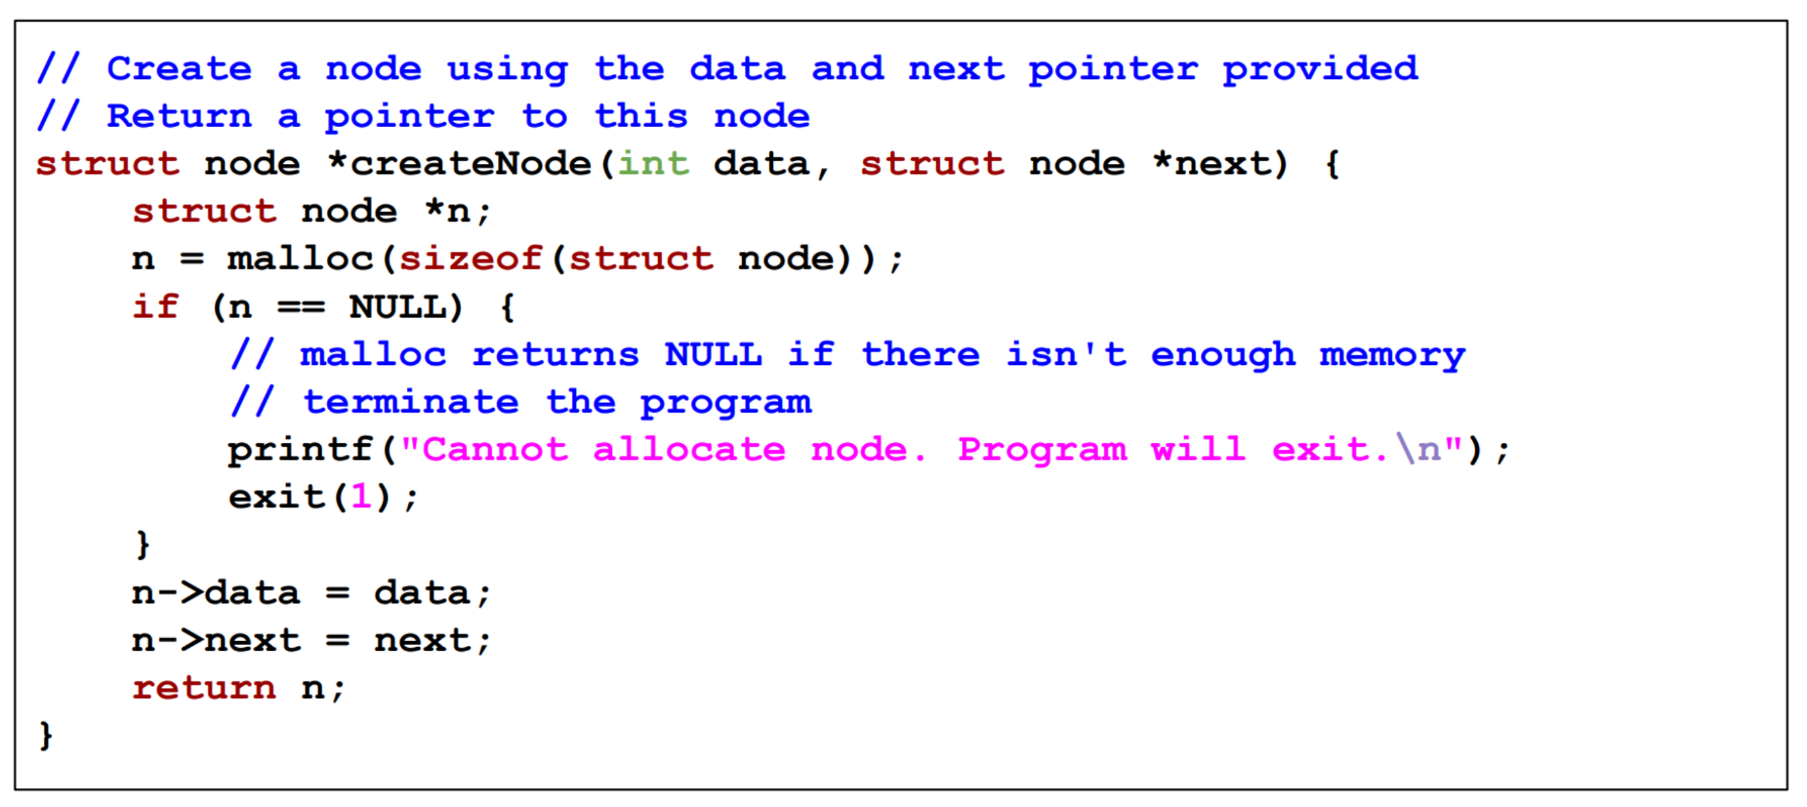

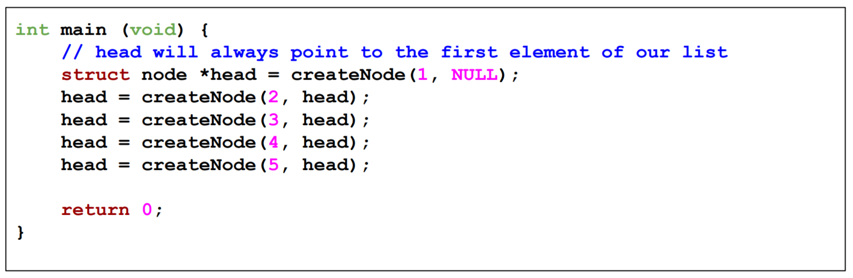

**Looping through a Linked List**

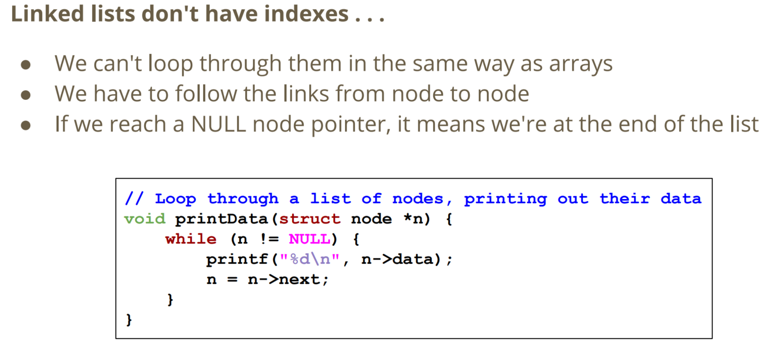

**Week 7/8 Tutorial Questions**

**What is the size of *char* variable, and what possible values can it have? What do these values mean?**

A char variable in C is 8 bits or 1 byte long. Its possible values are either -128 to 127 or 0 to 255. This depends on the compiler and computer architecture being used. You can not guarantee that a char can store negative values such as EOF. The value a char holds usually represents a character on the ASCII table.

**How do we use getchar and putchar? How does getchar signal to us that it has reached the end of the input? Why does getchar return an int instead of a char? How do we use fgets? How does fgets signal to us that it has reached the end of the input? When fgets scans in a line of text, will it include a '\n' at the end of the line? Is this always the case?**

* **getchar** will return **EOF** if it reaches the end of the input. Because EOF is a #define for a negative number, we can not guarantee this value can be stored in a char, so getchar must return an int.
* **fgets** will return **NULL** if it reaches the end of the input without scanning in any further characters.
* **fgets** generally will place a **'\n'** provided there is a newline at the end of the line of characters in the input (if the user presses Enter). If the user doesn't press Enter and only presses CTRL+D then fgets will not include a '\n' at the end of the string.

**What does the char *word input mean? What's the relationship between an array and a pointer?**

**char *word** means that the function takes in a pointer to a character as its input. A pointer is a variable which contains a memory address, but so is an array. This function in particular is expecting the character pointer to be telling us the address of the first character in an array of characters. Since this array of characters ends with a '\0', it is a string.

There are some subtle differences between arrays and pointers in C. A pointer can have an address directly assigned to it but an array can not. You can only directly assign values to elements inside an array. Also, the **sizeof** operator will return the size of the pointer itself for a pointer, while the **sizeof** operator will return the total size of the array for an array.

**What is a pointer? How do pointers relate to other variables?**

Pointers are variables that store a memory address. They are usually "aimed" at a variable of a particular type. They're able to read the value of that variable and also are handy because they can be passed into functions, giving the function write access to a variable.

**What is a struct? What are the differences between structs and arrays?**

* Arrays and struct are both compound data types, formed from other data types.
* Array are homogeneous - formed from a single data type.
* Structs can be heterogeneous - formed from multiple data types.
* Array elements are accessed with integer array indices.
* Struct members are accessed by name.
* Both structs and array are collection of things.
* Array – ordered sequence of same type
* Struct – labelled collection

**What is a linked list? How does it compare to an array?**

* Index based/sequential based
* Array has maximum size/linked list can grow indefinitely

A linked list is made up of separate, identical type structs that are usually in allocated memory. These are usually called list "nodes". These are linked together by a field of their struct that is a pointer to another node. An array is a single block of memory large enough to hold an exact number of an identical type of variable. These are accessed via an index which shows how far from the initial memory address the particular element is.

**Notes**

* Consider the null terminator when declaring the size of an array. i.e. MAX_LENGHT 100
  + char line [MAX_LENTH + 1] //+1 considers the size of the null terminator
* **a->b is the same as (*a).b**
  + The . is used to access the fields in a struct (struct student).
  + The -> is used to access the fields when we have a pointer to a struct (struct student *)

**07/04/20 – Week 8 Lecture 13**

**Printing out a Linked List**

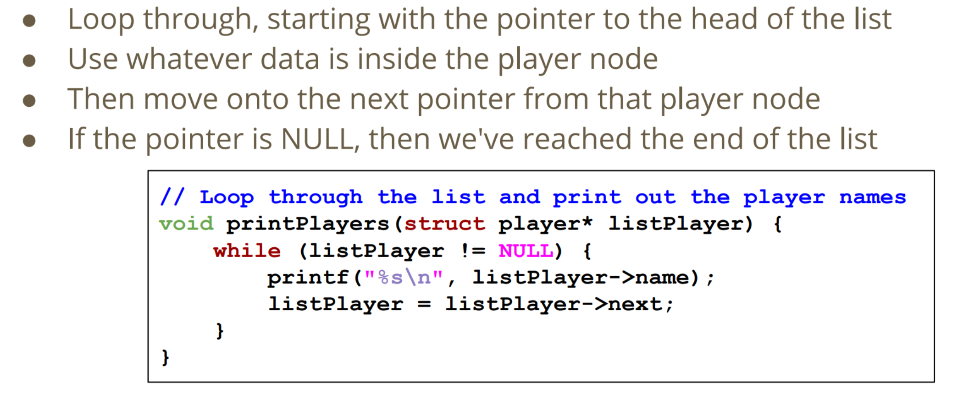

**Inserting a Node**

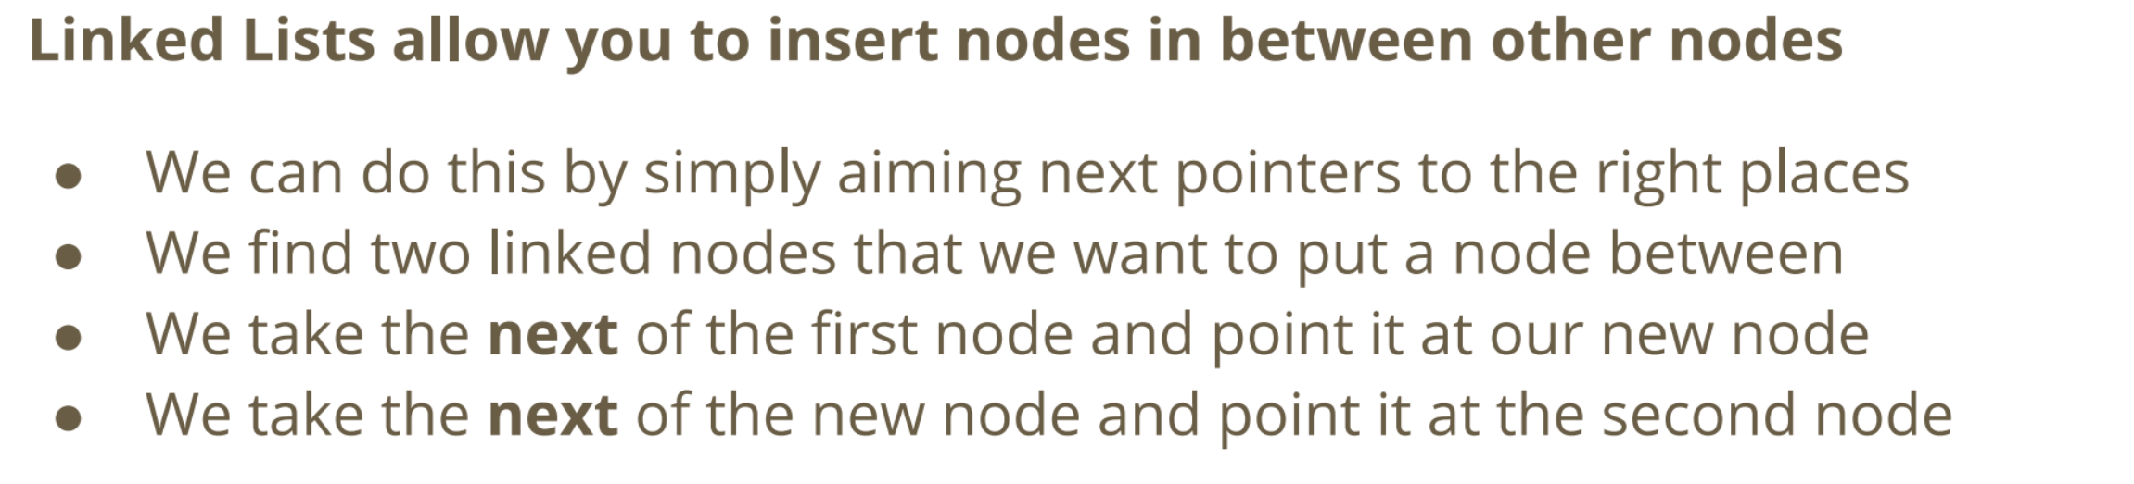

**1. Create a Node**

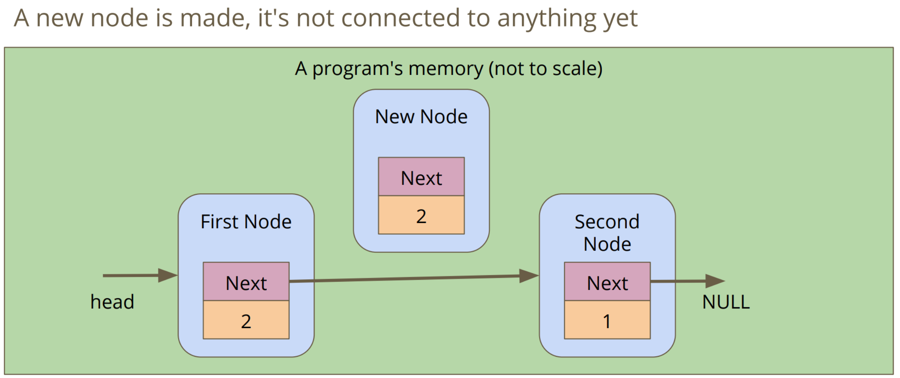

**2. Connect the new node with the second node**

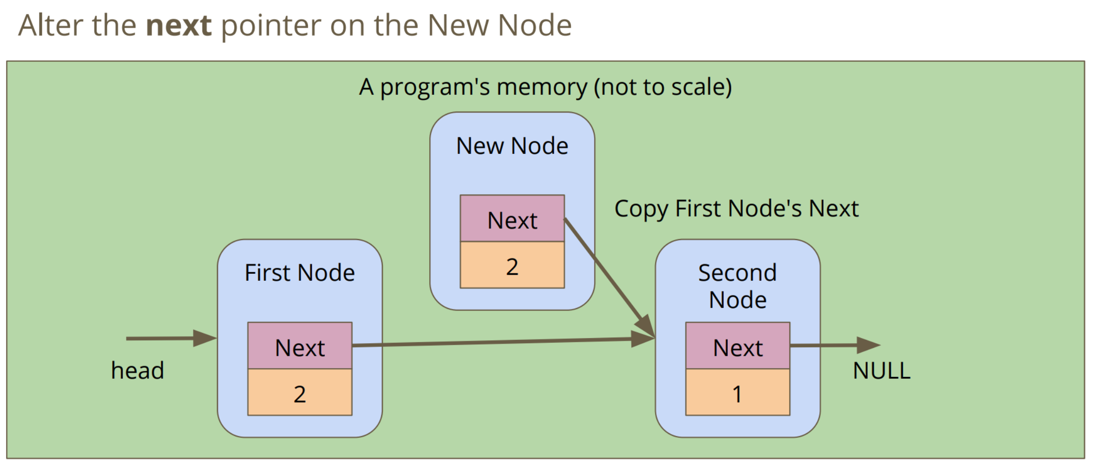

**3. Connect the first node to the new node**

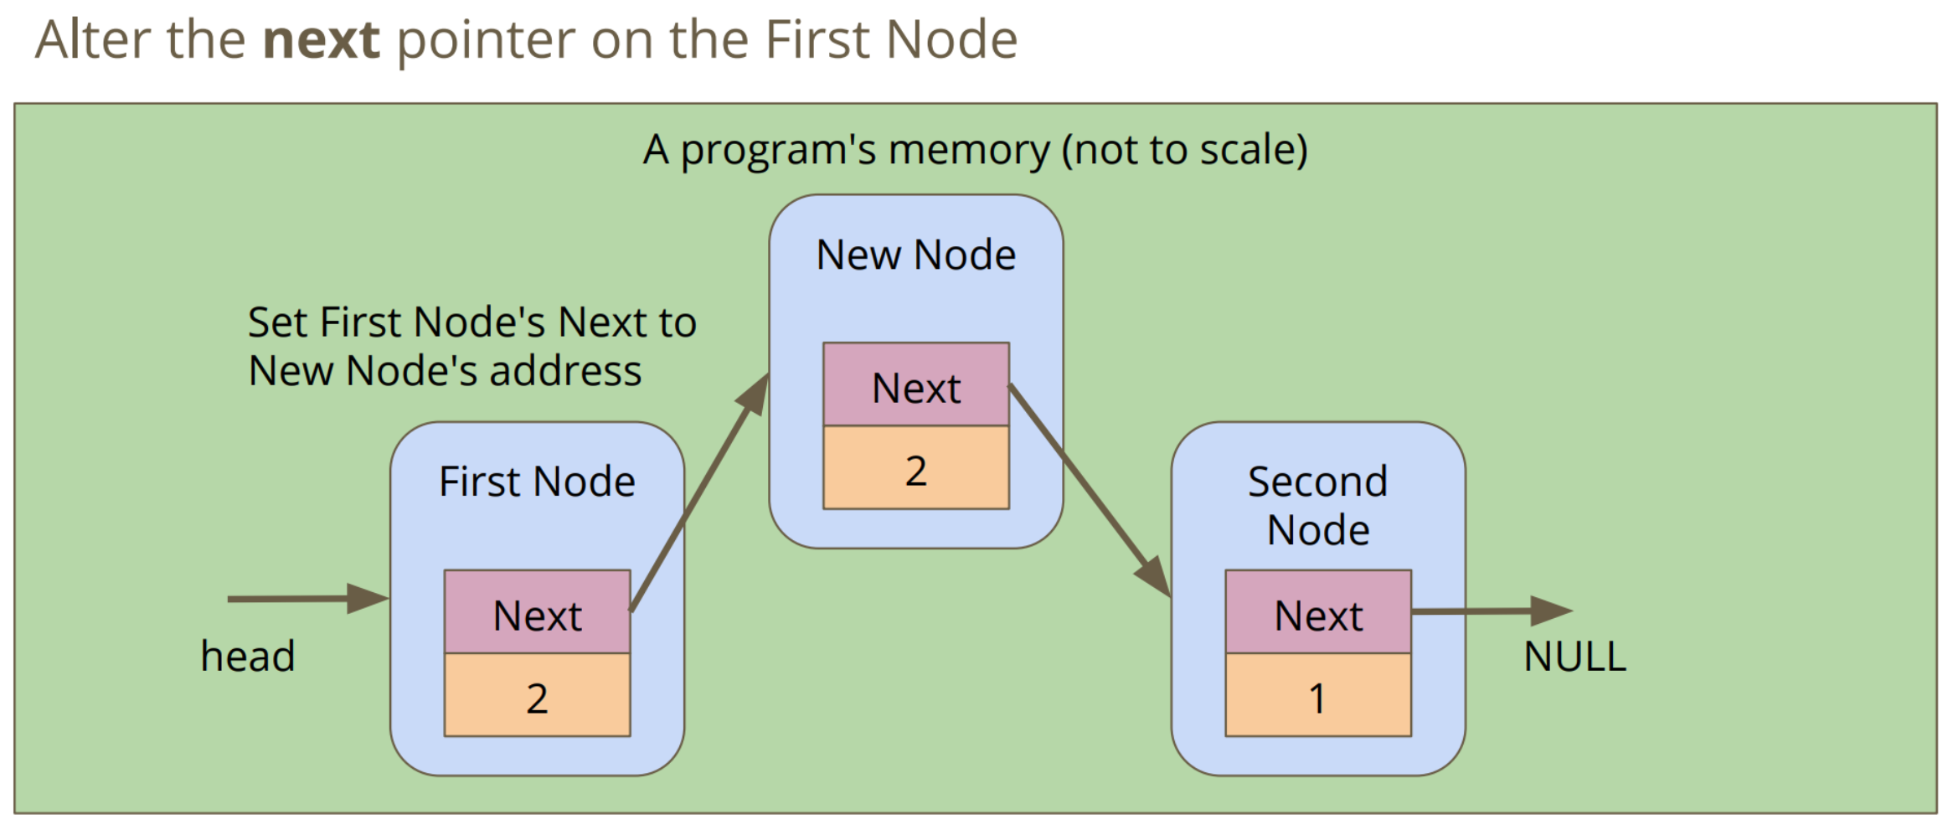

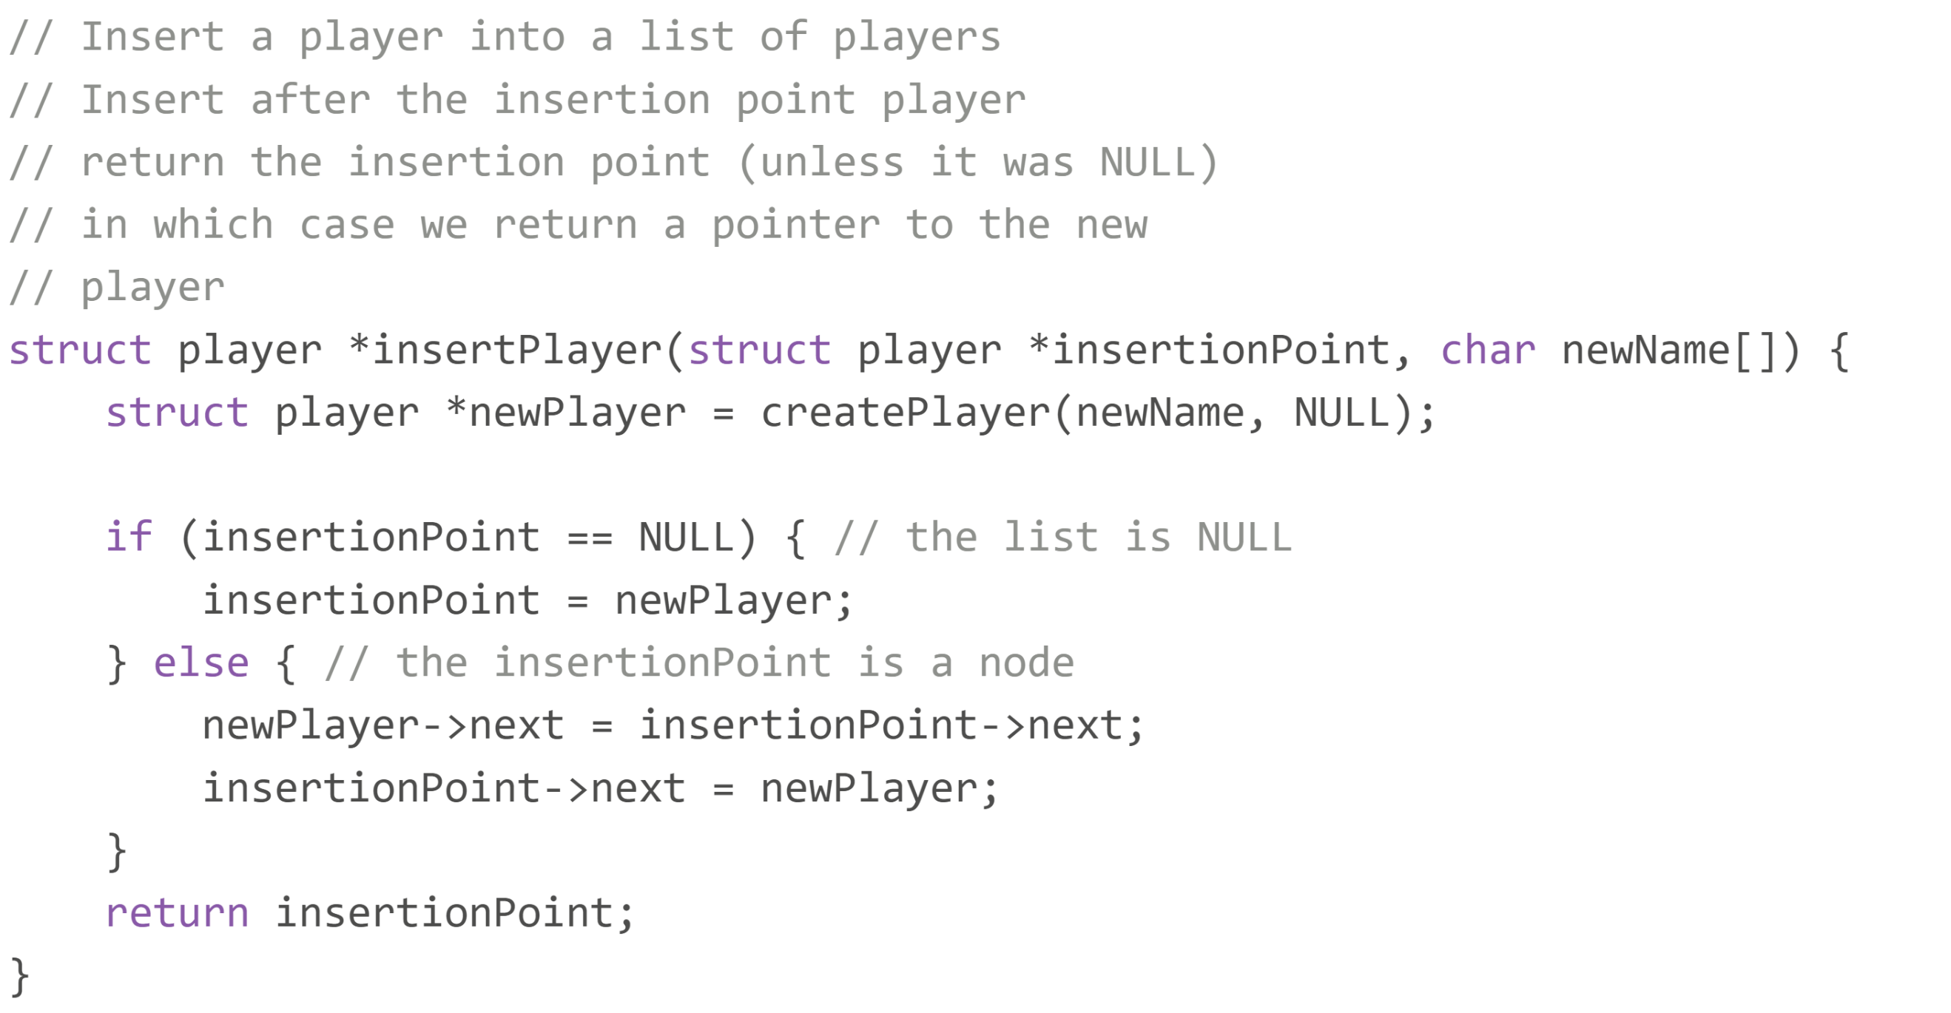

**08/04/20 – Week 8 Lecture 14**

**Inserting a Node with Condition**

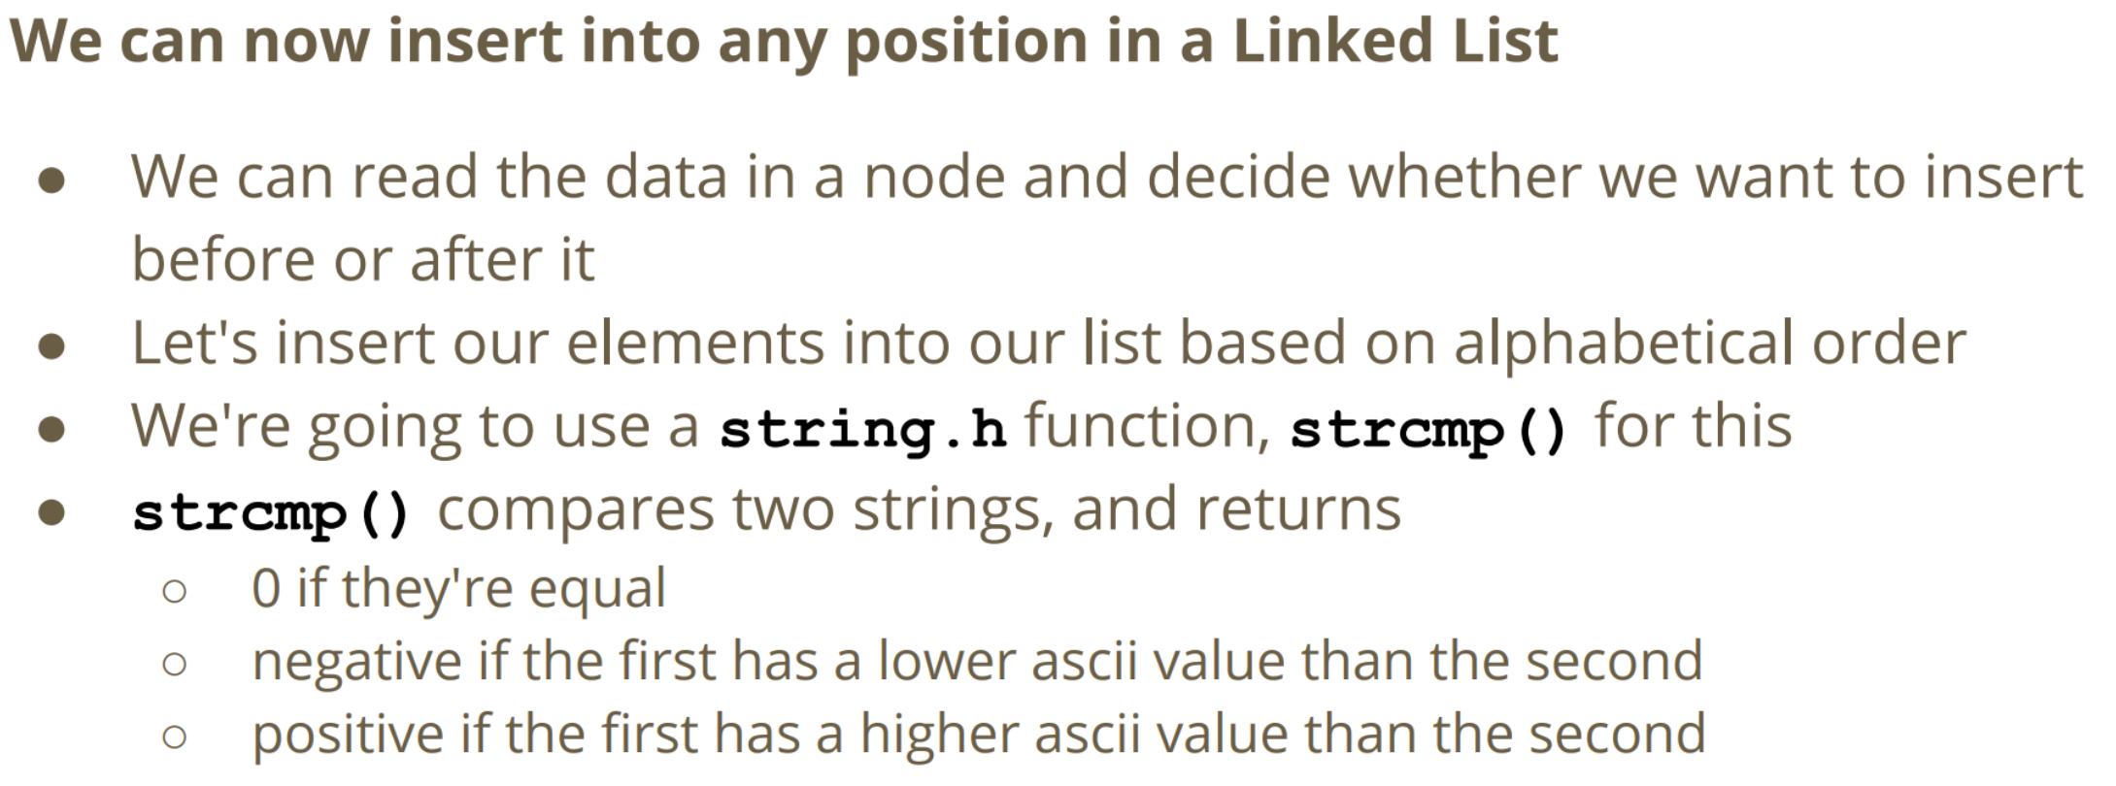

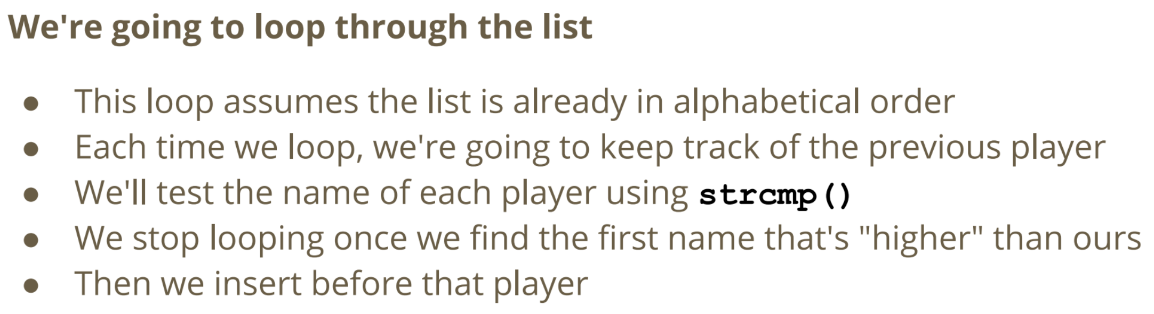

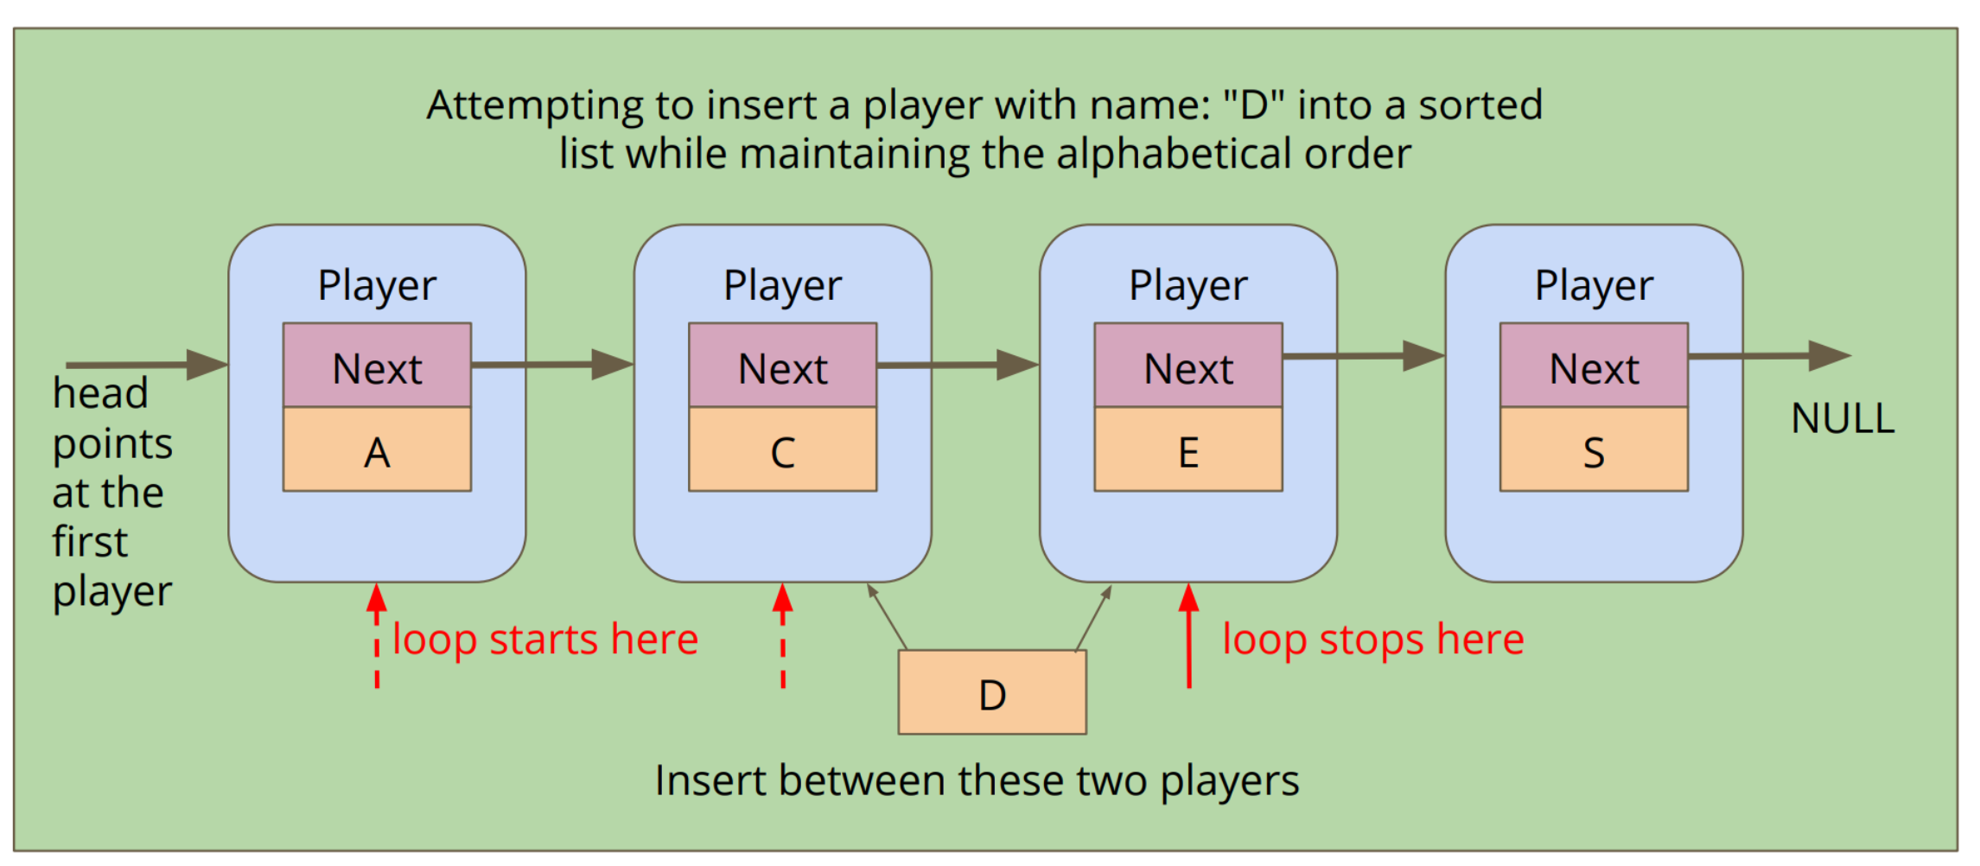

**Removing a Node**

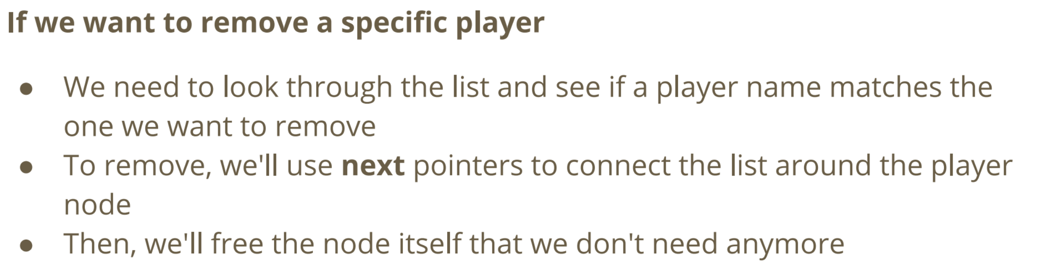

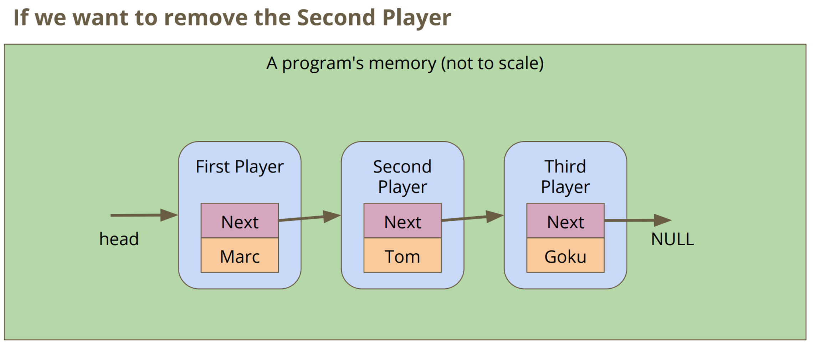

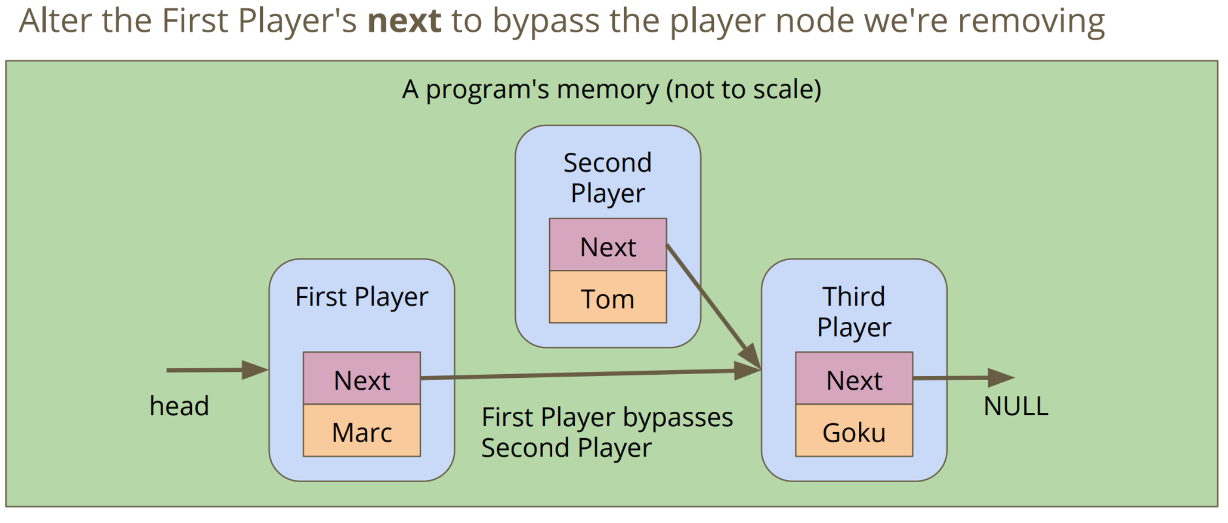

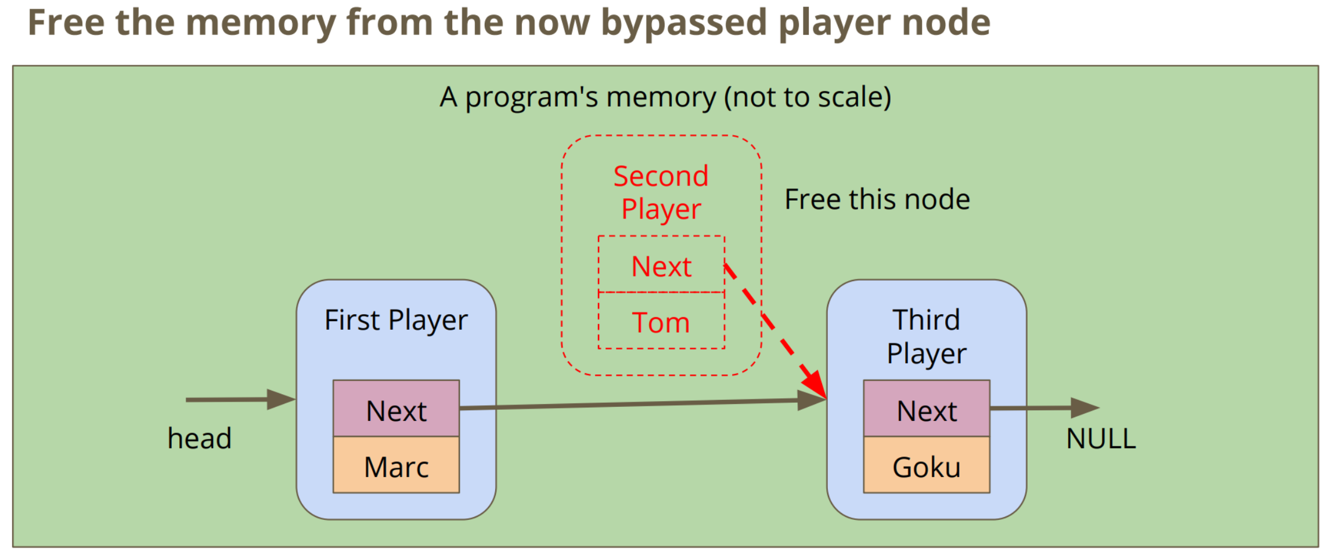

**Removing Node**

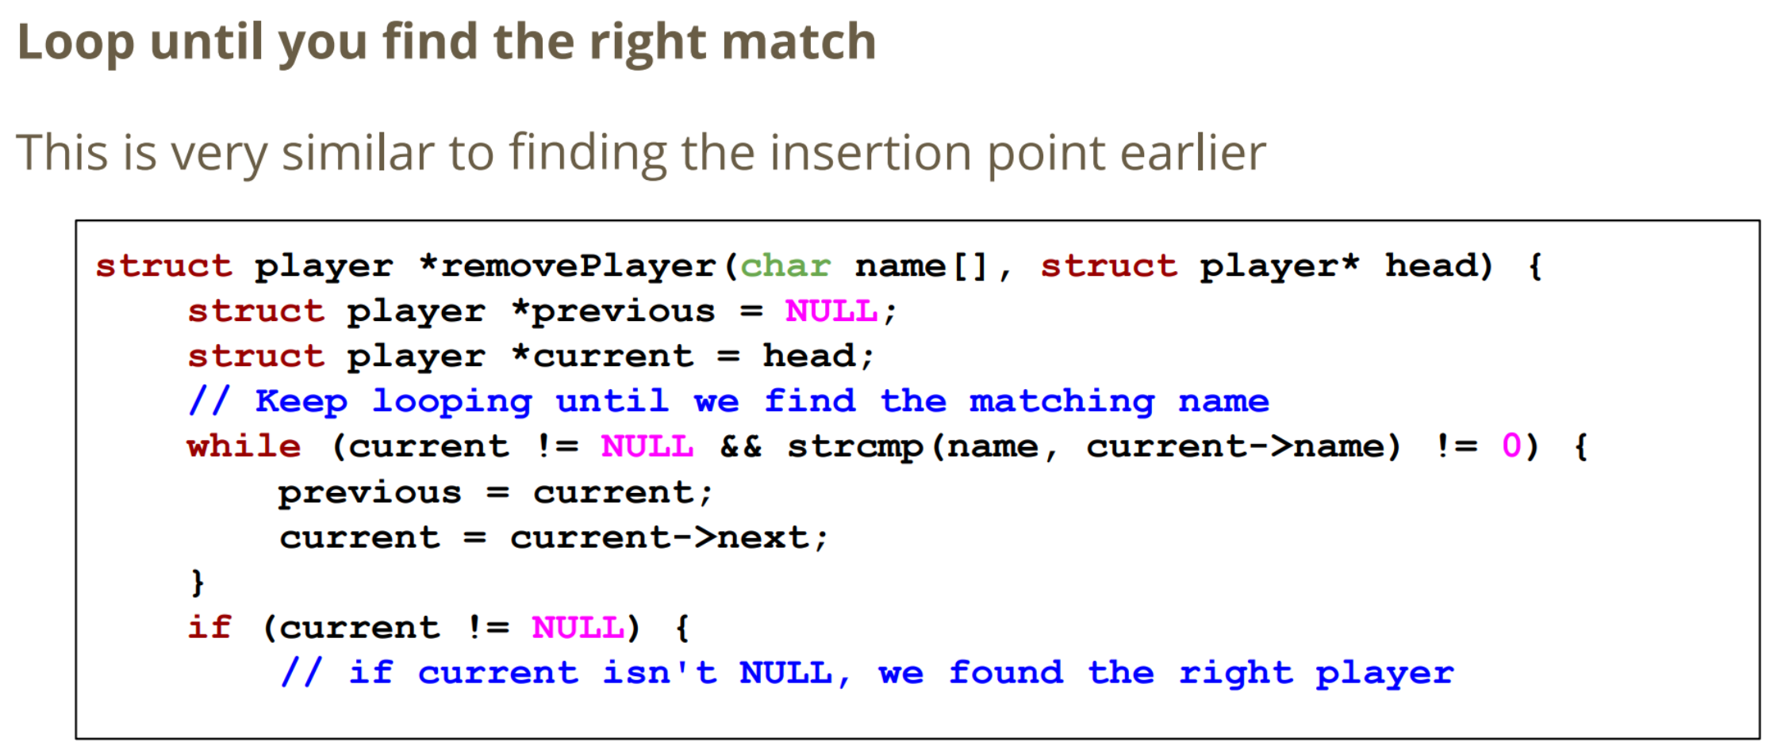

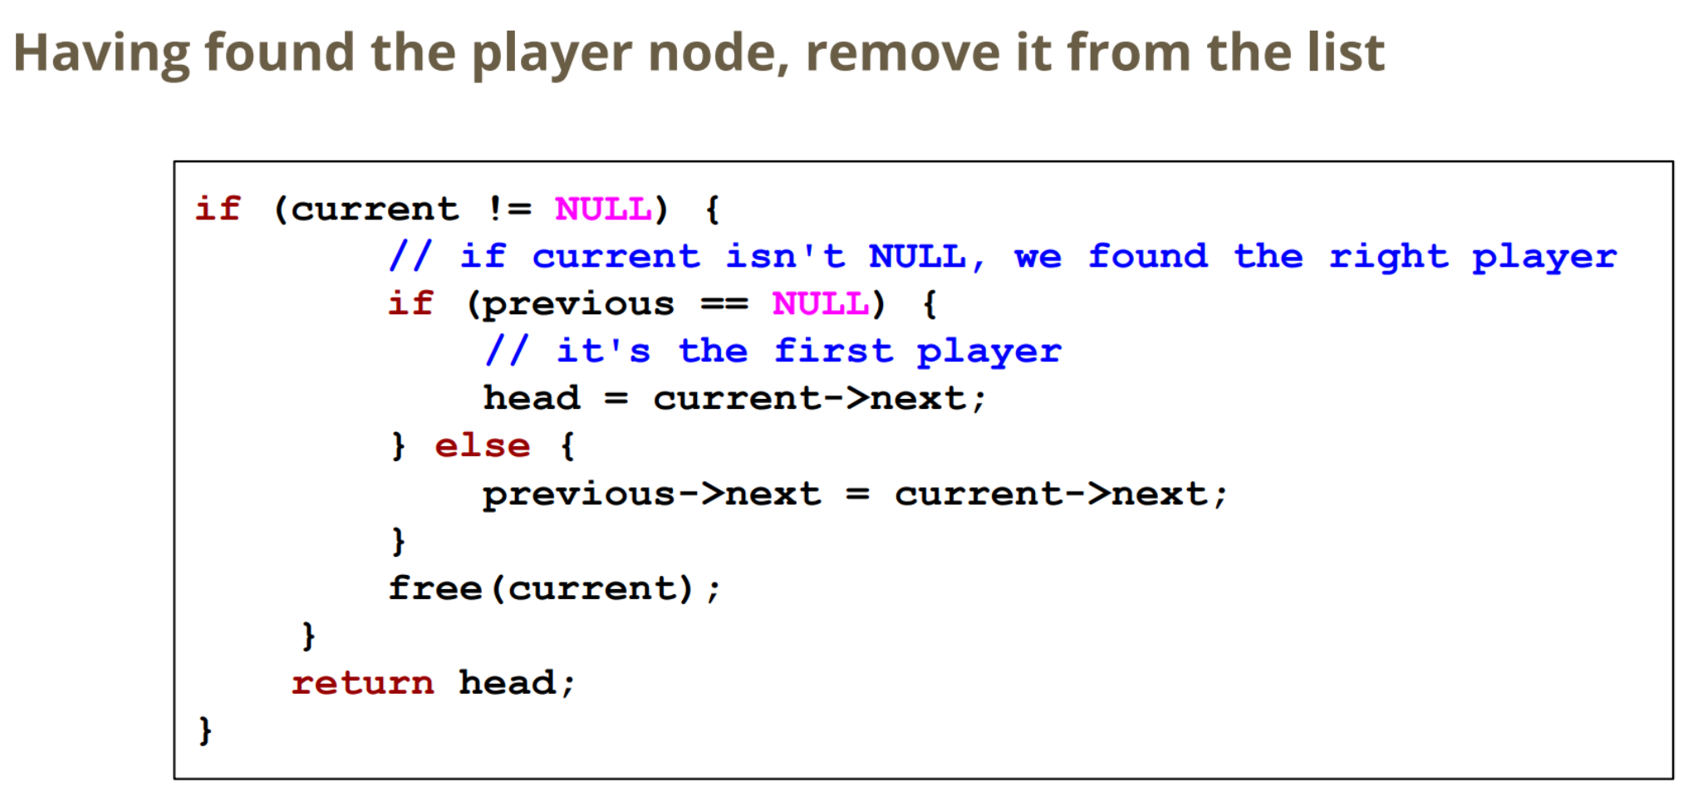

**Freeing Nodes**

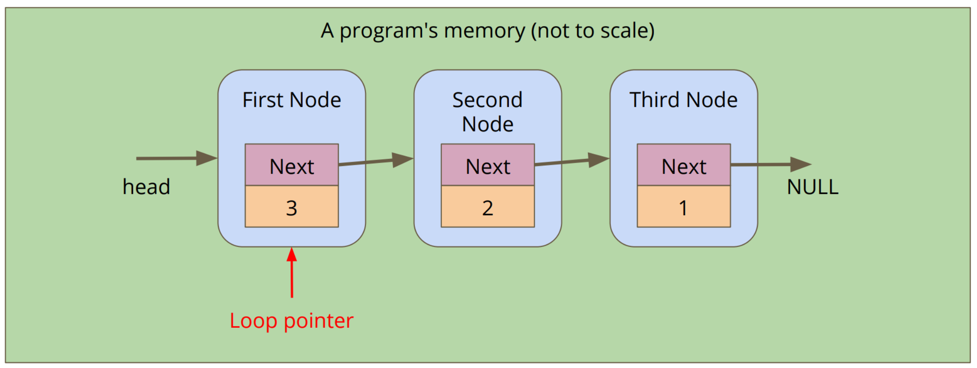

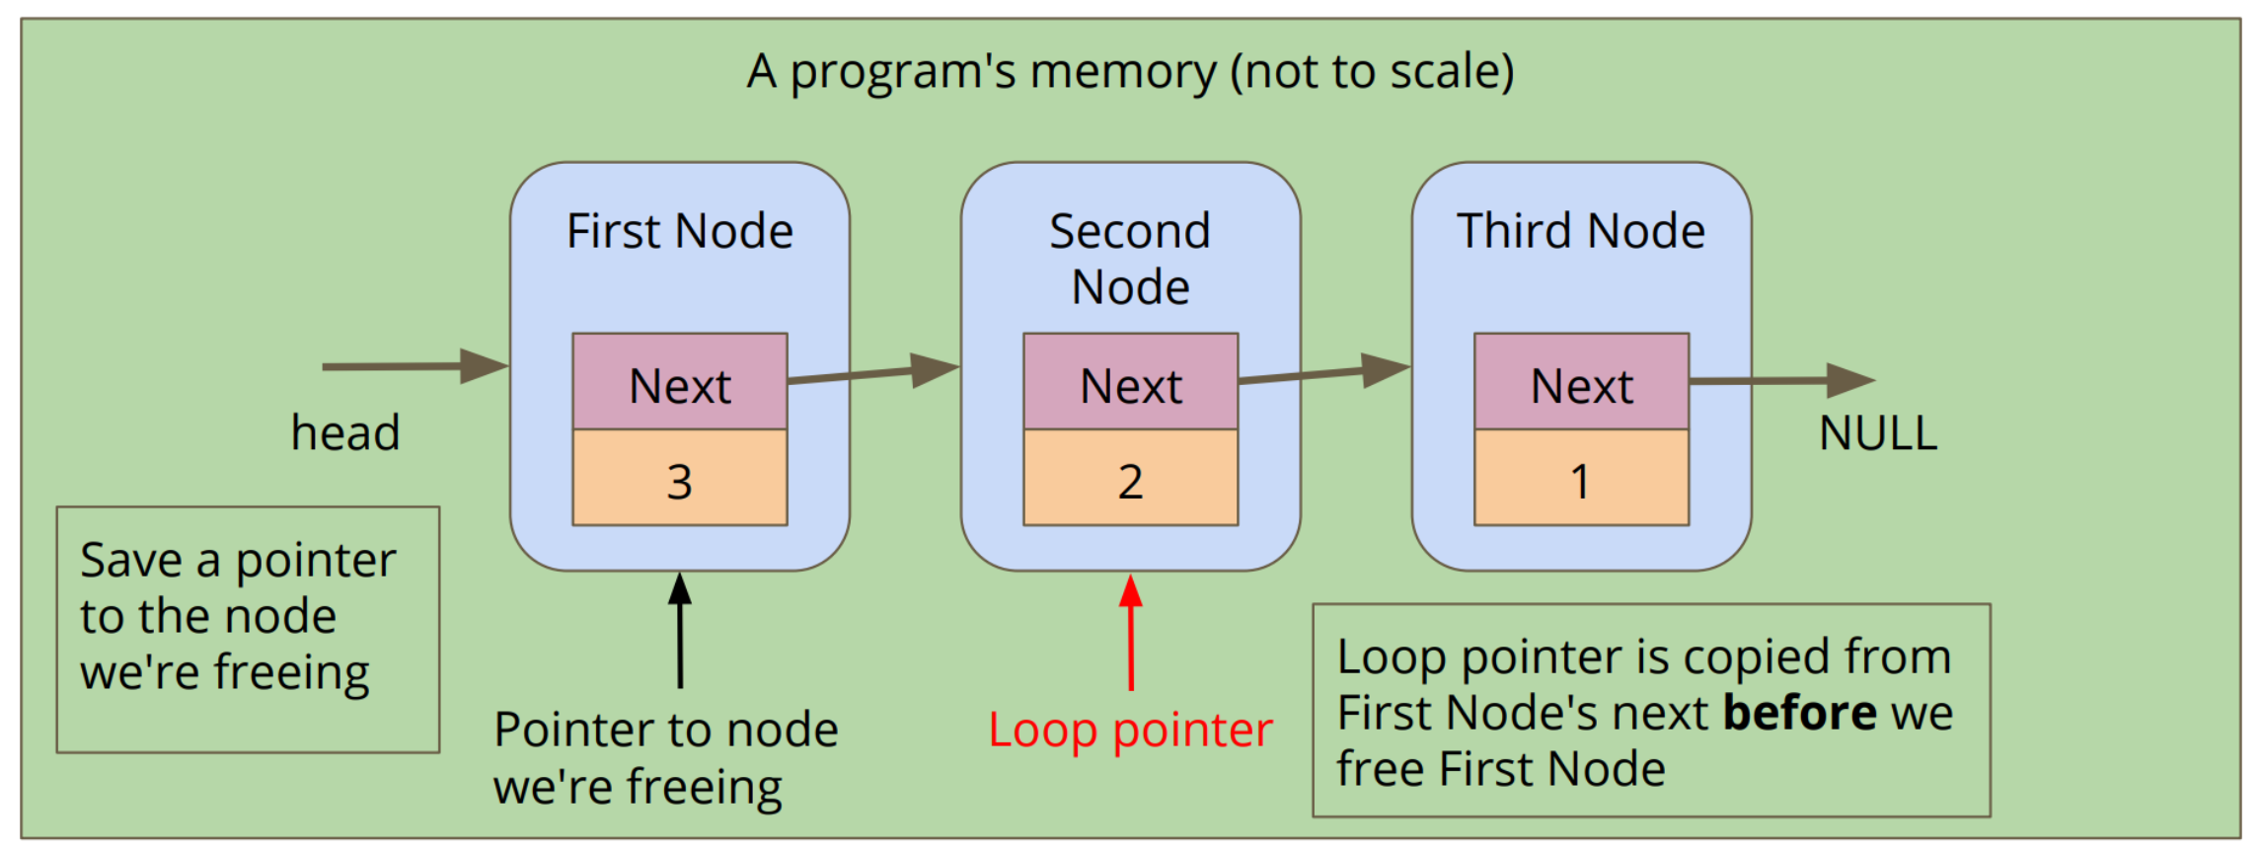

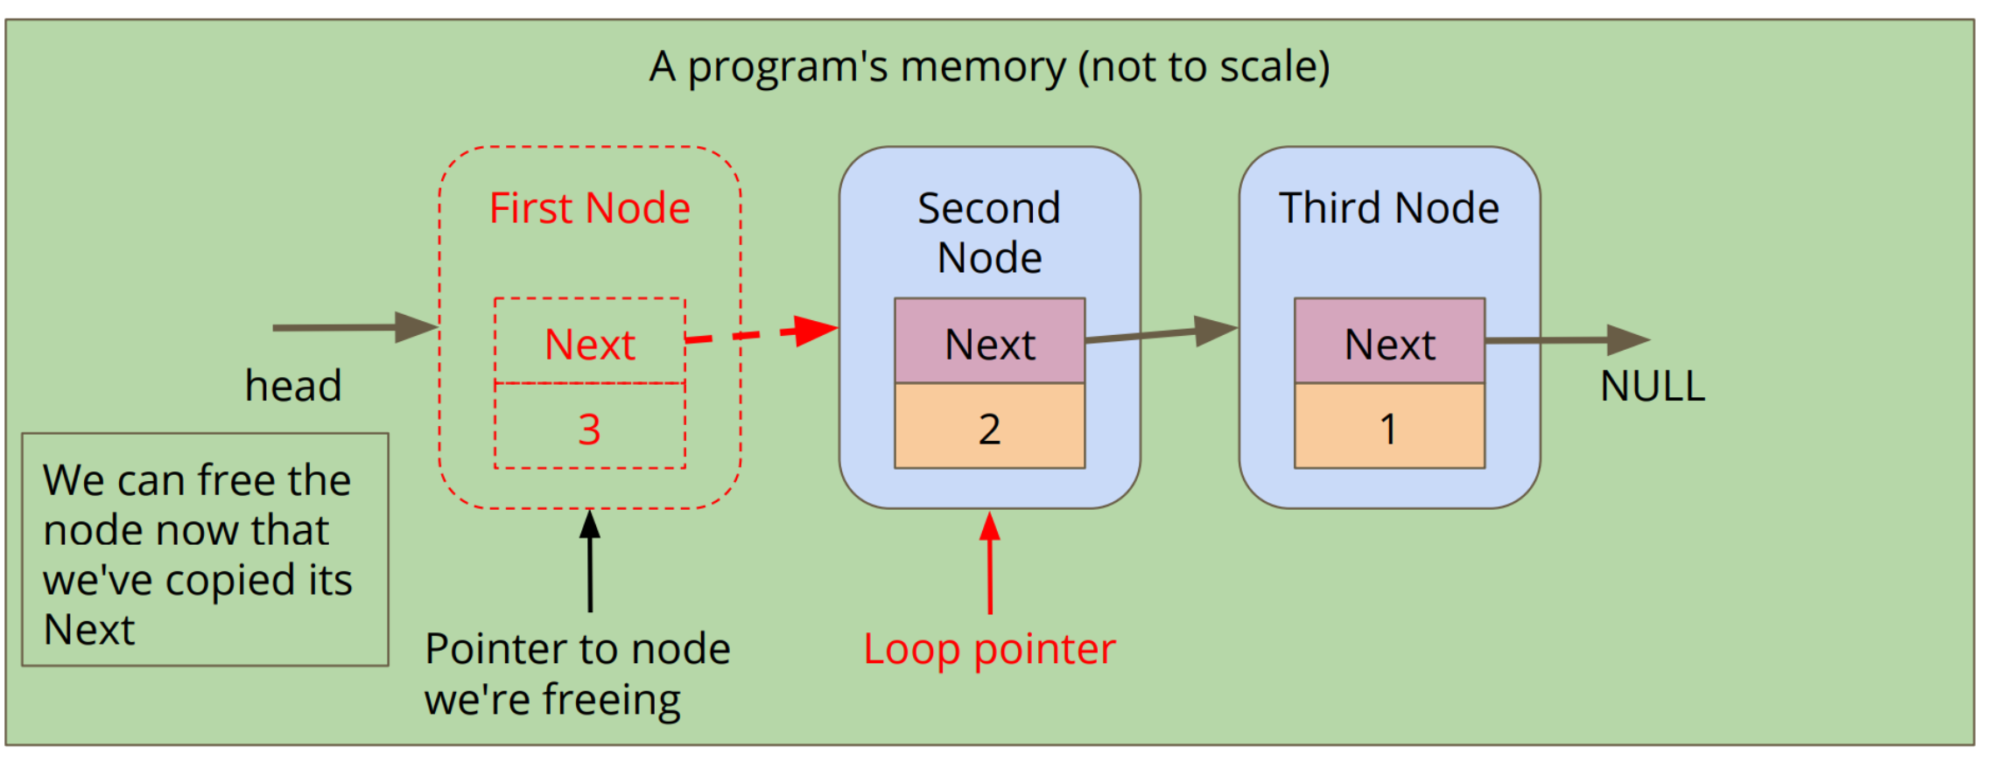

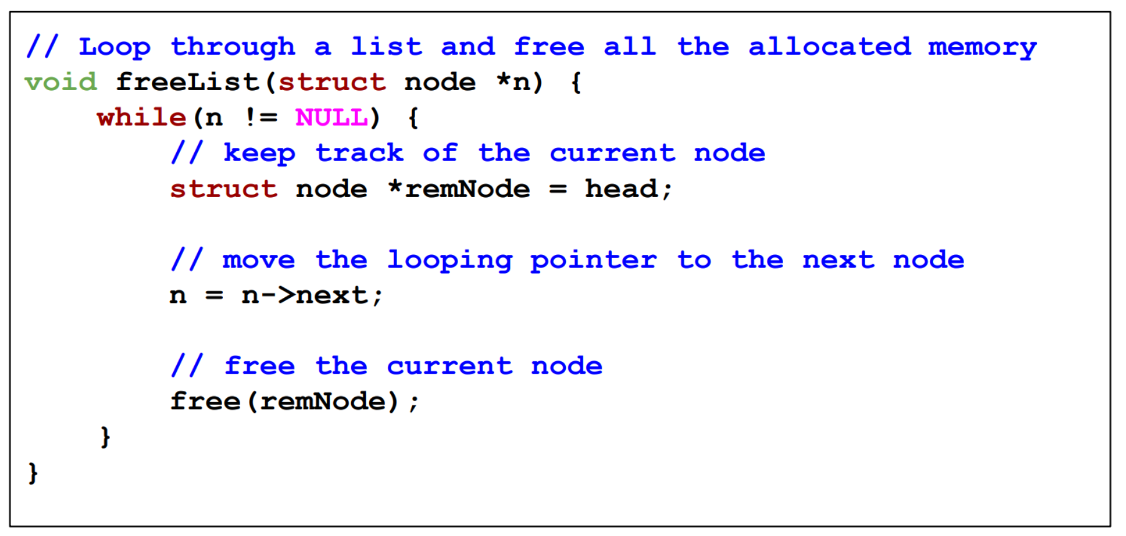

**14/04/20 – Week 9 Lecture 15**

**Using Multiple Files**

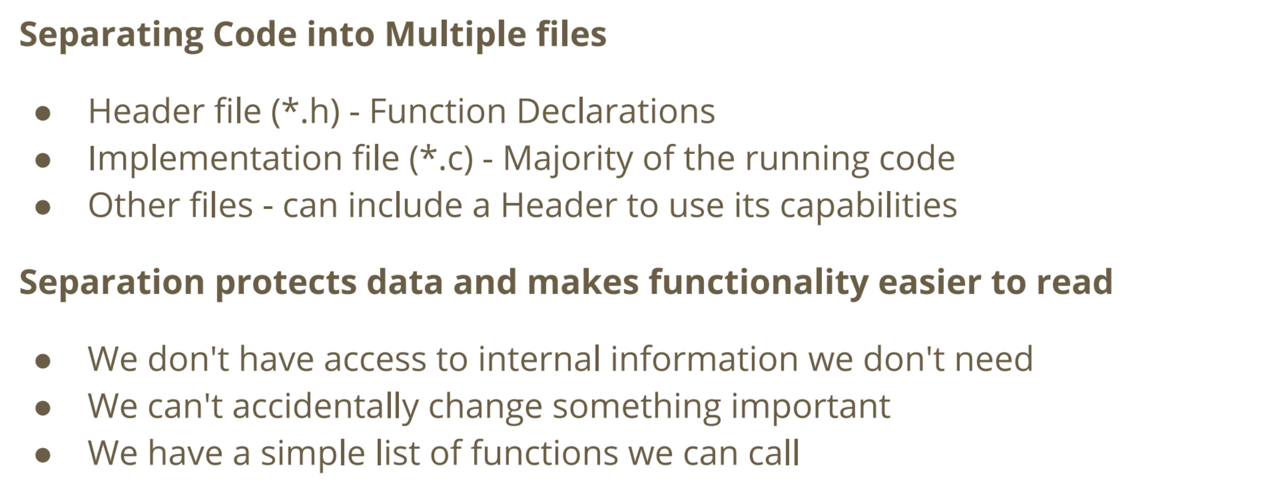

**Abstract Data Types**

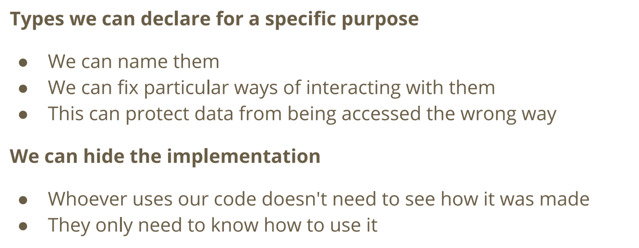

**Typedef (type definition)**

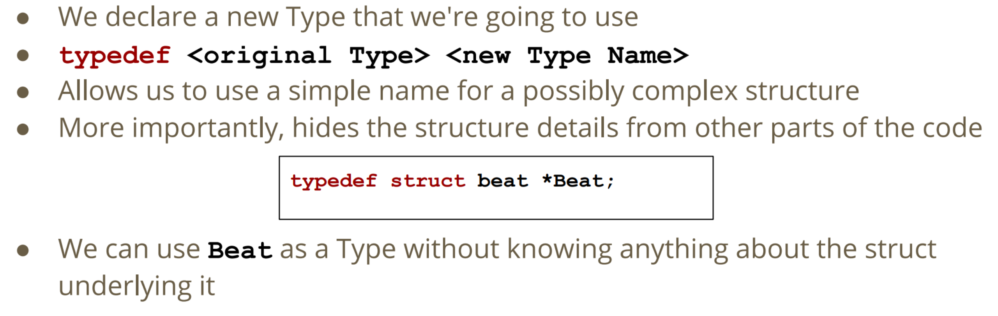

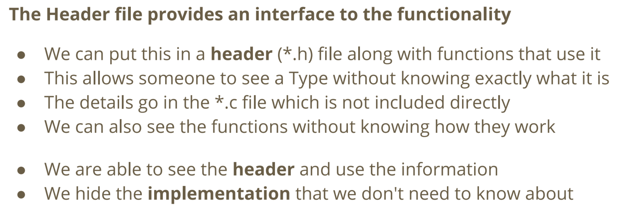

**Queue (FIFO)**

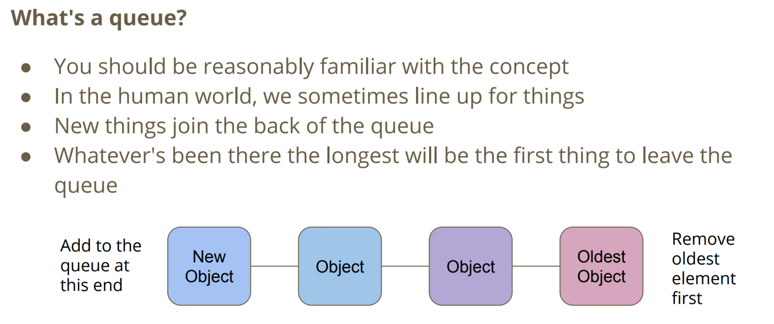

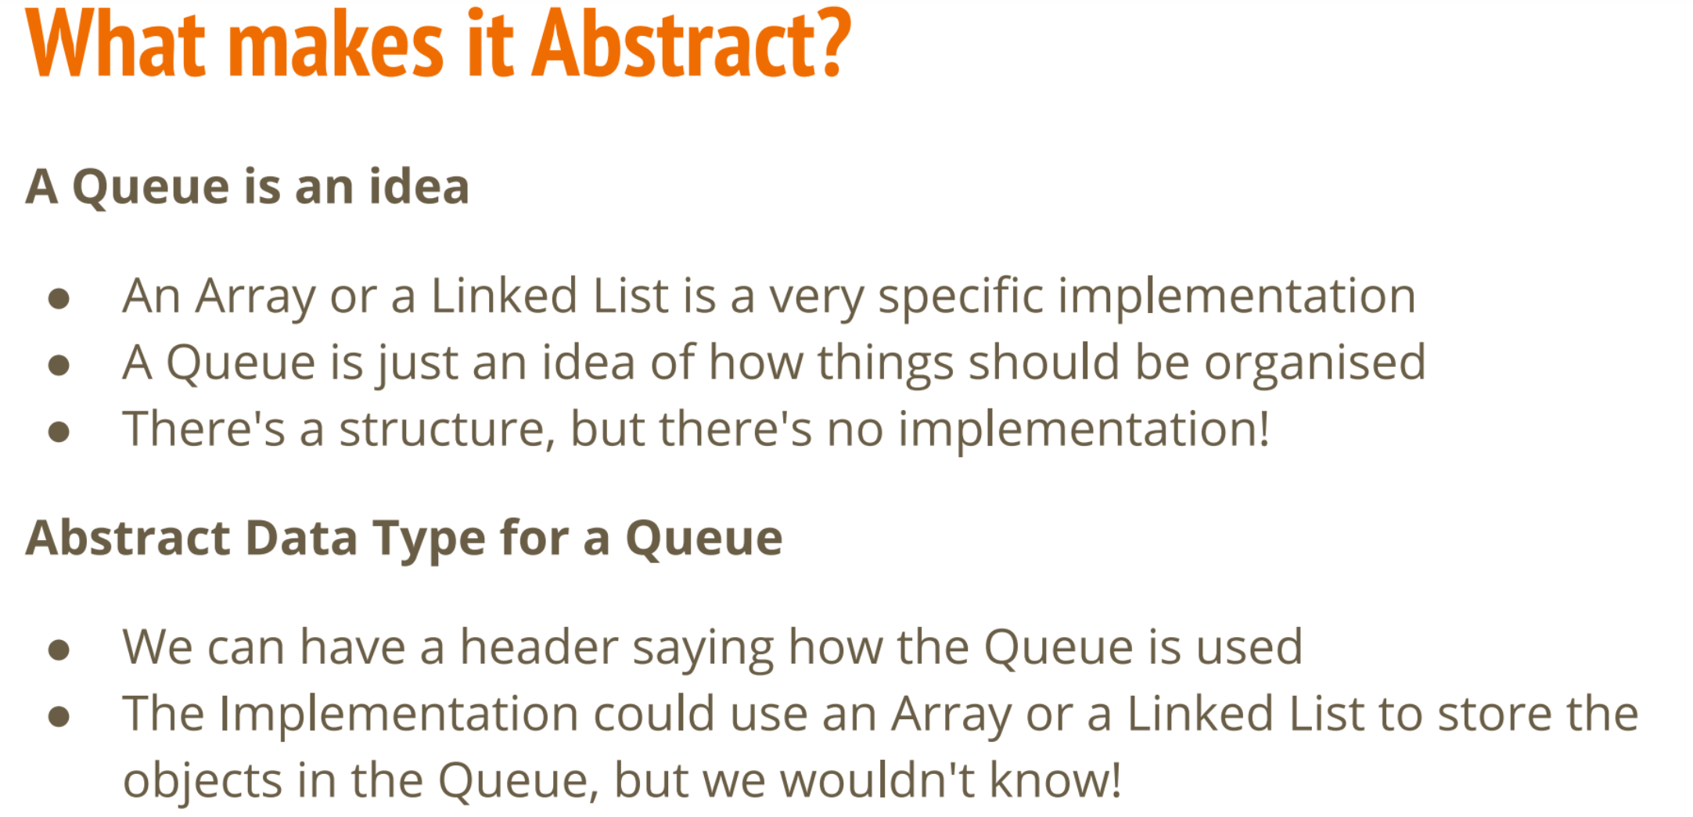

**Building a Queue**

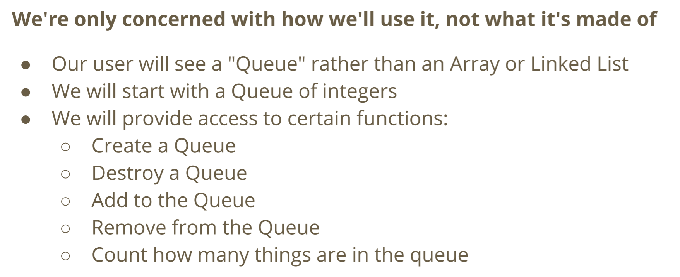

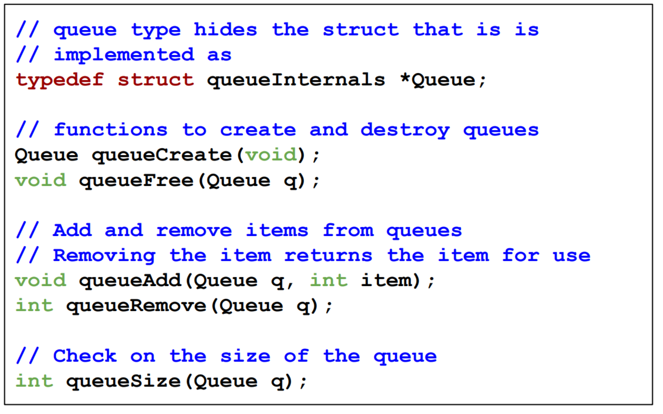

**What does the header file not provide? (Queue Header File)**

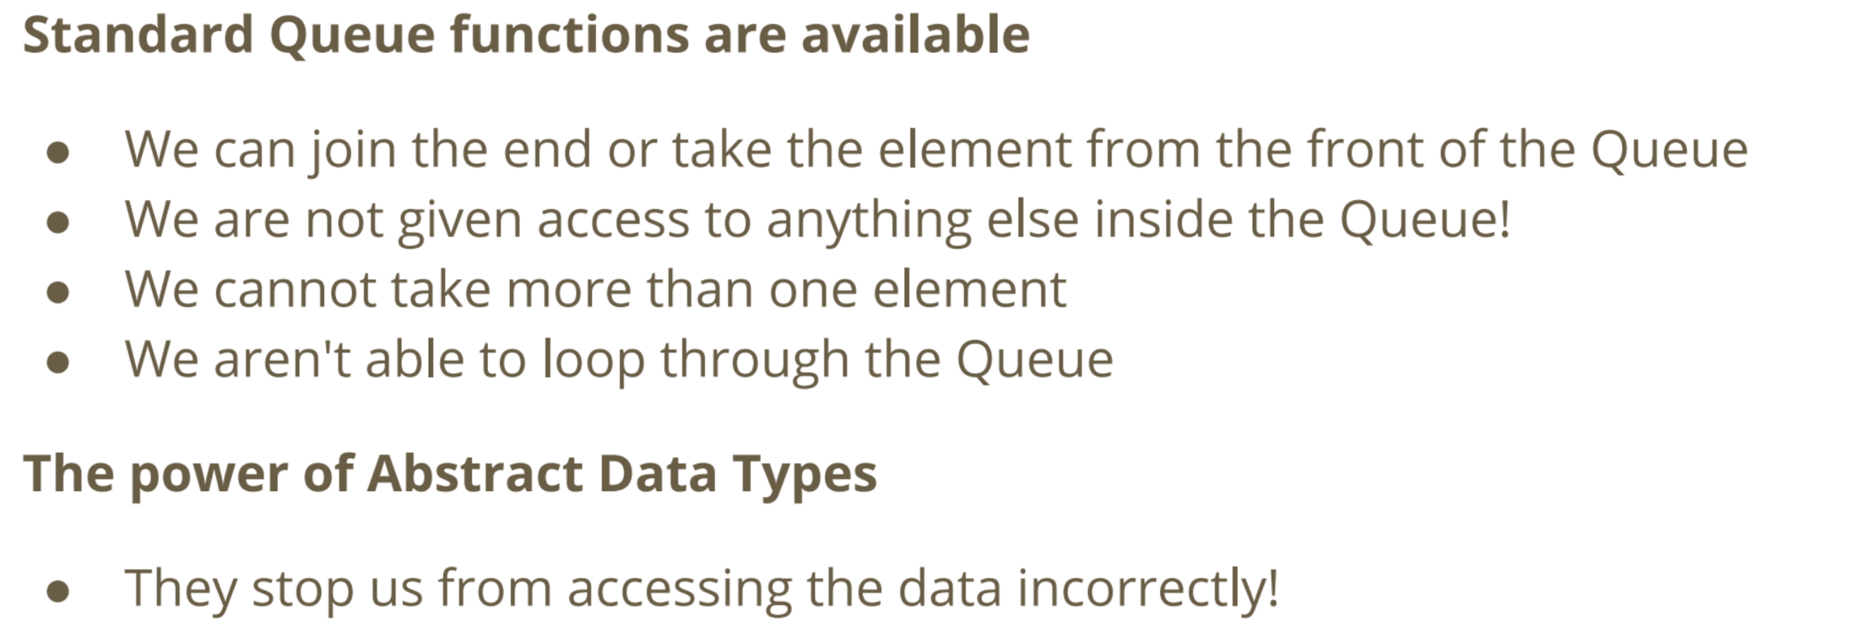

**Queue Implementation File (queue.c)**

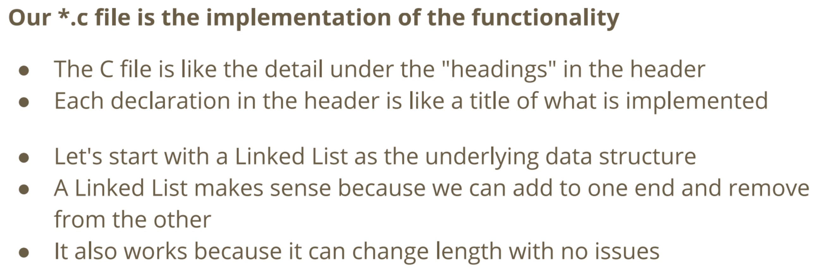

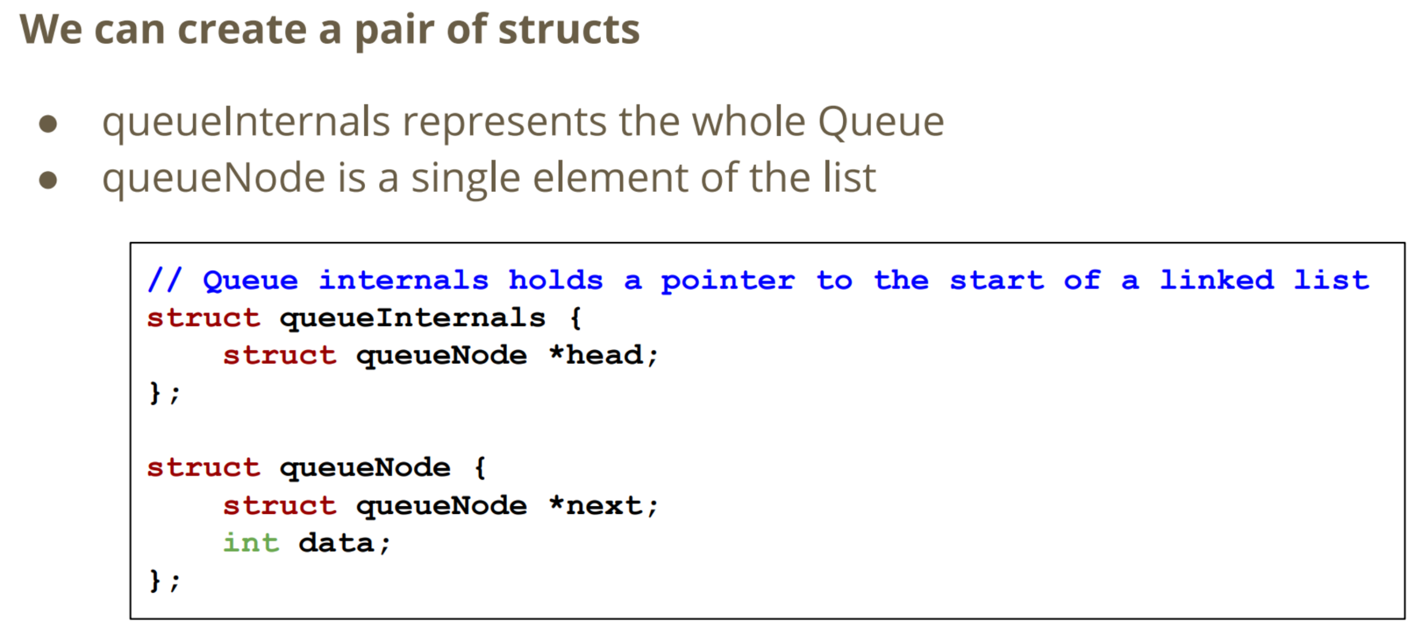

**Creating a Queue**

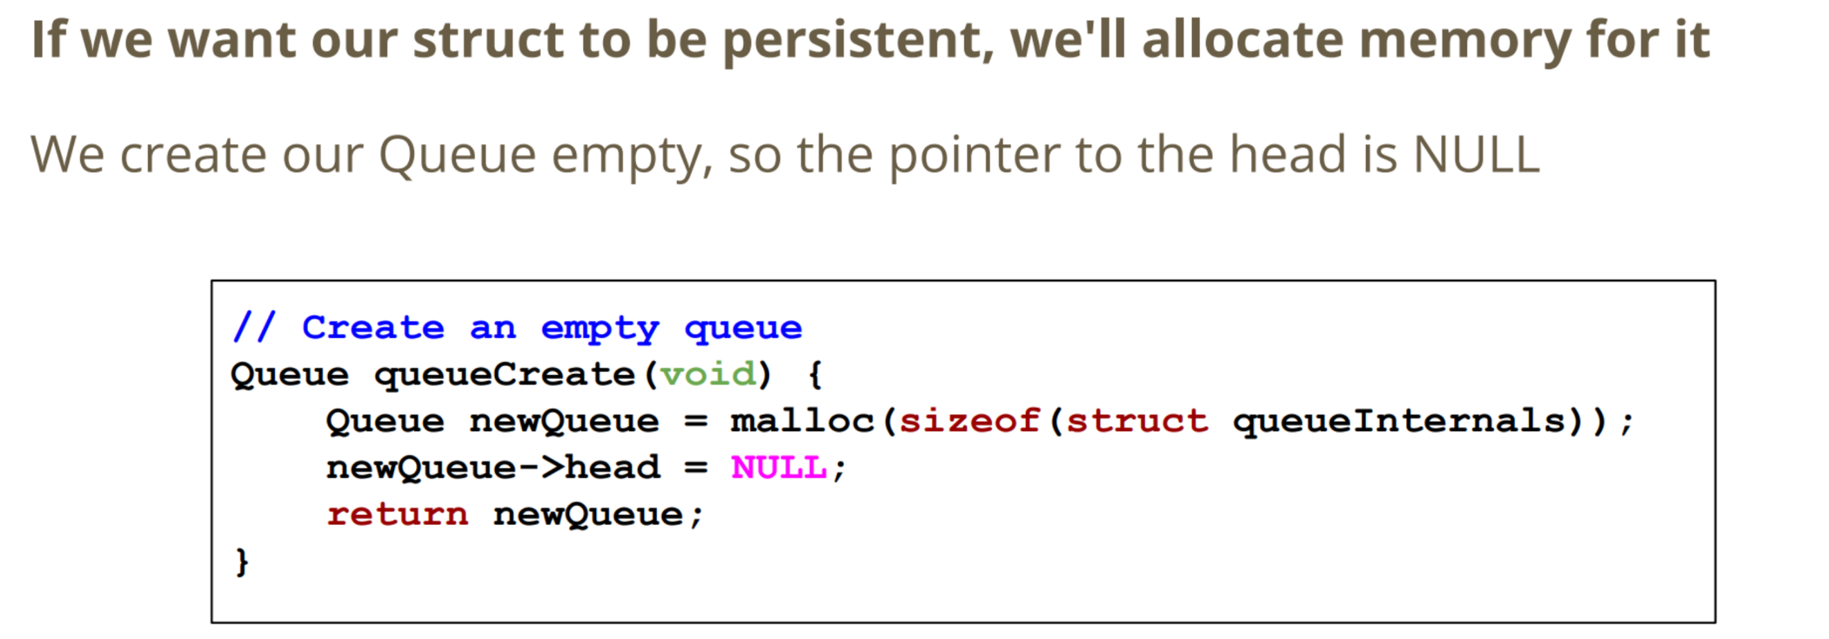

**Adding Items to a Queue**

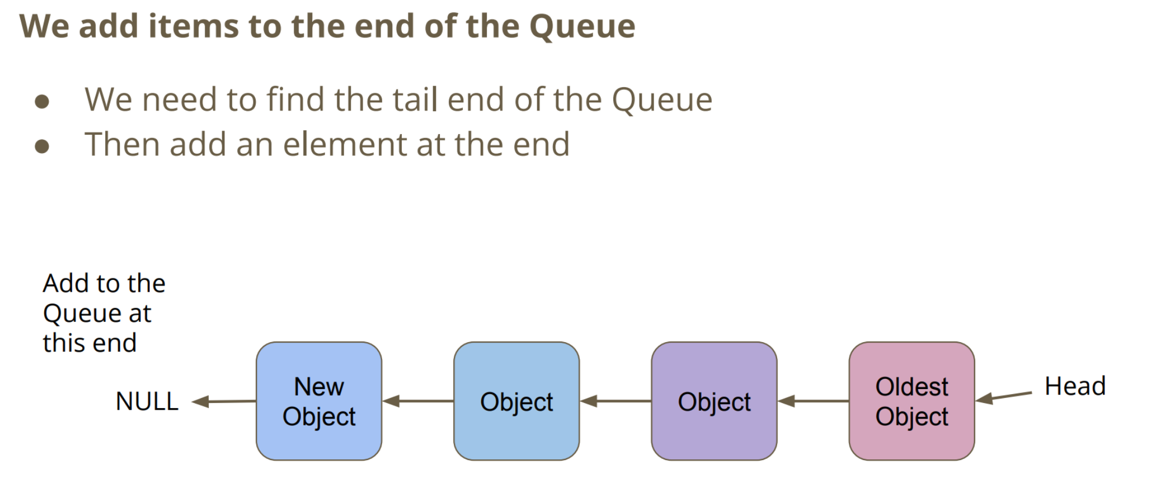

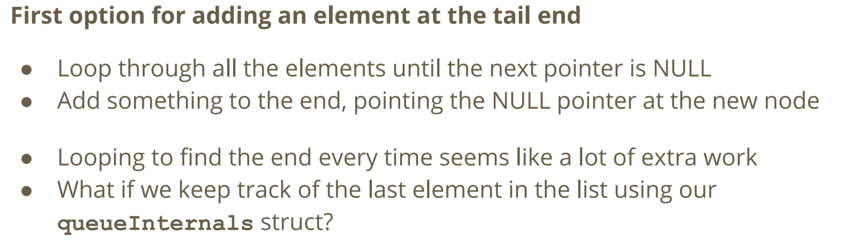

**Keeping Track of Both Ends of the Queue**

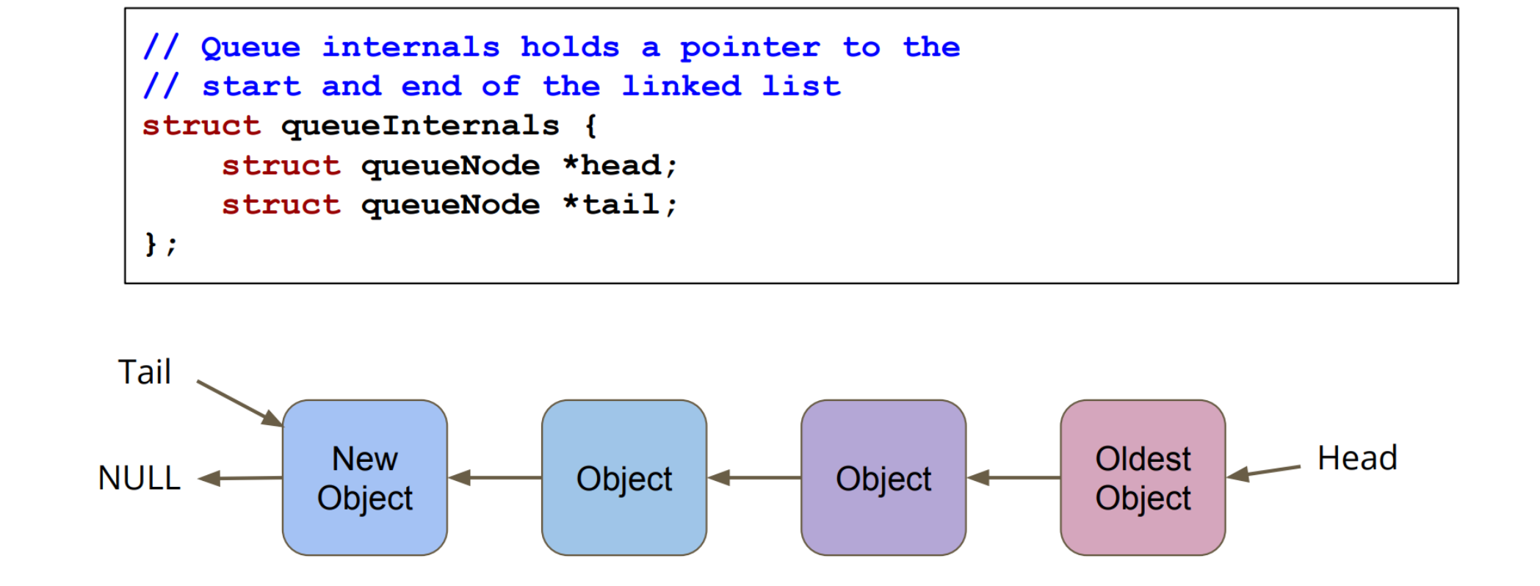

**Adding the Tail**

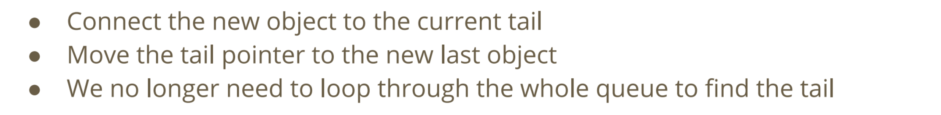

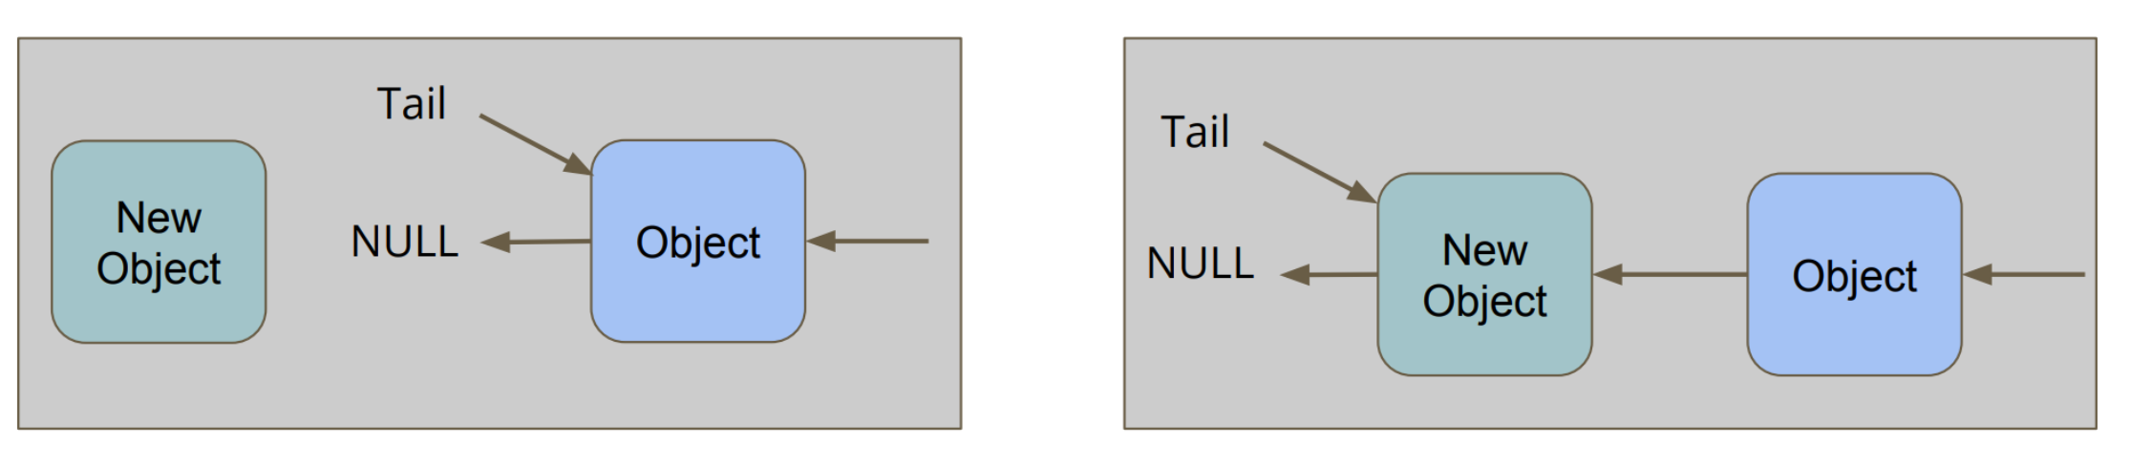

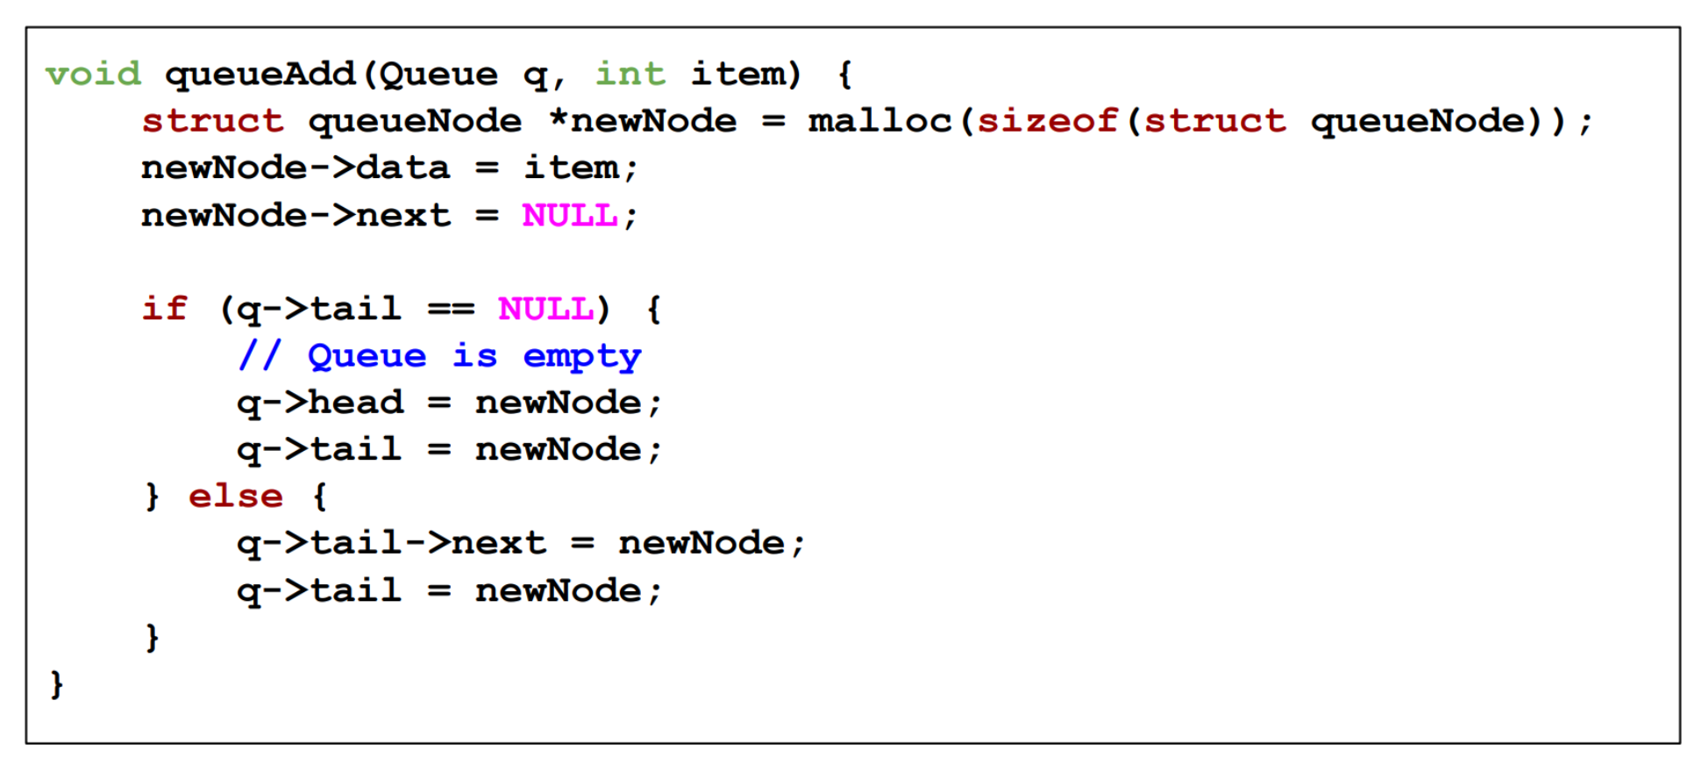

**Removing a Node**

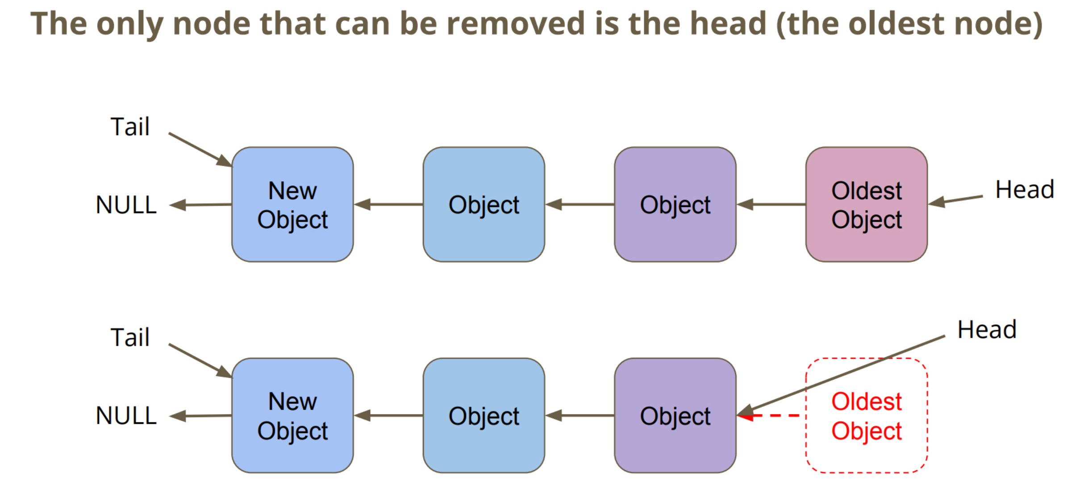

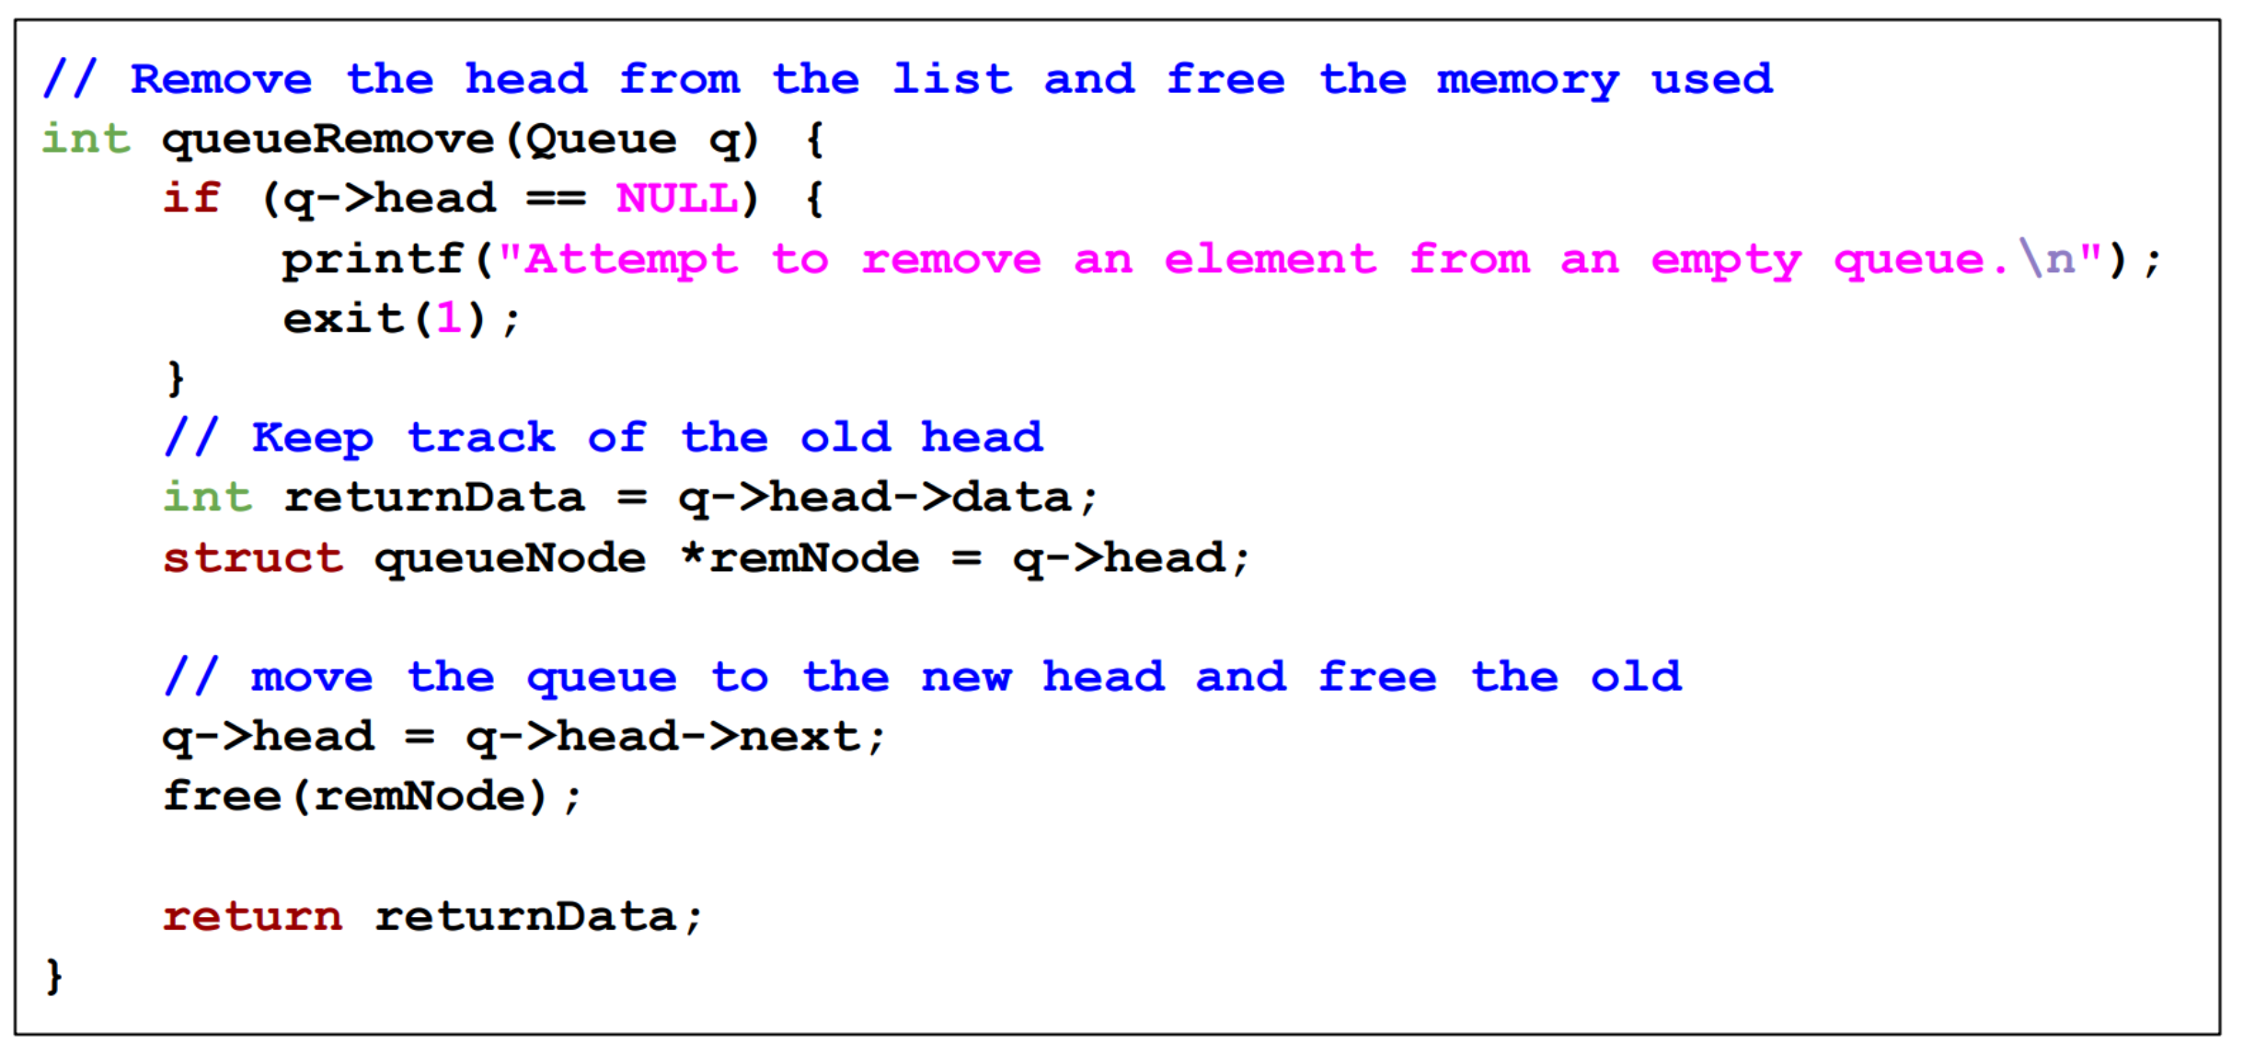

**15/04/20 – Week 9 Lecture 16**

**Freeing a Queue**

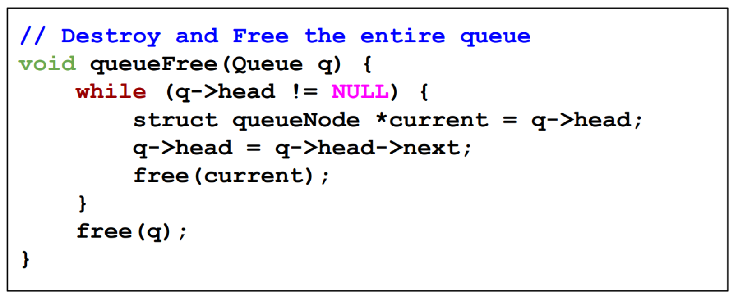

**Queue Counter**

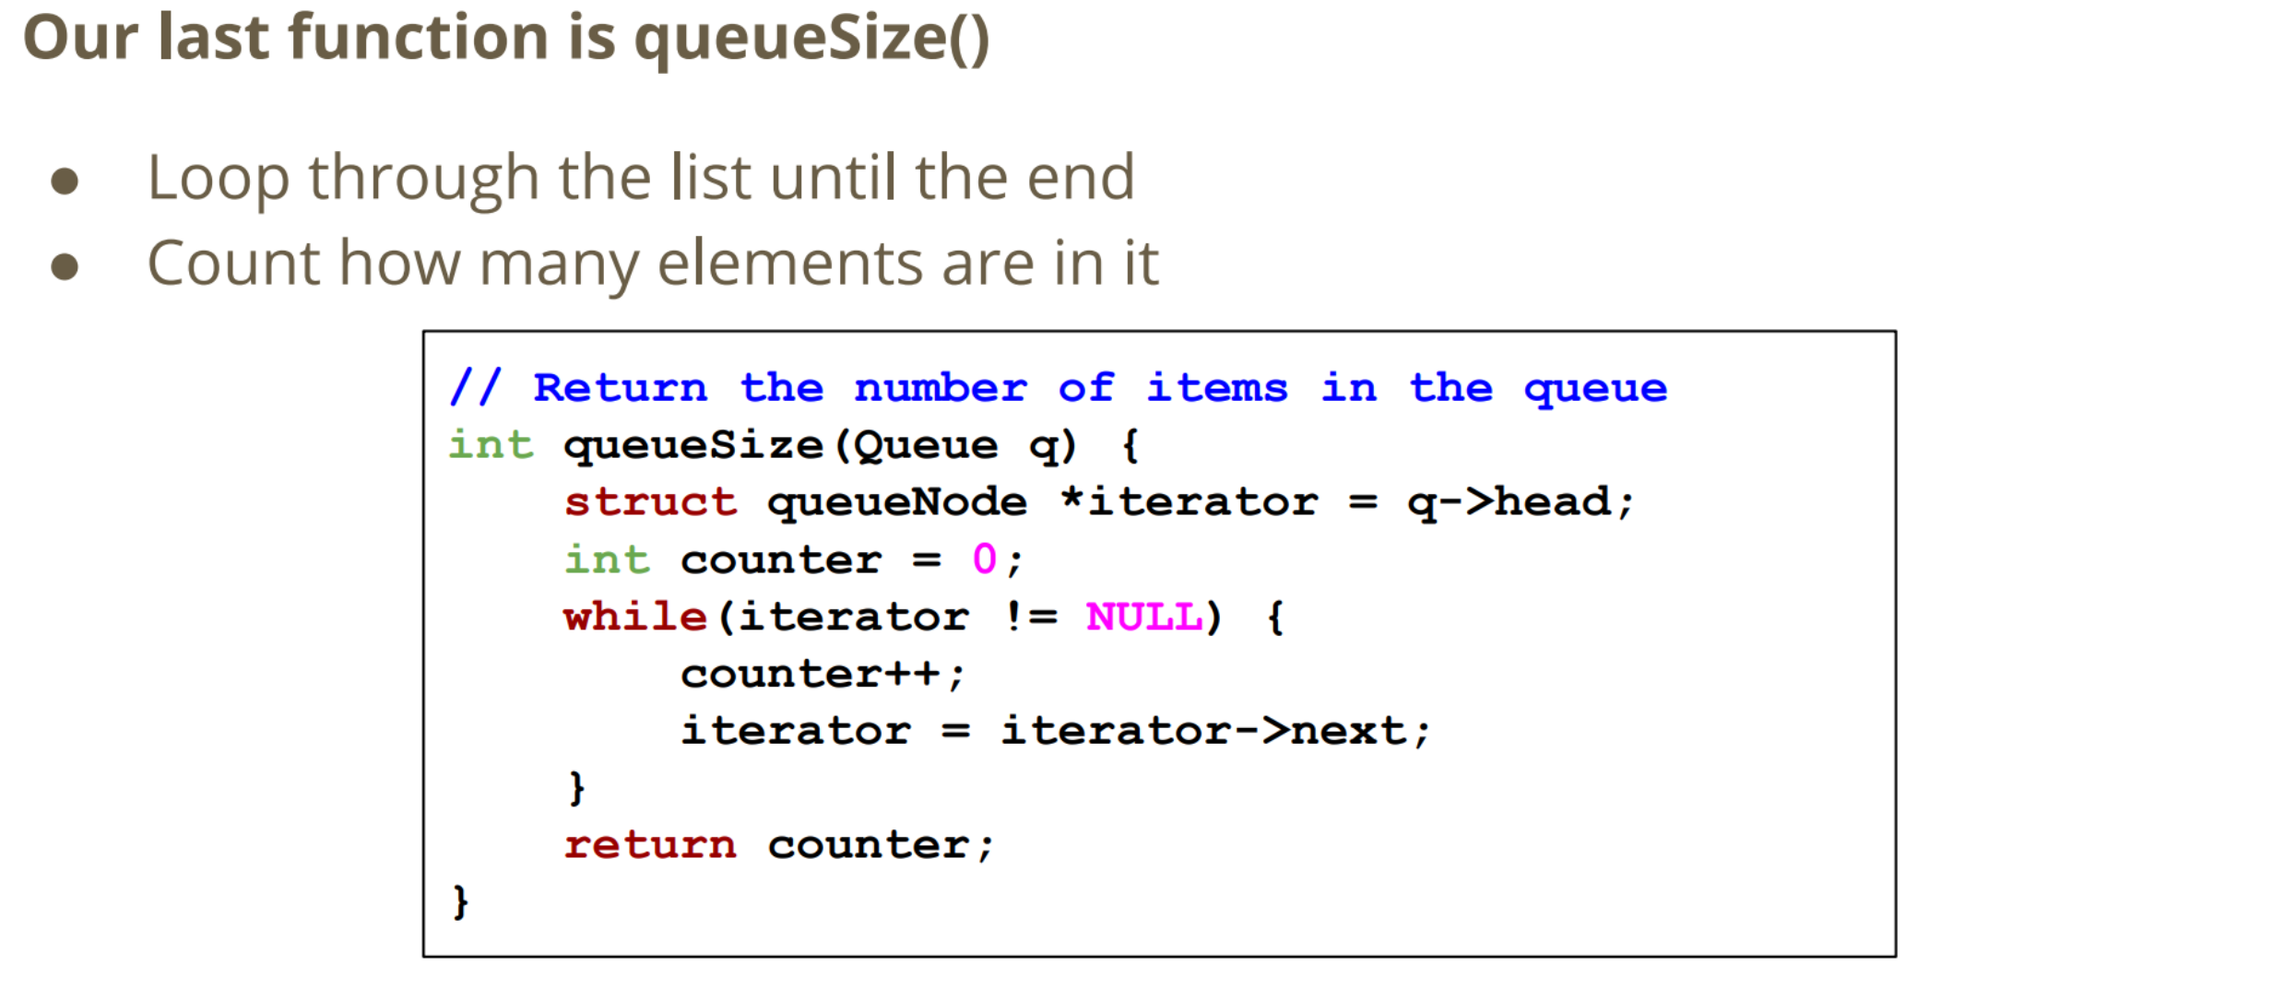

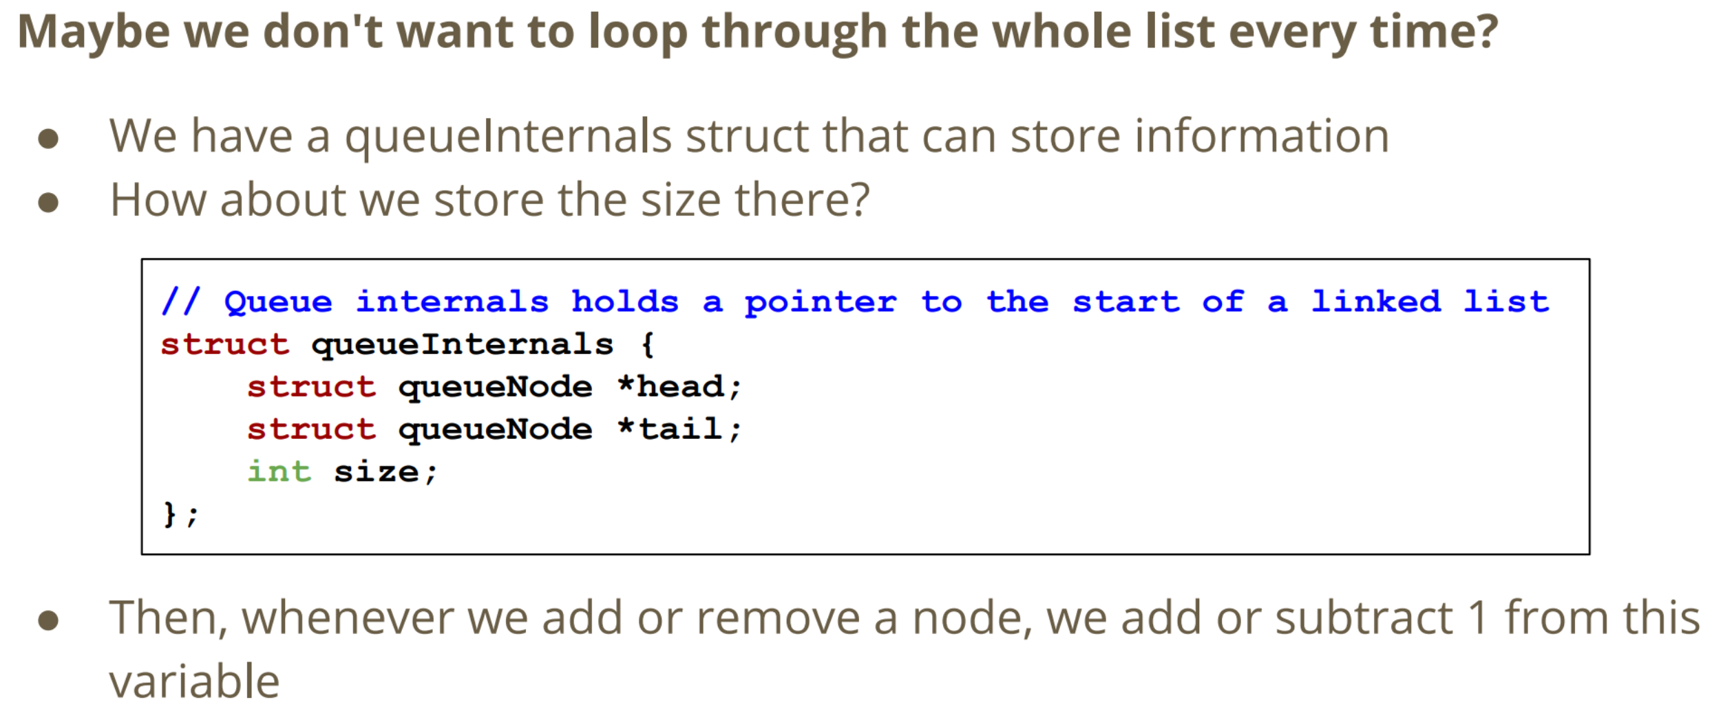

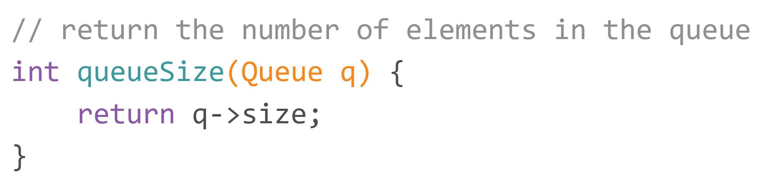

**Stack**

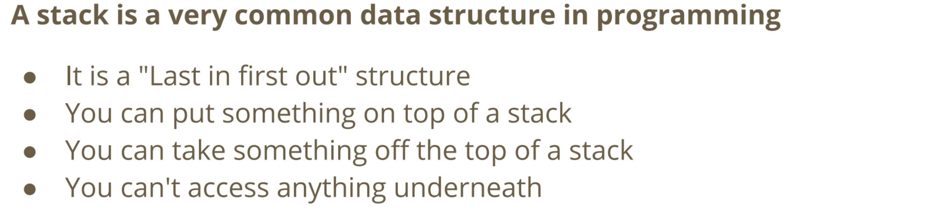

**Stack Header Implementation**

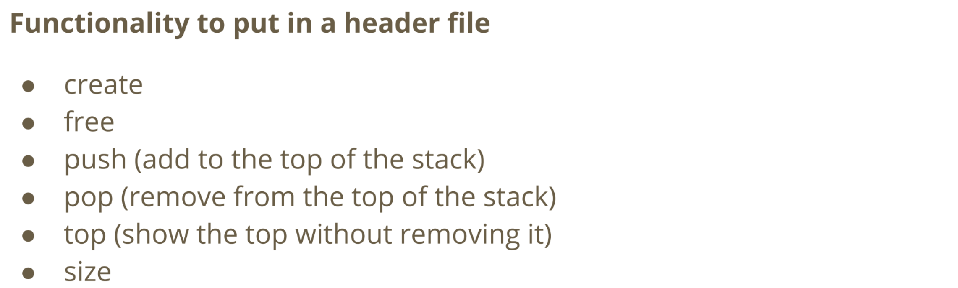

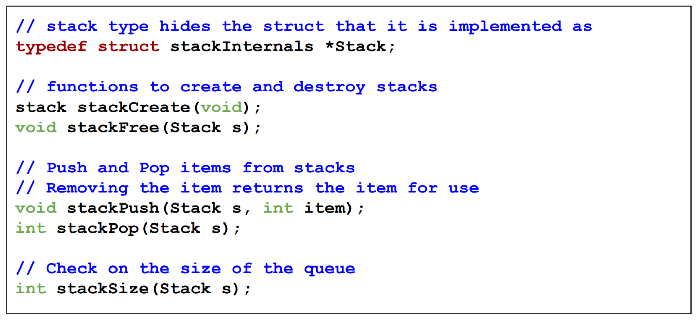

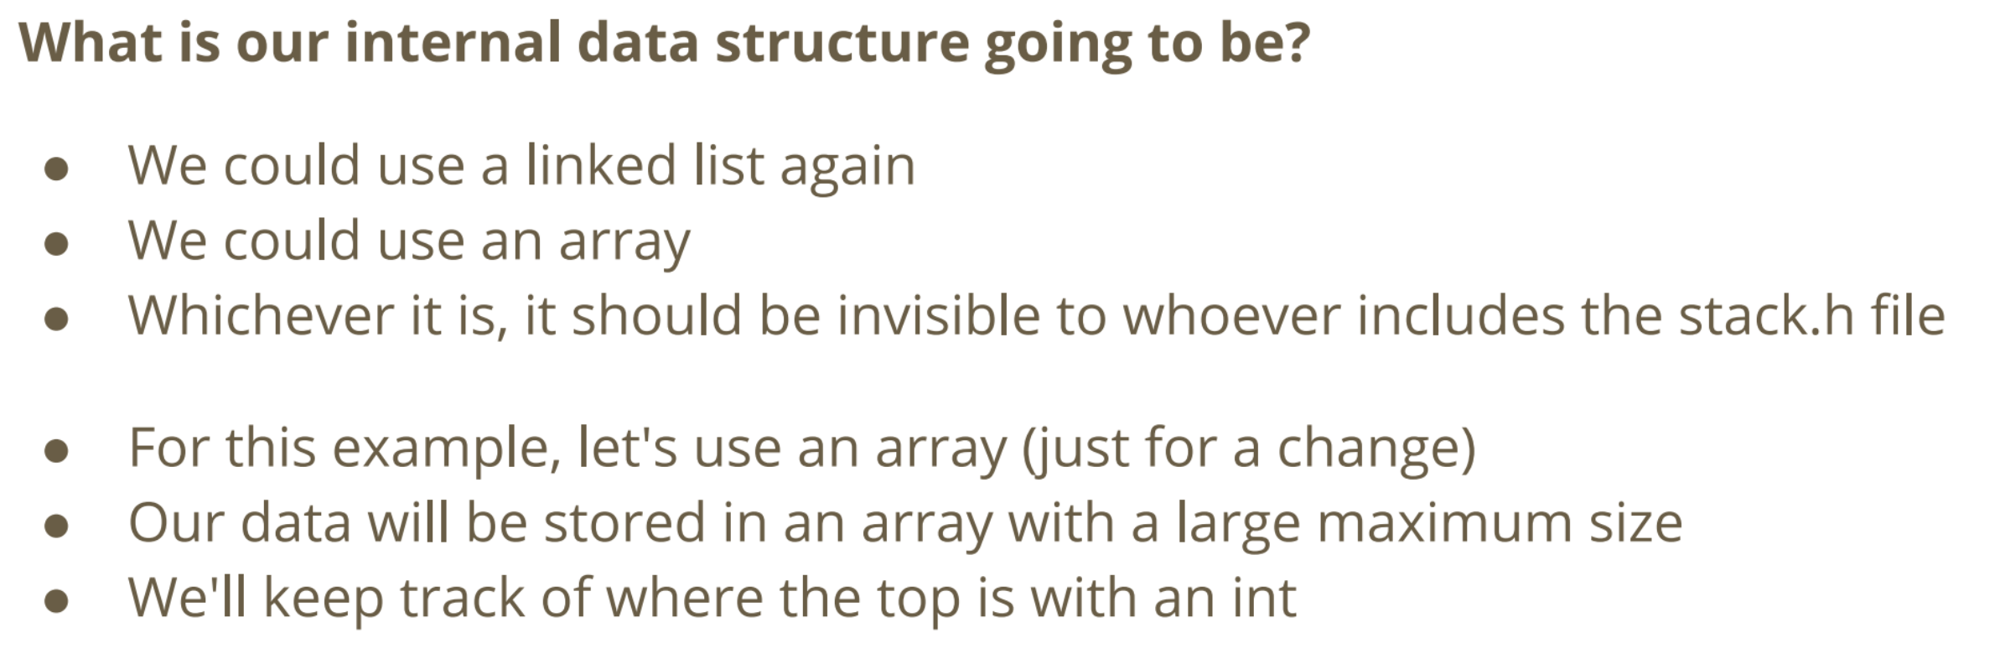

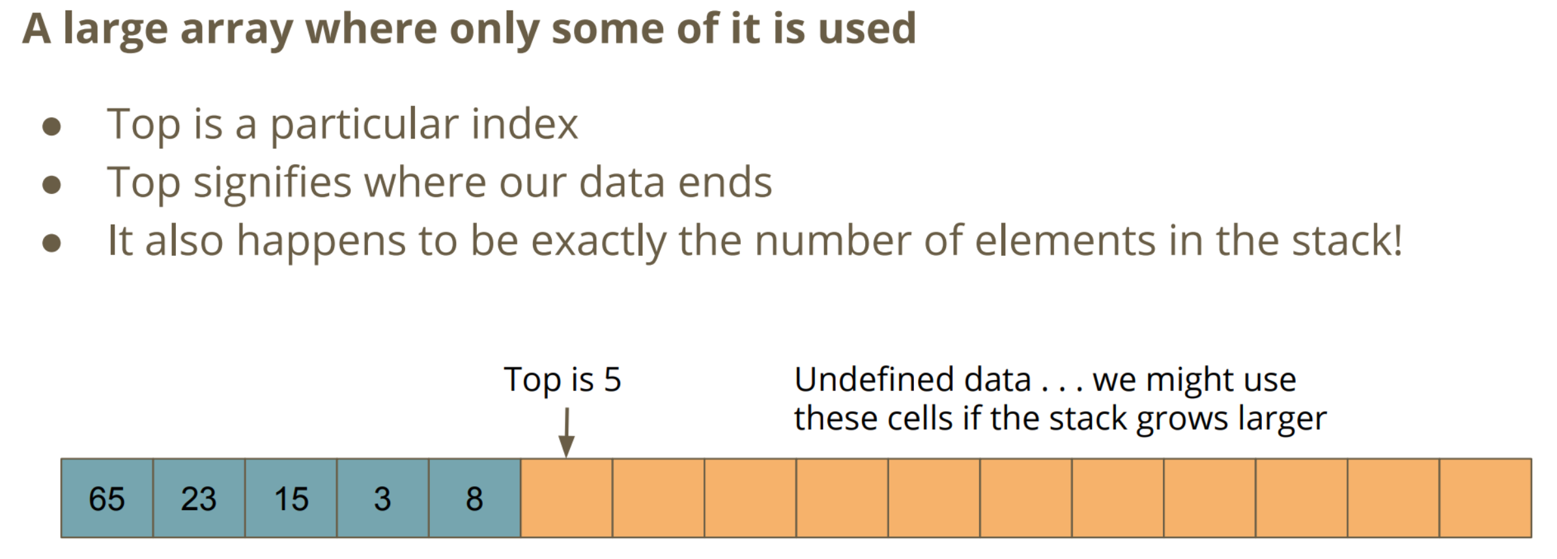

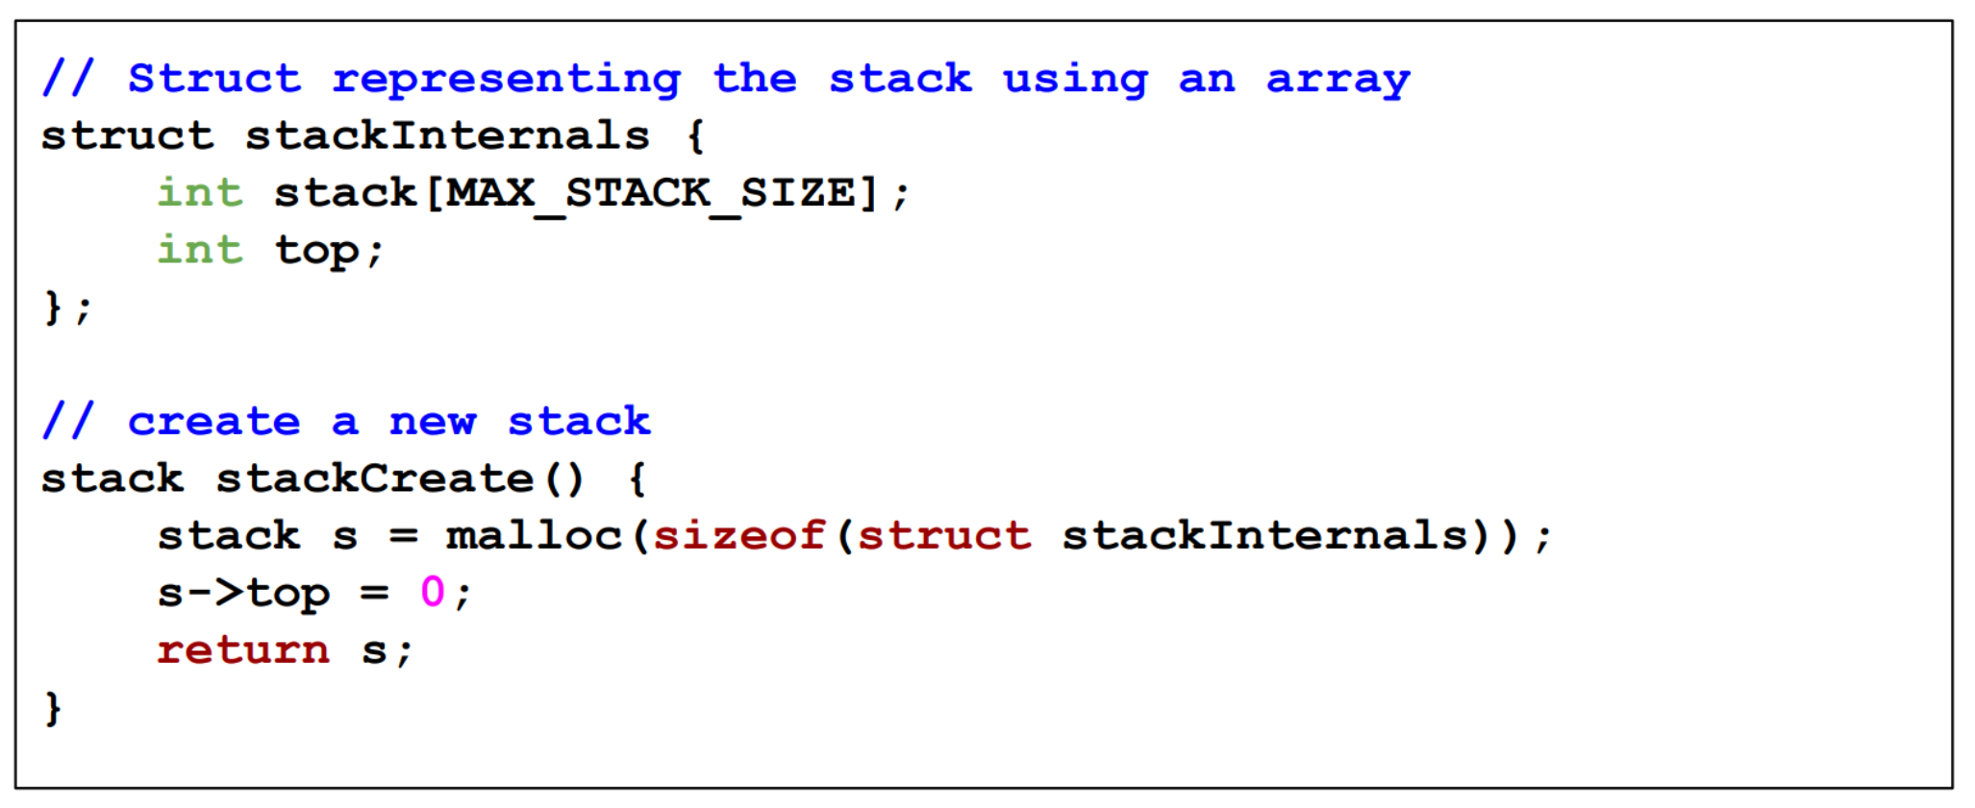

**Push and Pop (Array)**

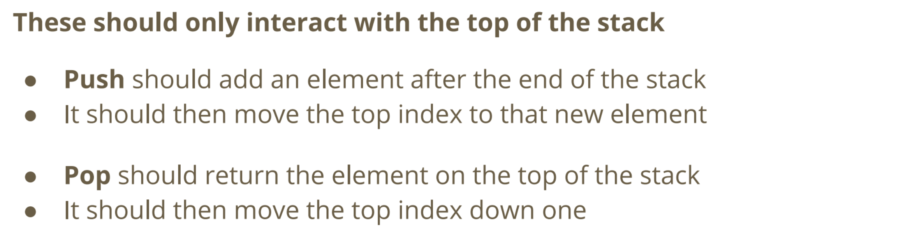

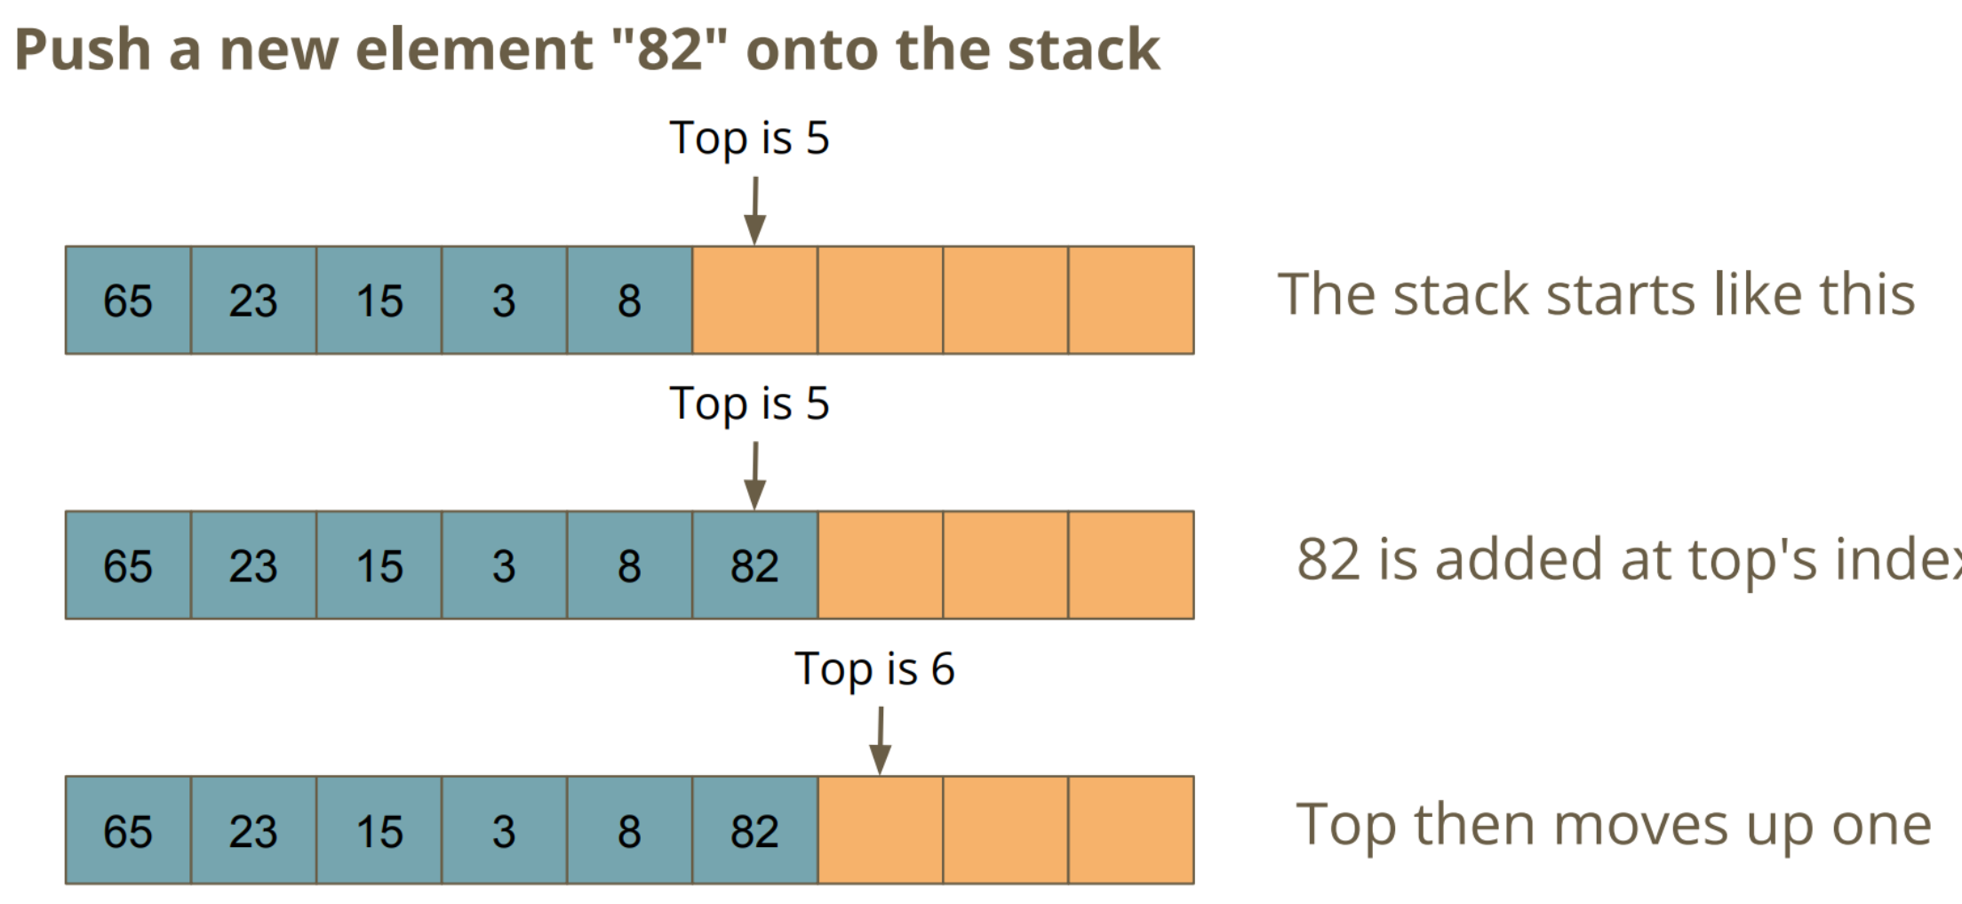

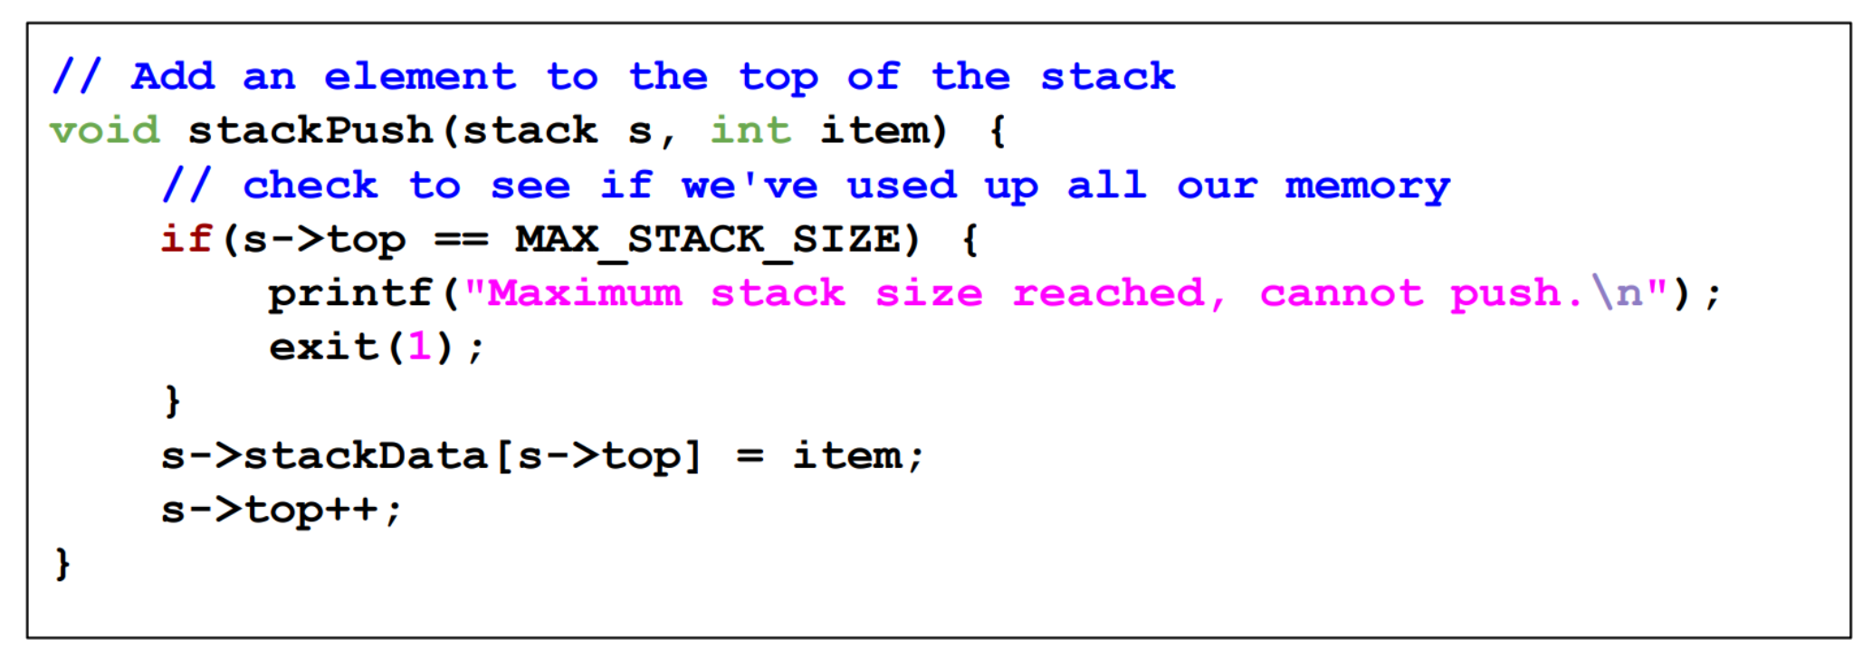

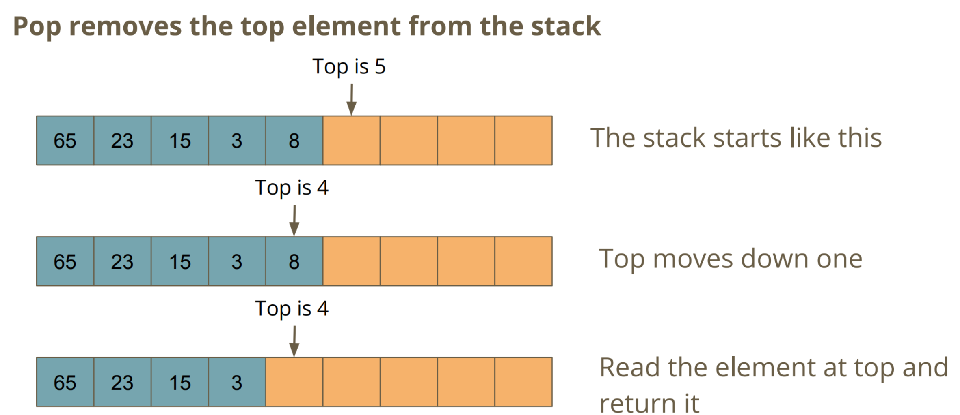

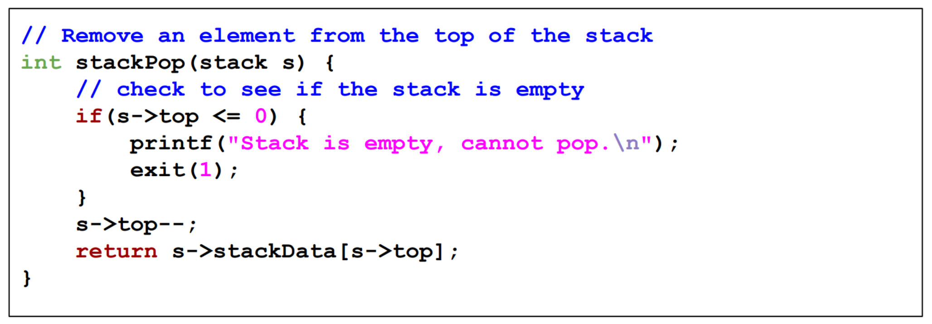

**Linked List Implementation**

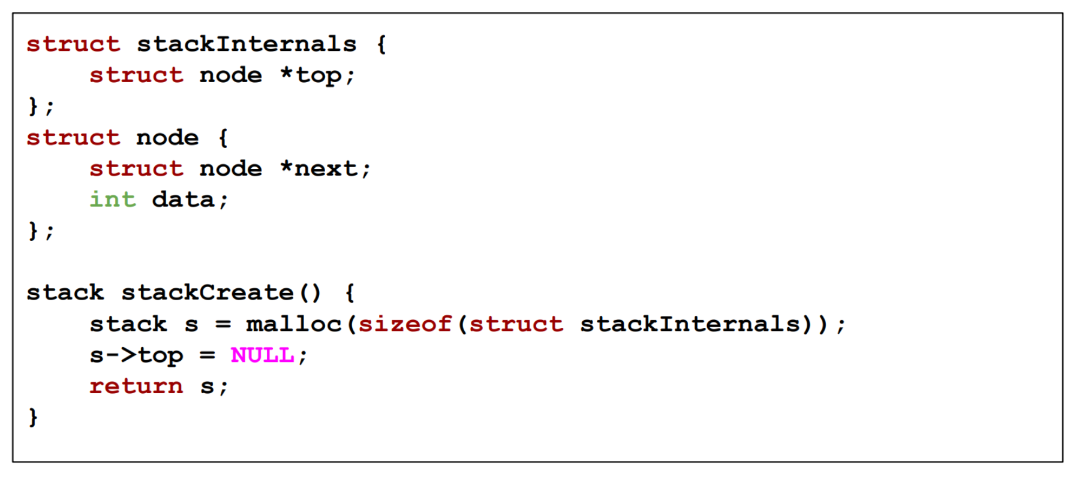

**Push and Pop (Linked List)**

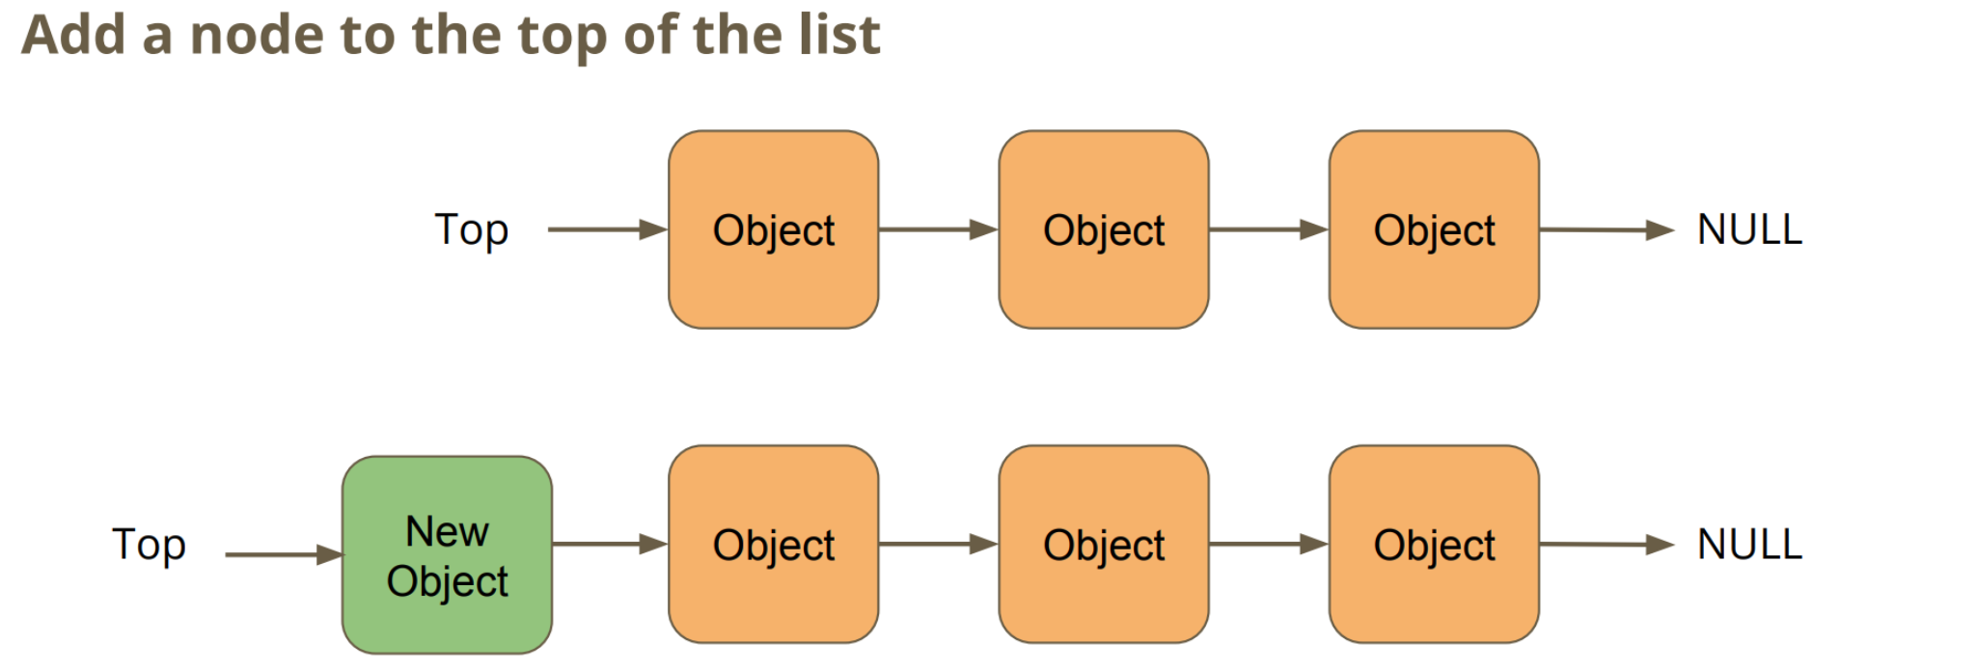

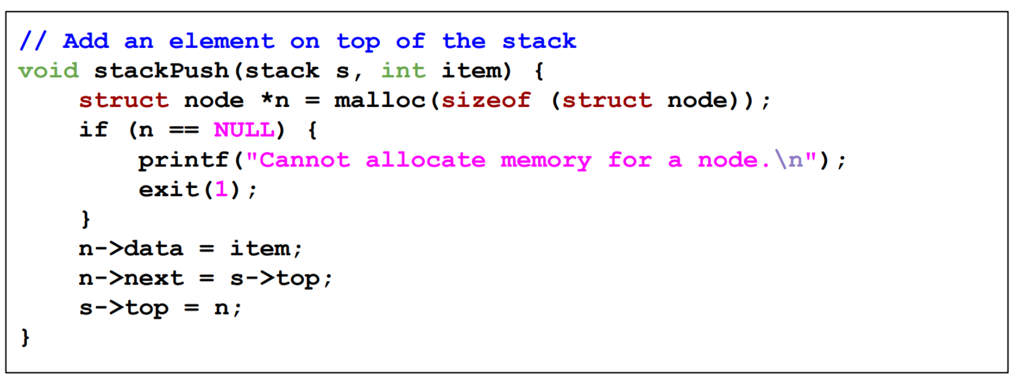

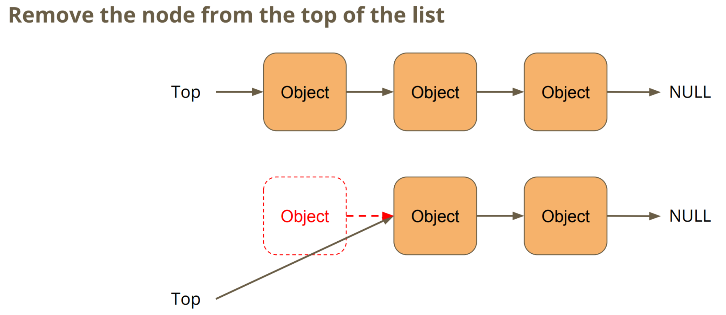

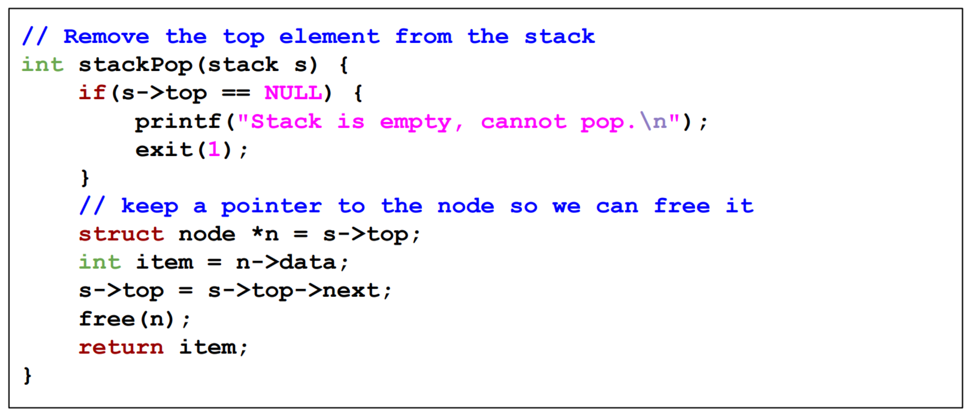

**Extra Stuff**

Recursion for Linked List

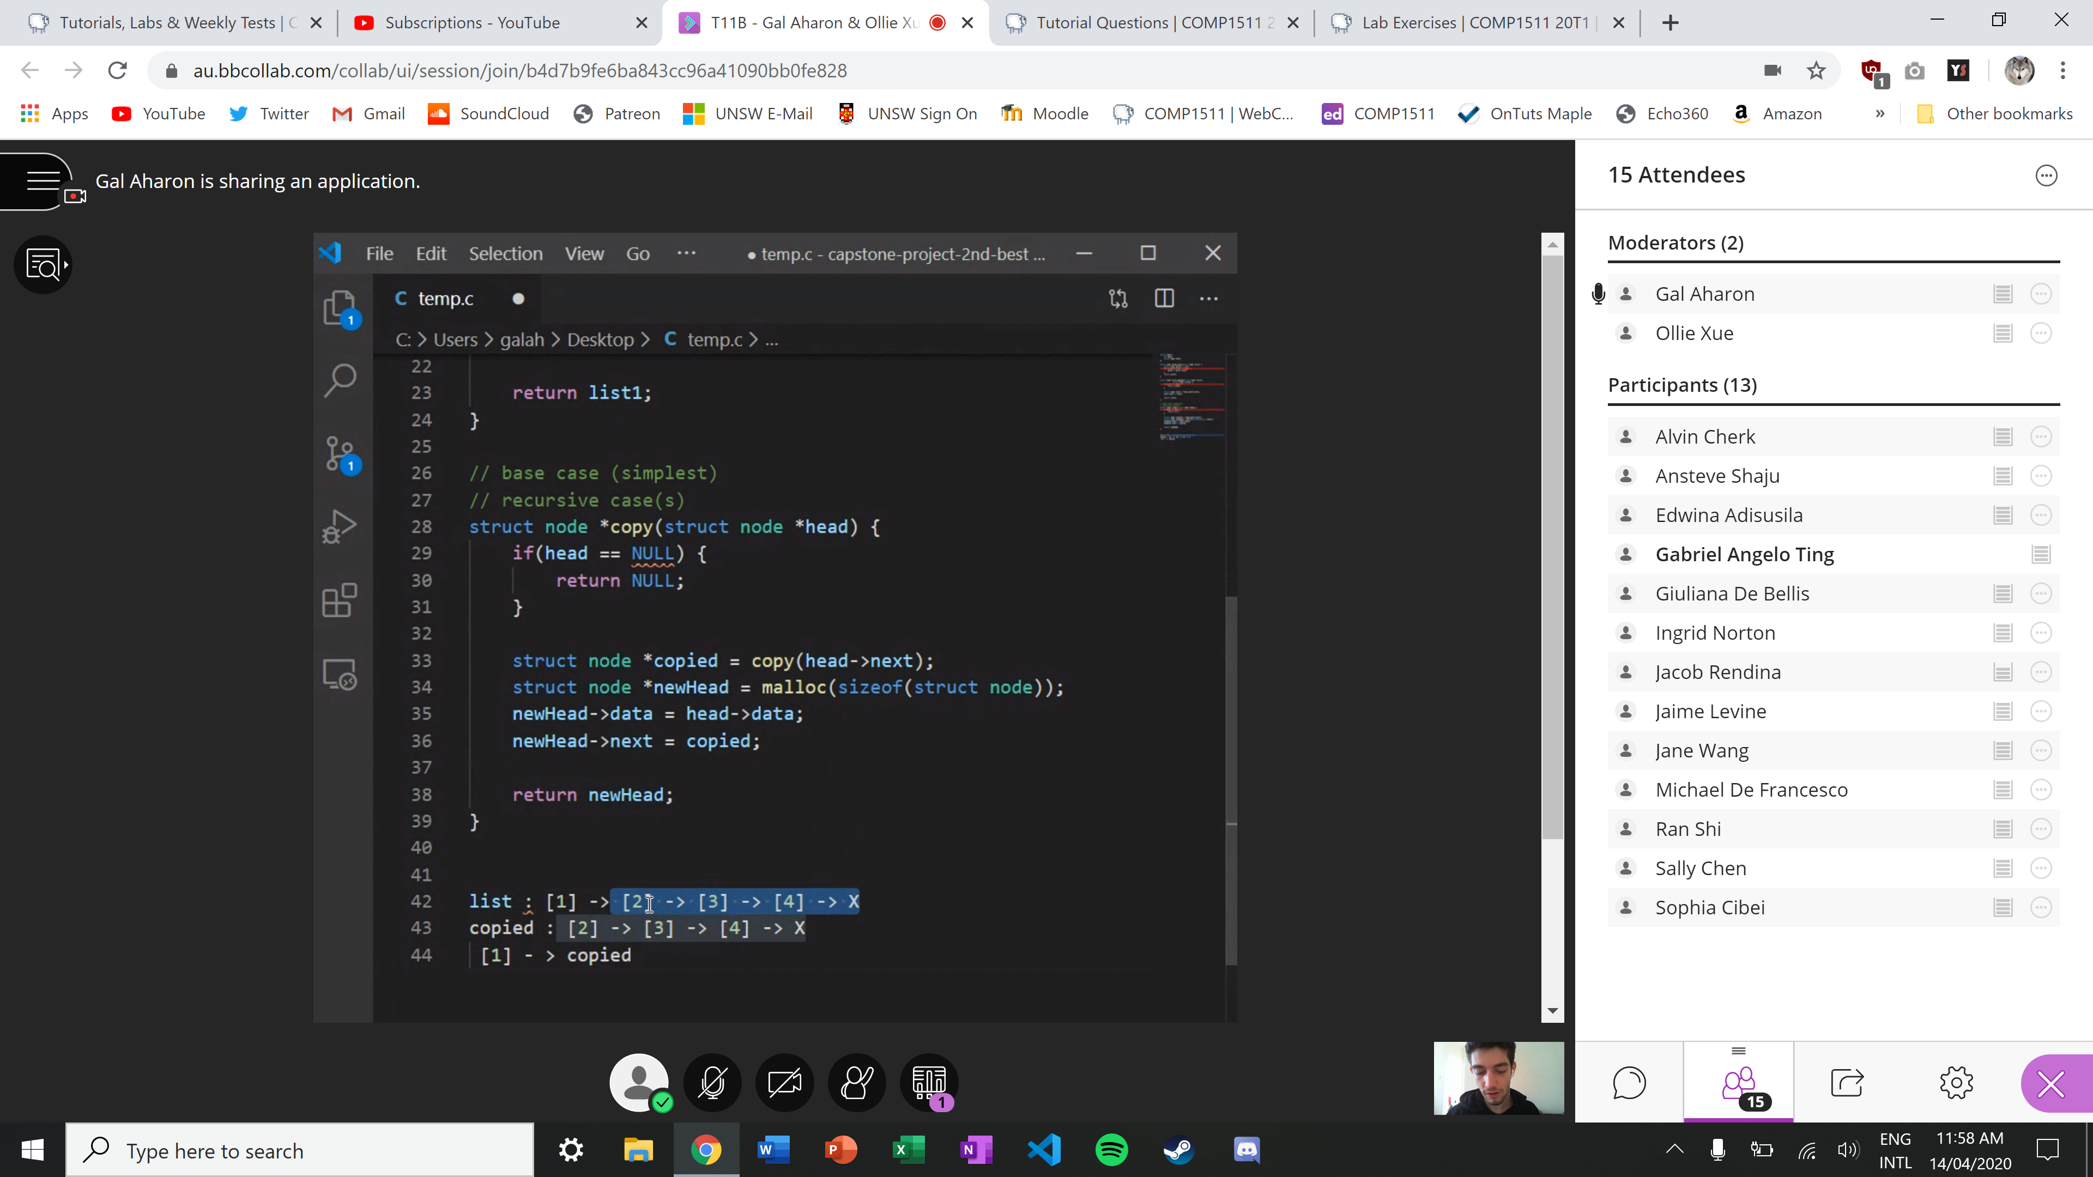

Common Function Names for List, Queue and Stacks

